Section 6.2 Parallelograms

# Objective 1: Use Relationships Among Sides and Angles of Parallelograms

A **parallelogram** is a quadrilateral with both pairs of opposite sides parallel.

In a parallelogram (and in all other convex quadrilaterals), **opposite sides** do not share a vertex and **opposite angles** do not share a side.

**Theorem: Opposite Sides of a Parallelogram**

If a quadrilateral is a parallelogram, then its opposite sides are congruent.

a. Write a proof of the Opposite Sides of a Parallelogram Theorem.

**Theorem: Opposite Angles of a Parallelogram**

If a quadrilateral is a parallelogram, then its opposite angles are congruent.

b. Write a proof of the Opposite Sides of a Parallelogram Theorem.

# Objective 2: Use Relationships Among Consecutive Angles and Diagonals of Parallelograms

Angles in a parallelogram that share a side are consecutive angles.

**Theorem: Consecutive Angles of a Parallelogram**

If a quadrilateral is a parallelogram, then its consecutive angles are supplementary.

**Theorem: Diagonals of a Parallelogram**

If a quadrilateral is a parallelogram, then its diagonals bisect each other.

*The proofs are left as exercises.*

a. Find the value of a in each parallelogram. (Figures not drawn to scale.)

i.

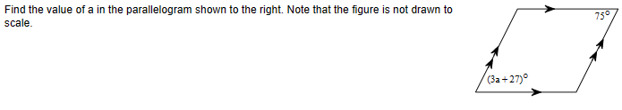

ii.

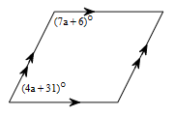

b. Find the lengths of the diagonals of parallelogram *PQRS* given that , , and .

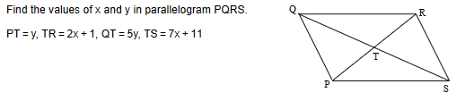

**Theorem: Multiple Parallel Lines and Transversals**

If three (or more) parallel lines cut off congruent segments on one transversal, then they cut off congruent segments on every transversal.

*The proof is left as an exercise.*

c. Given , , and , find the length of .

