Section 6.3 Proving that a Quadrilateral is a Parallelogram

# Objective 1: Determine whether quadrilaterals are Parallelograms

**Theorem: Converse of Opposite Sides of a Parallelogram Theorem**

If both pairs of opposite sides of a quadrilateral are congruent, then the quadrilateral is a parallelogram.

**Theorem: Converse of Opposite Angles of a Parallelogram Theorem**

If both pairs of opposite angles of a quadrilateral are congruent, then the quadrilateral is a parallelogram.

**Theorem: Converse of Consecutive Angles of a Parallelogram Theorem**

If an angle of a quadrilateral is supplementary to both of its consecutive angles, then the quadrilateral is a parallelogram.

*The proofs of the above theorems are left as exercises.*

**Theorem: Converse of Diagonals of a Parallelogram Theorem**

If the diagonals of a quadrilateral bisect each other, then the quadrilateral is a parallelogram.

a. Write a flow proof of this theorem.

**Theorem**

If one pair of opposite sides of a quadrilateral is both congruent and parallel, then the quadrilateral is a parallelogram.

b. Write a proof of this theorem.

b. For what value of the variable(s) is the quadrilateral is a parallelogram?

i.

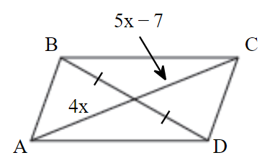

ii.

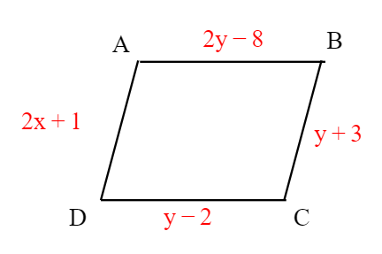

iii.

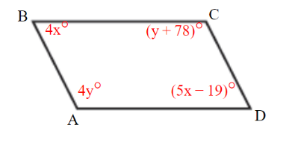

c. For which of the following is there enough information given to prove the quadrilateral is a parallelogram?

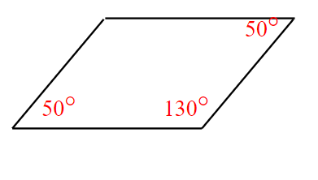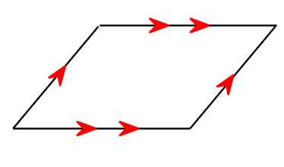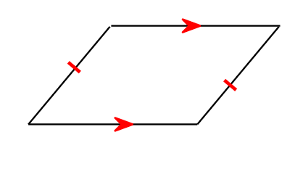

# Objective 2: Use Coordinate Geometry with Parallelograms

a. Show that a quadrilateral with the vertices shown is a parallelogram.

i.

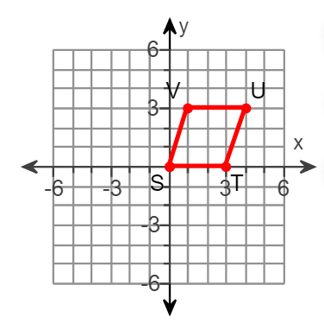

ii.

