6.4 Right Triangle Trigonometry

# OBJECTIVE 1: Understanding the Right Triangle Definitions of the Trigonometric Functions

**The Right Triangle Definition of the Trigonometric Functions:** Given a right triangle with acute angle and side lengths of *hyp*, *opp,* and *adj*, the sixtrigonometric functions of angle are defined as follows:

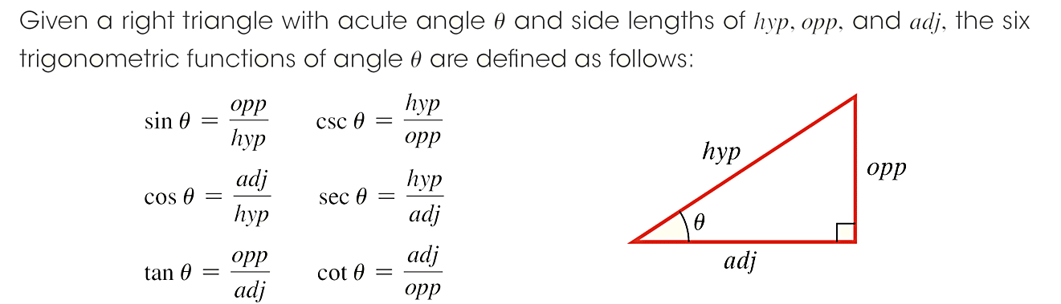

  

  

Though rationalizing is not required, simplifying will always be required. “Simplifying” means to remove all perfect squares from any radicals and to remove any common factors from the numerator and the denominator. This includes both integer factors and radical factors. The table below shows examples of simplifying radical expressions.

| **Calculated Result** | **Simplification Required** | **Correct Simplified, Unrationalized Answer** |
| --- | --- | --- |
|  | None |  |
|  | None |  |
|  |  |  |
|  | None |  |
|  |  |  |
|  | None |  |
|  |  |  |
|  |  |  |
|  |  | 7 |
|  |  |  |

# OBJECTIVE 2: Using the Special Right Triangles

There are two special right triangles:

1. the  (or ****) triangle labeled below with congruent legs of length 1 and hypotenuse of length , and
2. the(or ****) triangle labeled below with shorter leg of length 1, longer leg of length , and hypotenuse of length 2.

A right triangle with both acute angles pi over 4, both legs of length 1, and a hypotenuse of length square root of 2.
 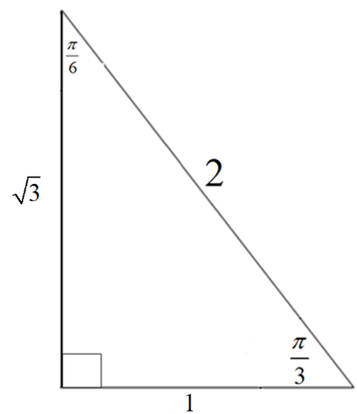

Using these special triangles, we can list the **Trigonometric Functions for Acute Angles** :



















# OBJECTIVE 3: Understanding the Fundamental Trigonometric Identities

**The Quotient Identities:**  

**The Reciprocal Identities:**  



 

**The Pythagorean Identities:**   

**OBJECTIVE 4: Understanding Cofunctions**

Two positive angles are said to be **complementary** if the sum of their measures is ****radians (or 90°). Complementary angles always come in pairs. The acute angles of every right triangle are complementary.

**Cofunction Identities:**













**OBJECTIVE 5: Evaluating Trigonometric Functions using a Calculator**

warning**It is extremely important to make sure that your calculator is set to the correct mode. Failing to set your calculator to the correct mode will yield erroneous answers.**