Section 6.4 Rhombuses, Rectangles, and Squares

# Objective 1: Define and Classify Special Types of Parallelograms

A **rhombus** is a parallelogram with four congruent sides.

A **rectangle** is a parallelogram with four right angles.

A **square** is a parallelogram with four congruent sides and four right angles.

Because rhombuses, rectangles, and squares are also parallelograms, these figures also have all the properties of parallelograms.

a. Use a Venn diagram to show the relationships between parallelograms, rhombuses, rectangles, and squares.

# Objective 2: Use Properties of Diagonals of Rhombuses, Rectangles, and Squares

When a conditional statement and its converse are both true, we often write a single “If and only if” statement. For example, previously we proved that the statement “If a figure is a parallelogram, then both pairs of its opposite sides are congruent” is true. We also proved that its converse “If both pairs of opposite sides of a quadrilateral are congruent, then the quadrilateral is a parallelogram” is true. These two statements can be equivalently written as the following:

A quadrilateral is a parallelogram if and only if both pairs of its opposite sides are congruent.

**Theorem: Rhombus Diagonals/Perpendicular Theorem**

A parallelogram is a rhombus if and only if its diagonals are perpendicular.

**Theorem: Rhombus Diagonals Theorem**

A parallelogram is a rhombus if and only if each diagonal bisects a pair of opposite angles.

*To prove an “if and only if” statement, rewrite it as a conditional statement and its converse, and then prove each of those statements is true. The proofs of the above theorems are left as exercises.*

**Theorem: Rectangle Diagonals Theorem**

A parallelogram is a rectangle if and only if its diagonals are congruent.

a. Write a proof of the Rectangle Diagonals Theorem.

b. Can you conclude that the parallelogram is a rhombus, a rectangle, or a square? Be as precise as possible.

i.

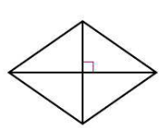

ii.

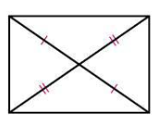

c. Find the measures of the numbered angles in the rhombus.

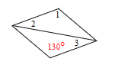

d. Find the length(s) of the diagonals of the parallelogram given  and . 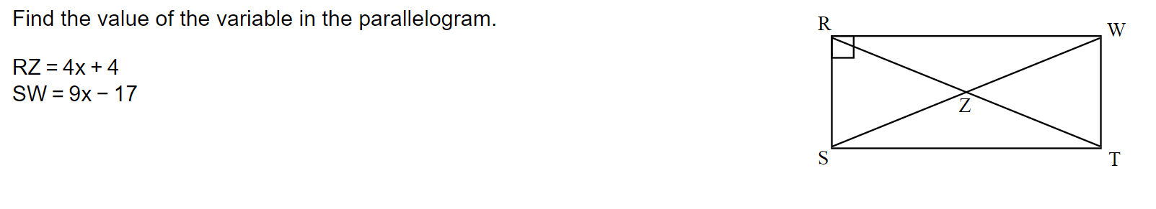

e. Find the values of the variables for the parallelogram given .

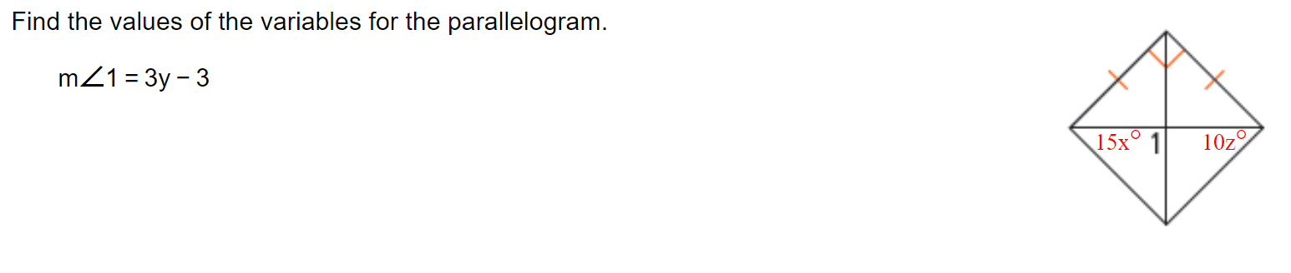

# Objective 3: Use Properties of Diagonals to form Rhombuses, Rectangles, and Squares

a. For what value of *x* is the parallelogram a rhombus?

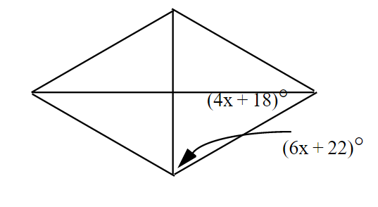

b. For what value of *x* is the parallelogram a rectangle?

i.

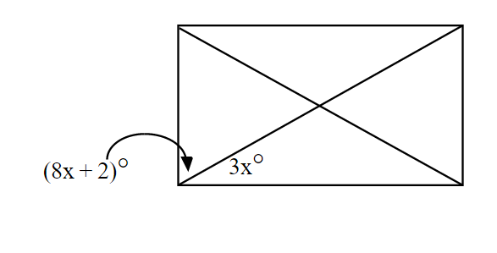

ii.

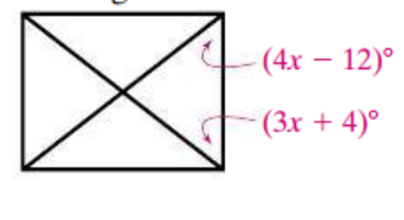

c. For what values of *x* and *y* is the figure a square?

