Section 6.5 Trapezoids and Kites

*The proofs of the theorems in this section are left as exercises.*

# Objective 1: Use Properties of Trapezoids

A **trapezoid** is a quadrilateral with exactly one pair of parallel sides. The parallel sides of a trapezoid are called **bases**. The nonparallel sides are called **legs**. The two angles that share a base of a trapezoid are called **base angles**. A trapezoid has two pairs of base angles.

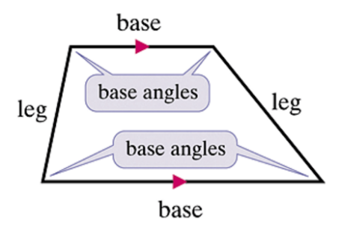

An **isosceles trapezoid** is a trapezoid with legs that are congruent.

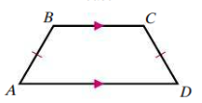

**Theorem: Base Angles of an Isosceles Trapezoid**

If a trapezoid is isosceles, then each pair of base angles is congruent.

**Theorem: Isosceles Trapezoid**

If a trapezoid has a pair of congruent base angles, then the trapezoid is isosceles.

**Theorem: Diagonals of an Isosceles Trapezoid**

A trapezoid is isosceles if and only if its diagonals are congruent.

a. Find the measures of the numbered angles in the trapezoid.

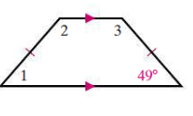

The **midsegment of a trapezoid** is the segment that joins the midpoints of its legs.

**Theorem: Trapezoid Midsegment**

If a quadrilateral is a trapezoid, then

(1) the midsegment is parallel to the bases, and

(2) the length of the midsegment is half the sum of the lengths of the bases.

b. In the trapezoid below, find the length of EF.

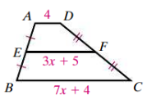

# Objective 2: Use Properties of Kites

A **kite** is a quadrilateral with two pairs of consecutive sides congruent and no opposite sides congruent.

**Theorem: Diagonals of a Kite**

If a quadrilateral is a kite, then its diagonals are perpendicular.

**Theorem: Opposite Angles of a Kite**

If a quadrilateral is a kite, then exactly one pair of opposite angles is congruent.

a. Find the measures of the numbered angles in each kite.

i.

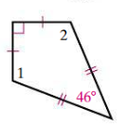

ii.

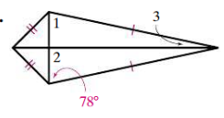

b. Find the value of the variables in the kite.

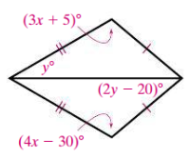

c. Make a tree diagram showing the relationships between the different types of quadrilaterals. Include parallelograms, trapezoids, isosceles trapezoids, squares, rectangles, rhombuses, and kites.

d. Determine whether each statement is true or false.

i. All rectangles are squares.

ii. A trapezoid is a parallelogram.

iii. Some parallelograms are squares.

iv. Every squares is a rhombus.

v. No kites are parallelograms.