Section 7.3 Similar Polygons

# Objective 1: Identify Similar Polygons

Two polygons are **similar polygons** if corresponding angles are congruent and if the lengths of corresponding sides are proportional. We use the symbol  for “is similar to”.

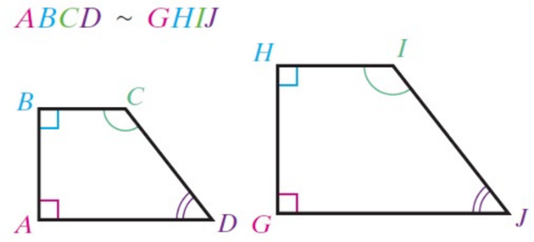

In the figures above, , , , , and .

We write a similarity statement with corresponding vertices in order just as we did for congruence statements. For the figures above, the similarity statement is .

A proportion with three or more equal ratios is an example of an **extended proportion**.

A **scale factor** is the ratio of corresponding linear measurements of two similar figures. For similar triangles, we use the ratio of the lengths of corresponding sides to identify the scale factor.

a. Determine whether each pair of figures is similar or not. If the figures are similar, write a similarity statement and state the scale factor from the figure on the left to the figure on the right.

i.

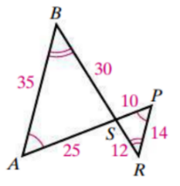

ii.

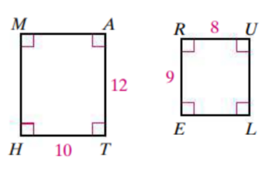

iii.

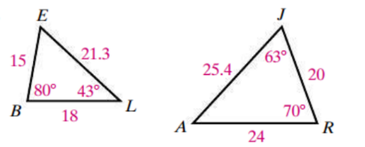

b. The polygons are similar. Find the values of each variable.

i.

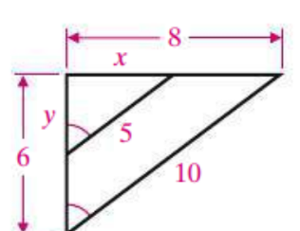

ii.

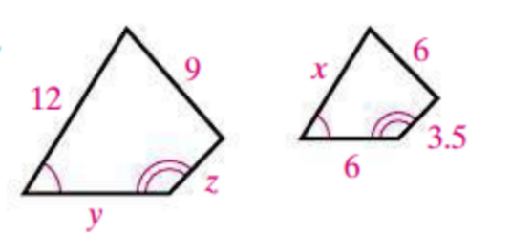

# Objective 2: Use Similar Polygons to Solve Applications

a. A scale drawing of a building needs to be made using the scale 1 inch equals 270 feet. How tall will the building in the scale drawing be if the building is 1620 feet tall?

b. A company produces a standard-size U. S. flag that is 3 feet by 5 feet. The company also produces a giant-size flag that is similar to the standard-size flag. If the shorter side of the giant-size flag is 72 feet, what is the length of its longer side?

c. The scale drawing at the right is part of a floor plan for a home. Each one of the squares on the grid measures 1 cm on a side. The scale is 1 cm = 4 feet. What are the actual dimensions of the master bedroom? Round any floor plan measurements to the nearest 0.5 cm.

