Section 7.4 Proving Triangles are Similar

*The proofs of the theorems in this section are left as exercises.*

# Objective 1: Use the AA Similarity Postulate and the SAS and SSS Similarity Theorems

**Postulate: Angle-Angle Similarity (AA) Postulate**

If two angles of one triangle are congruent to two angles of another triangle, then the triangles are similar.

**Theorem: Side-Angle-Side Similarity (SAS) Theorem**

If an angle of one triangle is congruent to an angle of a second triangle and the two sides that include the two angles are proportional, then the triangles are similar.

**Theorem: Side-Angle-Side Similarity (SSS) Theorem**

If the corresponding sides of two triangles are proportional, then the triangles are similar*.*

a. Determine whether the triangles are similar. If they are similar, state the postulate or theorem used, and write a similarity statement for the triangles.

i.

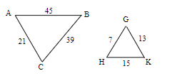

ii.

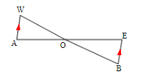

iii.

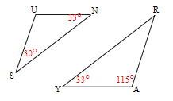

iv.

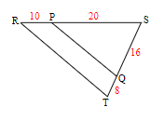

b. Given , identify a pair of similar triangles.

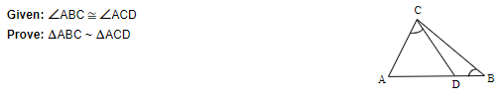

c. Prove  is an isosceles triangle given, , and .

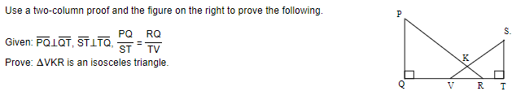

d. Find the value of *x*.

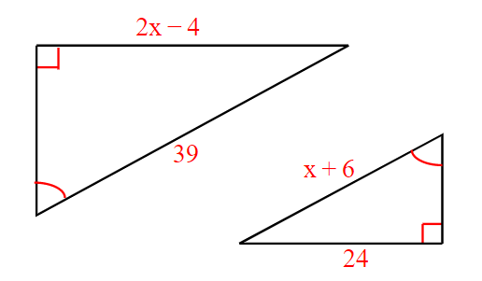

# Objective 2: Use Similarity to Find Indirect Measurements

Similar triangles can often be used to find lengths that cannot be measured easily. This is called **indirect measurement**. One method of indirect measurement uses the fact that light reflects off a mirror at the same angle at which it hits the mirror.

a. Before rock climbing, a student wants to know how high he will climb. He places a mirror on the ground and walks backward until he can see the top of the cliff in the mirror. What is the height of the cliff?

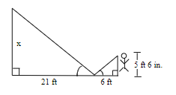

b. A hiker wants to determine the height of a tree. She measures the tree’s shadow to be 17.1 meters long. At the same time, while standing near the tree, her own shadow is 1.8 meters long. If the hiker is 1.7 meters tall, how tall is the tree?