Section 7.5 Geometric Mean and Similarity in Right Triangles

# Objective 1: Use Altitudes of Right Triangles to Prove Similarity

**Theorem: Altitude of a Right Triangle Theorem**

The altitude to the hypotenuse of a right triangle divides the triangle into two triangles that are similar to the original triangle and to each other.

# Objective 2: Find the Geometric Mean of the Lengths of Segments in a Right Triangle.

For any two positive numbers a and b, the **geometric mean** of a and b is the positive number *x* such that  .

a. Find the geometric mean of 9 and 35.

*The proofs of the following corollaries to the Altitude of a Right Triangle Theorem are left as exercises.*

**Corollary 1: Geometric Mean in Similar Right Triangles: Hypotenuse**

The length of the altitude to the hypotenuse of a right triangle is the geometric mean of the lengths of the segments of the hypotenuse.

**Corollary 2: Geometric Mean in Similar Right Triangle: Legs**

The altitude to the hypotenuse of a right triangle separates the hypotenuse so that the length of each leg of the triangle is the geometric mean of the length of the hypotenuse and the length of the segment of the hypotenuse adjacent to the leg.

a. Find the values of each variable in the figures.

i.

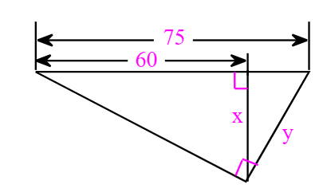

ii.

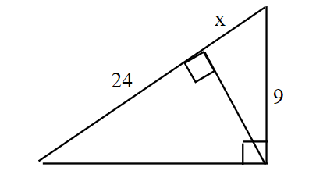

# Objective 3: Solve Applications Involving Right Triangles

a. To estimate the height of a stone figure, an observer holds a small square up to her eyes and walks backward from the figure. She stops when the bottom of the figure aligns with the bottom edge of the square and when the top of the figure aligns with the top edge of the square. Her eye level is 1.89 m from the ground. She is 4.20 m from the figure. What is the height of the figure to the nearest hundredth of a meter?

