Section 8.1 Rigid Transformations

# Objective 1: Identify Rigid Transformations or Isometries

A **transformation** of a plane figure is a change in the position, shape, or size of the figure.

In a transformation, the original figure is the **preimage**. The resulting figure is the **image**.

An **isometry** is a transformation in which the preimage and the image are congruent. This means the angles measures and side lengths are the same in the preimage and the image. An isometry is also called a **rigid transformation** because the original shape and size of the figure do not change.

In this section, we study three basic isometries (rigid transformations):

* **translations**, also called slides
* **reflections**, also called flips
* **rotations**, also called turns

a. Does each transformation appear to be an isometry?

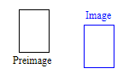



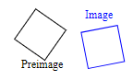

b. Identify the single transformation from the preimage to each image.

i.

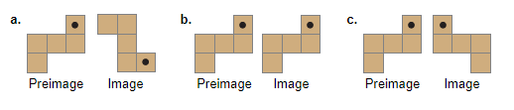

ii.

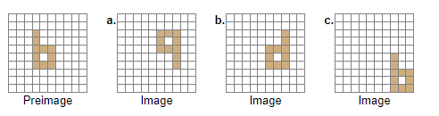

# Objective 2: Name Images and Corresponding Parts

A transformation maps (or moves) a figure to its image and may be described with arrow notation

(). Prime notation ( ‘ ) may be used to identify image points. For example, in the figure below, is the image of , and we can write . We can also write . 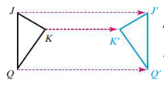

a. The figure on the right is the image of the figure on the left. Name the images of points *W* and *B*. Name the pairs of corresponding congruent sides.

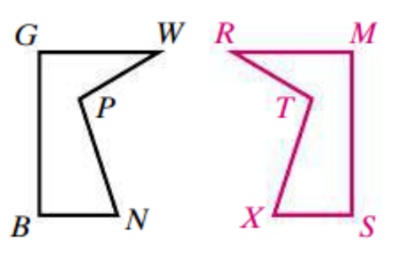

b. Which triangle maps to ? Which triangle maps to ?

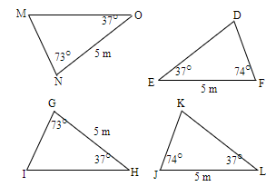

c. The transformation shown is an isometry. Find the values of the variables.

