Section 8.2 Translations

**Objective 1: Find Translation Images of Figures**

A **translation** is a transformation that maps all points of a figure the same distance in the same direction. A translation is an isometry.

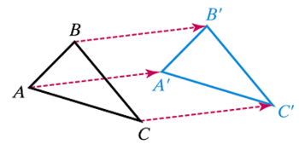



Each point of square *ABCD* in the figure below moves 4 units right and 2 units down. Using ordered pair notation, we say each point  in the original figure is mapped to the point  where  and . We will use mapping notation to write this translation rule as .

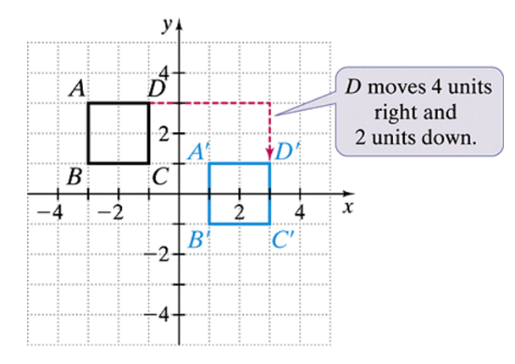

a. Use the graph of  and the translation rule  to find the coordinates of the image of each vertex as an ordered pair and then graph the image.

vertex A has coordinates negative 7, 5.  vertex B has coordinates negative 2, 4.
vertex C has coordinates negative 6, 1.

b. Write an ordered pair translation rule for the figure shown.

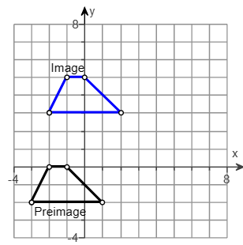

c. Use the ordered pair translation rule  to find each of the following:

i. the image of the origin.

ii. the preimage of .

d. has coordinates , , and . A translation maps point *M* to . What are the coordinates of the other two vertices of the image?

A **composition of transformations** is a combination of two or more transformations. In a composition, we perform each transformation on the image of the preceding transformation.

e. Rosie is visiting a large city. From her hotel, she walks 3 blocks east and 4 blocks north to a coffee shop. Then she walks 7 blocks west and 1 block north to a museum. Where is the museum in relation to her hotel?

f. Find a single translation that has the same effect as the composition of translations  followed by .