Section 8.3 Reflections

**Objective 1: Find Reflection Images of Figures**

When a figure flips across a line, the preimage and its image are congruent and have *opposite orientations*.

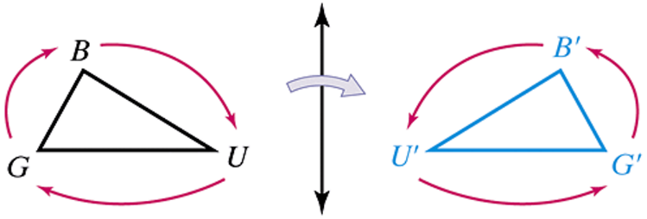

A **reflection** across a line *r* (called the **line of transformation**) is a transformation with these two properties:

* If *A* is on *r*, then .
* If *B* is not on *r*, then *r* is the perpendicular bisector of .

A reflection across a line is an isometry.

a. Find the coordinates of the image of point *R* under each reflection:

i. across the *y*-axis

ii. across the line 

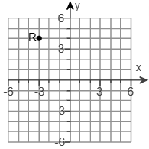

b.  has vertices , , and . Graph the reflection of  under a reflection across the *x*-axis.

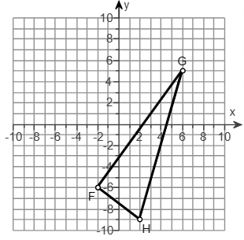

c. Town officials in town W and town D plan to construct a water pumping station along a canal. The station will provide both towns with water. Where along the canal should the officials build the pumping station to minimize the total length of pipe needed?

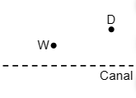

d. Find the line of reflection for the figure and its image.

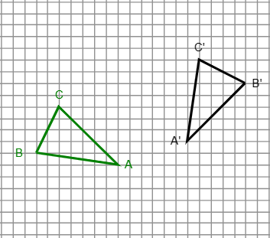

e. Find the image of the origin after two reflections: first across the line  and then across the line .

**Objective 2: Identify Line Symmetry**

A plane figure has **line symmetry** or **reflectional symmetry** if the figure on one side of the line is a reflection of the figure on the other side of the line. The line of reflection is called a **line of symmetry.** It divides the plane figure into two congruent halves.

a. Identify all lines of symmetry for each figure:

i.

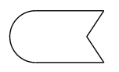

ii. a rectangle that is not a square

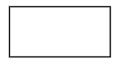

iii. a regular hexagon

