Section 8.4 Rotations

**Objective 1: Find Reflection Images of Figures**

The size, shape, and orientation of a geometric figure stay the same when we rotate or turn the figure about a point.

A **rotation** of  about a point *R* (called the **center of rotation**) is a transformation with these two properties:

* The image of *R* is itself (that is, ).
* For any other point V,  and .

The positive number of degrees a figure rotates is the **angle of rotation**. A rotation about a point is an isometry. In this course, rotations are *counterclockwise* unless otherwise stated.

a. Use a protractor, a compass, and a straightedge to draw the image of the figure under a rotation of 60° about point *P*.

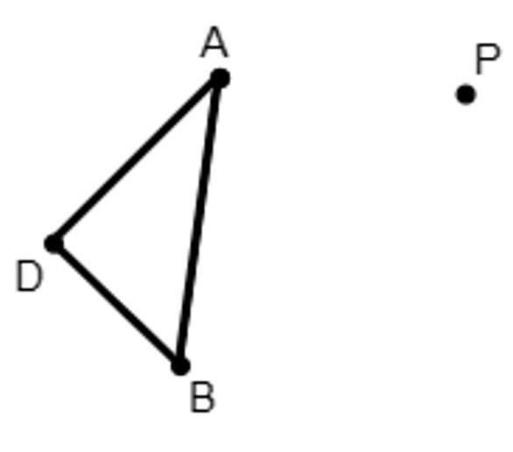

The center of a regular *n*-gon is the point that is equidistant from its vertices. The center and the vertices of a regular *n*-gon determine n congruent triangles. We can use this fact to find rotation images of regular polygons.

b. Point *A* is the center of the square shown. Under what angle of rotation about point *A* would vertex *B* be the image of vertex *L*?

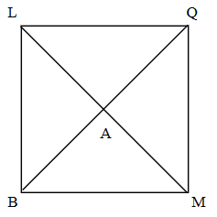

c. Point *O* is the center of the regular pentagon. What is the image of point *A* under a 216° rotation about point *O*?

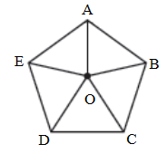

A composition of rotations about the same point is itself a rotation about that point. To sketch the image, add the angles of rotation to find the total rotation angle.

d. Which figure shows the image of  under the composition of rotations 120° and then 150° about point *Q*?

i. 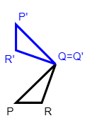ii. 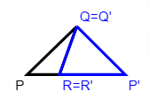 iii. 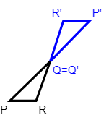 iv. 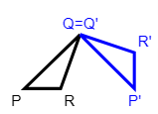

**Objective 2: Identify Rotational Symmetry**

In general, a figure has symmetry if there is an isometry that maps the figure onto itself.

A plane figure has **rotational symmetry**  if there is a rotation of 180° or less for which the figure is its own image. The angle of rotation for rotational symmetry is the smallest angle needed for the figure to rotate onto itself.

a. Does the figure have rotational symmetry? If so, what is the angle of rotation to the nearest tenth of a degree?

i.

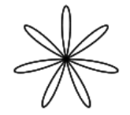

ii.

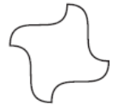

b. State the type(s) of symmetry for each figure, if any. Sketch any lines of symmetry and state the angle of rotational symmetry, if any.

i.

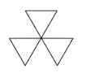

ii.

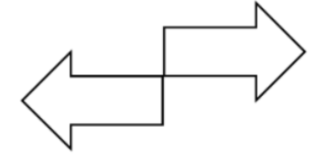

iii.

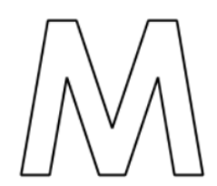

c. State the type(s) of symmetry for each figure, if any. If the figure has line symmetry, state the number of lines of symmetry. If the figure has rotational symmetry, state the angle of rotational symmetry.

i. square

ii. parallelogram

iii. kite

iv. regular octagon