Section 8.5 Dilations

# Objective 1: Understand Dilation Images of Figures

A dilation is a transformation that changes the size, but not the shape of a figure. A dilation is a non-rigid transformation and is not an isometry.

A **dilation** with center *C* and scale factor *n*, , , is a transformation with these two properties:

* The image of *C* is itself (that is, ).
* For any other point *R*, *R*’ is on ray  and  or .

The image of a dilation is similar to its preimage.

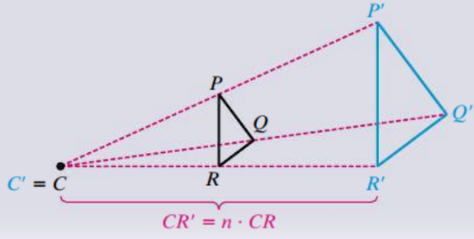

The scale factor of a dilation is the same as the scale factor of the two similar figures. In the figure above, .

A dilation is an **enlargement** if the scale factor is greater than 1 and a **reduction** if the scale factor is between 0 and 1.

a. The outer figure is a dilation of the inner figure with center L. What is the scale factor? Is this an enlargement or reduction?

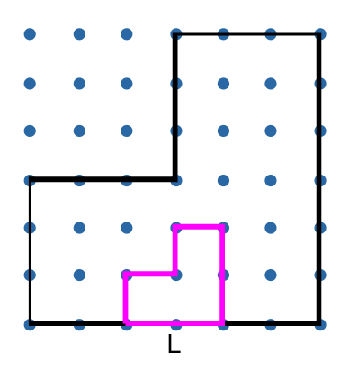

b. The left figure is a dilation of the right figure with center Q. What is the scale factor? Is this an enlargement or reduction?

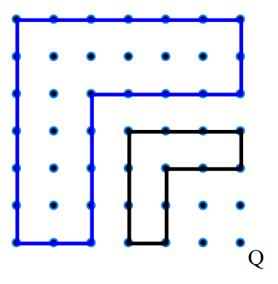

c. A dilation has center at the origin. Find the image of each point using the given scale factor:

i. , scale factor 1.5

ii. , scale factor 

d. The coordinates of the vertices of  are , , and . Find the images of the vertices of  for a dilation with center at the origin and scale factor 4. Sketch both triangles.

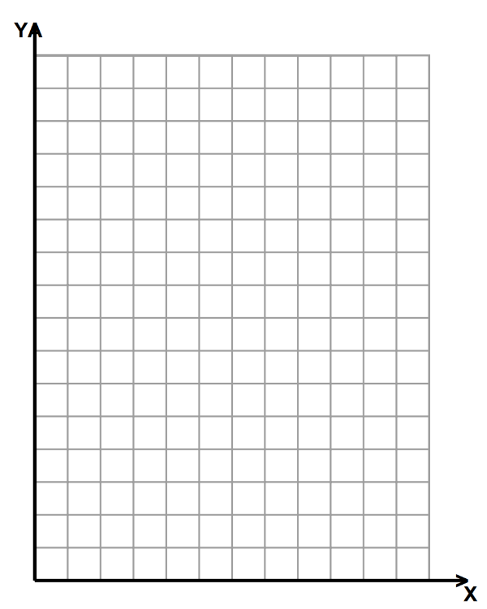

e. You look at a button under a magnifying glass. Find the actual length of the button if the image of the button is 6 times the button’s actual size and has a diameter of 15 centimeters.

f. Draw the image of  for the dilation with center O and scale factor .

