Section 8.6 Compositions of Reflections

# Objective 1: Find Compositions of Transformations, Including Glide Reflections

Any isometry can be expressed as a composition of reflections. If two figures in a plane are congruent, we can map one onto the other using a composition of reflections.

**Theorem**

A translation or rotation is a composition of two reflections.

**Theorem**

* A composition of reflections across two parallel lines is a translation.
* A composition of reflections across two intersecting lines is a rotation.

a. Use the given points and lines to graph  and its image after a reflection first across line *L*1 and then across line *L*2. Is the resulting transformation a translation or a rotation? For a translation, describe the direction and distance. For a rotation, state the center of rotation and the angle of rotation.

i. , ; , 

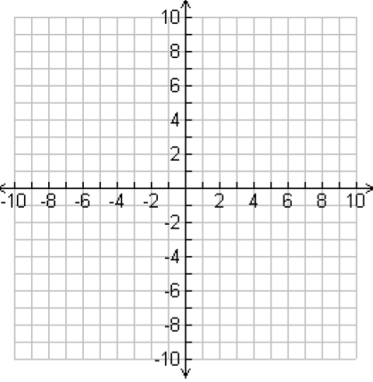

ii. , ; *L*1: *x*-axis, *L*2: *y*-axis



Suppose two figures *A* and *B* in a plane are congruent but have opposite orientations. Then, the reflection *A*’ of *A* has the same orientation as *B*. *B* is a translation or rotation image of *A*’, so therefore, *A*’ can be mapped to *B* using two reflections. This means *A* can be mapped to *B* using at most three reflections. This is an important theorem.

**Theorem: Fundamental Theorem of Isometries**

In a plane, one of two congruent figures can be mapped to the other by a composition of at most three reflections.

If two figures are congruent and have opposite orientations (but are not simply reflections of each other, there are a translation and a reflection that will map one onto the other. A **glide reflection** is the composition of a translation (or glide) and a reflection across a line parallel to the direction of the translation. Footprints are a real-life example of a glide reflection.

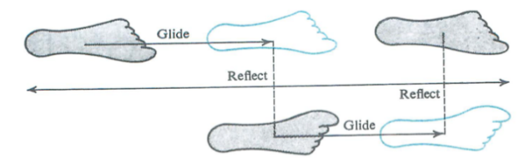

b. Find the glide reflection image of the triangle shown below given the translation  and the reflection line.

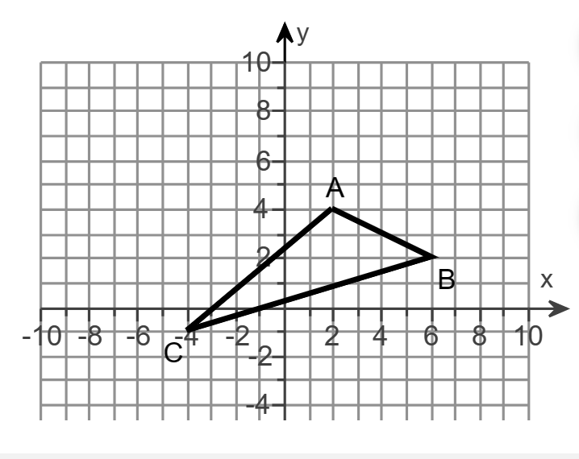

c. Find the coordinates of point P under the transformation  for  and the reflection line.

# Objective 2: Classify Isometries

**Theorem: Isometry Classification Theorem**

There are only four isometries: translations, rotations, reflections, and glide reflections. In translations and rotations, the orientation remains the same.

In reflections and glide reflections, the orientation is opposite.

a. Each transformation is an isometry. Classify the isometry as a translation, reflection, rotation, or glide reflection.

i.

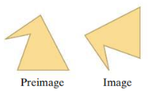

ii.

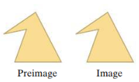

iii.

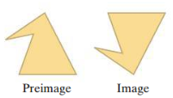

iv.

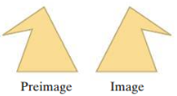

b. Identify each mapping as a single translation, reflection, rotation, or glide reflection. Find the translation rule, reflection line, center of rotation and angle of rotation, or glide translation rule and reflection line.

point A has coordinates negative 9, 0.
point B has coordinates negative 9, negative 4. point C has coordinates negative 7, 0. point D has coordinates negiative 5, 4. point E has coordinates negative 5, 0. point F has coordinates negative 4, 0. point G has coordinates negative 2, 4. point H has coordinates negative 2, 0. poing I has coordinates negative 2, negative 4.  point J has coordinates 2, 0. point L has coordinates 2, negative 4. point M has coordinates 4, 0.  point N has coordinates 4, 4. Point Q has coordinates 6, negative 4.  Point P has coordinates 6, 0.

i. 

ii. 

iii. 

iv. 