Section 9.1 The Pythagorean Theorem and Its Converse

# Objective 1: Use the Pythagorean Theorem

**Pythagorean Theorem**

If a triangle is a right triangle, then the sum of the squares of the lengths of the legs is equal to the square of the length of the hypotenuse.

Alternatively, we could write

In a right triangle with legs of length *a* and *b* and hypotenuse of length *c*, .

a. Prove the Pythagorean Theorem.

b. Find the exact, simplified value of *x*.

i.

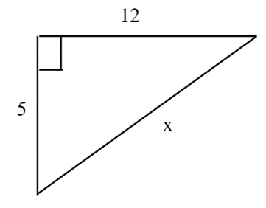

ii.

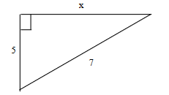

A Pythagorean Triple is a set of positive integers *a*, *b*, and *c* that satisfy the equation  . Notice that *c* must be the greatest number. Some common Pythagorean Triples are

3, 4, 5

5, 12, 13

8, 15, 17

7, 24, 25

c. Is the set of numbers a Pythagorean Triple?

i. 6, 8, 10

ii. 61, 60, 11

iii. 25, 10, 28

The Pythagorean Triple 6, 8, 10 suggests that if *a*, *b*, and *c* form a Pythagorean Triple, then *ka*, *kb*, *kc* is also a Pythagorean Triple for any positive integer *k*. This can be proven to be true with a little algebra.

d. A wire is needed to support a vertical pole 20 feet tall. The cable wil be anchored to a stake 15 feet from the base of the pole. How much cable is needed?

e. A walkway forms one diagonal of a square playground. The walkway is 22 m long. How long is a side of the playground? Round to the nearest tenth.

f. Find the exact, simplified value of *x*.

i.

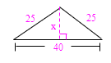

ii.

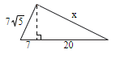

# Objective 2: Use the Converse of the Pythagorean Theorem

**Converse of the Pythagorean Theorem**

If the sum of the squares of the lengths of two sides of a triangle is equal to the square of the length of the third side, then the triangle is a right triangle.

*The proof is left as an exercise.*

***Extensions****:*

*The following two theorems are based on the Hinge Theorem and/or its converse.*

**Theorem**

If the square of the length of the longest side of a triangle is greater than the sum of the squares of the lengths of the other two sides, then the triangle is obtuse.

**Theorem**

If the square of the length of the longest side of a triangle is less than the sum of the squares of the lengths of the other two sides, then the triangle is acute.

**Summary**

If the lengths of the sides of a triangle are *a*, *b*, and *c,* and *c* is the largest length, then

* the triangle is acute if .
* the triangle is right if .
* the triangle is obtuse if .

a. Determine if a triangle with the given side lengths is acute, right, or obtuse.

i. 9, 40, 41

ii. 4, 6, 8

iii. 9, 12, 14

iv. 

b. Given that two sides of a triangle are 20 and 21, find an integer length for the third side that makes the triangle a right triangle.

c. Find integers *j* and *k*, such that

(a) an acute triangle has sides of length 5, 10, and *j* where j is the longest side, and

(b) an obtuse triangle has sides of length 5, 10, and *k* where 10 is the longest side.