9.2 The Law of Sines

# OBJECTIVE 1: Determining if the Law of Sines Can Be Used to Solve an Oblique Triangle

**The Law of Sines:** If *A*, *B*, and *C* are the measures of the angles of any triangle and if *a*, *b*, and *c* are the lengths of the sides opposite the corresponding angles, then

 or .

| **Triangle** | **Description of Case** | **Abbreviation of Case** |
| --- | --- | --- |
| A triangle with the 2 angles at the bottom labeled A and the side opposite the angle on the right labeled S. | Side-Angle-Angle: two angles and a side opposite one of the angles are known | SAA |
| A triangle with the 2 angles at the bottom labeled A and the base labeled S. | Angle-Side-Angle: two angles and the side between them are known | ASA |
| a triangle with the bottom and left sides labeled S and the angle on the right opposite the left side labeled A | Side-Side-Angle: two sides and an angle opposite one of the sides are known | SSA |
| a triangle with two sides labeled S and the angle between them labeled A | Side-Angle-Side: two sides and the angle between them are known | SAS |
| a triangle with the three sides labeled S | Side-Side-Side: all three sides are known | SSS |
| a triangle with the three angles labeled A | Angle-Angle-Angle: all three angles are known | AAA |

Since the Law of Sines uses proportions that involve both angles and sides, the following pieces of information are needed in order to solve an oblique triangle using the Law of Sines:

1. The measure of an angle must be known
2. The length of the side opposite the known angle must be known
3. At least one more side or one more angle must be known

The first three cases listed in the table above involve situations where this information is known. Therefore, the Law of Sines can be used to solve the SAA, ASA, and SSA cases.

# OBJECTIVE 2: Using the Law of Sines to Solve the SAA Case or ASA Case

When the measure of any two angles of an oblique triangle is known and the length of any side is known, always start by determining the measure of the unknown angle. Then use appropriate Law of Sines proportions to solve for the lengths of the remaining unknown sides. Whenever possible, we will avoid using rounded information to solve for the remaining parts of the triangle. When this cannot be avoided, we will agree to use information rounded to one decimal place unless some other guideline is stated.

# OBJECTIVE 3: Using the Law of Sines to Solve the SSA Case

| **Value of sin *B*** | **Number of Triangles** | **Possible Triangles** | **Description** |
| --- | --- | --- | --- |
|  | No triangle | There are two figures:  the first shows acute angle A formed by segment b and a dotted line and the second shows obtuse angle A formed by segment b and a dotted line.  In both cases, side a is attached at the end of b opposite angle A and is too short to finish the triangle. | No angle B exists and side a is too short to reach the opposite side. |
|  | One right triangle | a right triangle with right angle B opposite side b and angle A opposite side a | The measure of B is 90°. |
|  | One oblique triangle | two triangles:  the first has 3 acute angles and the second has one obtuse angle. | If there is one solution for B, then the triangle is oblique with either 3 acute angles or one obtuse angle. |
|  | Two oblique triangles | A triangle with sides a and b making an angle B subscript 1 and A with the 3rd side respectively, has another side a from the 3rd vertex making an angle of B subscript 2 with the base such that B subscript 2 lies between A and B subscript 1. The result is 2 smaller triangles contained within the bigger original triangle. | If there are two solutions for B (B1 and B2), then there are two oblique triangles: one with 3 acute angles and one with one obtuse angle. |

Here is a summary of the three cases for which the Law of Sines can be used.

If *S* represents a given side of a triangle and if *A* represents a given angle of a triangle, then the Law of Sines can be used to solve the three oblique triangle cases SAA, ASA, and SSA (Ambiguous Case). Each case is illustrated below.

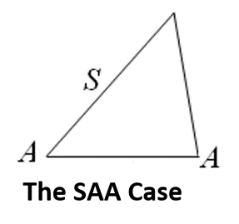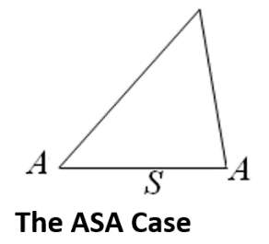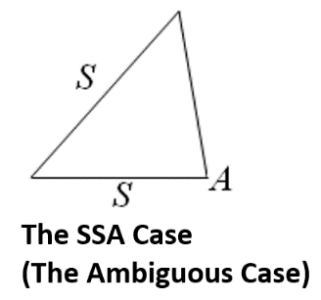

**OBJECTIVE 4: Using the Law of Sines to Solve Applied Problems Involving Oblique Triangles**