Section 9.2 Special Right Triangles

# Objective 1: Use the Properties of 45°-45°-90° Triangles

The acute angles of a right isosceles triangle are both 45° angles. Another name for a right isosceles triangle is a **45°-45°-90° triangle**.

**Theorem**

In a 45°-45°-90° triangle, both legs are congruent, and the length of the hypotenuse is  times the length of a leg.

a. Prove this theorem.

b. Find the value of each variable.

i.

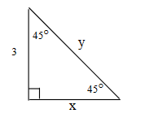

ii.

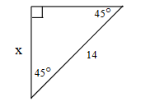

# Objective 2: Use the Properties of 30°-60°-90° Triangles

Another type of special right triangle is a **30°-60°-90° triangle**.

**Theorem**

In a 30°-60°-90° triangle, the length of the hypotenuse is twice the length of the shorter leg. The length of the longer leg is  times the length of the shorter leg.

a. Prove this theorem.

b. Find the values of the variables.

i.

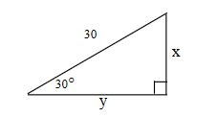

ii.

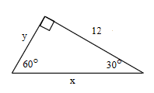

iii.

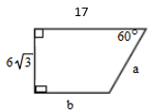

iv.

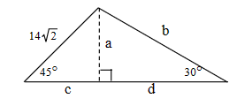

c. After heavy winds damaged a house, workers placed a 3-m brace against its side at a 45° angle. Then, at the same spot on the ground, they placed a second, longer brace to make a 30° angle with the side of the house. How long is the longer brace? How much higher does the longer brace reach than the shorter brace? Round to the nearest tenth.

