Section 9.3 Trigonometric Ratios

# Objective 1: Use the Sine, Cosine, and Tangent Ratios to Determine Side Lengths in Right Triangles

The word *trigonometry* is derived from ancient Greek and means “three-angle measurement” or “triangle measurement.” Recall that in any two similar right triangles, corresponding angles are congruent and the ratios of corresponding sides are equal. We call these ratios **trigonometric ratios** and give them special names.

**Trigonometric Ratios**

Let  be a right triangle with acute , acute , and hypotenuse *c*. The leg opposite  is labeled *a*, and the leg adjacent to (and opposite ) is labeled *b*.

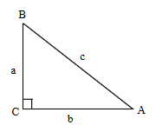

**sine** of : 

**cosine** of : 

**tangent** of : 

Instead of using letters for the sides of , suppose we name the hypotenuse “hyp” and then name the legs in terms of their relationship to : “adj” for the leg adjacent to  and “opp” for the leg opposite .

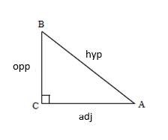

Then, our trigonometric ratios become







The acronym SOHCAHTOA or a silly phrase such as “Some Old Horse Caught Another Horse Taking Oats Away” can be used to help remember these ratios.

a. Write the trigonometric ratios for angle M in the right triangle shown.

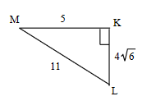

b. Write the trigonometric ratios for 45°, 30°, and 60°.

Note: All 45°-45°-90° triangles are similar, and all 30°-60°-90° triangles are similar. Therefore, any correct side lengths will give us the same trigonometric values for 30°, 45°, and 60° respectively.

c. Use a calculator to approximate the value to four decimal places.

i. 

ii. 

iii. 

d. Find the value of *x*. Round to the nearest tenth.

i.

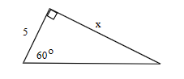

ii.

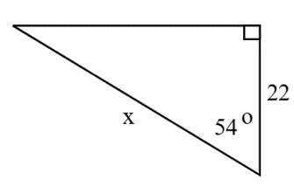

e. A road is inclined at an angle of 6°. After driving 4,798 feet along this road, find the driver’s increase in altitude. Round to the nearest foot.

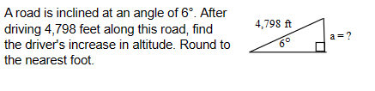

f. A skateboarding ramp is 14 inches high and rises at an angle of 21°. How long is the base of the ramp? Round to the nearest inch.

# Objective 2: Use the Sine, Cosine, and Tangent Ratios to Determine Angle Measures in Right Triangles

If we know the sine, cosine, or tangent ratio for an angle, we can use an inverse key on a calculator to find the measure of an angle. Be sure your calculator is in degree mode.

a. Use a calculator to approximate the measure of acute  to the nearest degree.

i. 

ii. 

iii. 

b. Find the value of *x* to the nearest degree.

i.

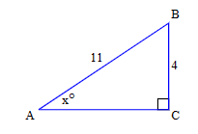

ii.

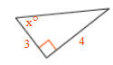

iii.

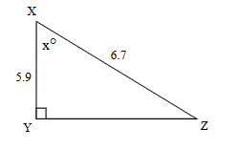

c. The sine, cosine, and tangent ratios each have a reciprocal ratio. The reciprocal ratio for sine is called **cosecant** (csc). The reciprocal ratio for cosine is called **secant** (sec). The reciprocal relationship for tangent is called **cotangent**. Use the triangle below to write the reciprocal ratios for angle A.

