Section 9.4 Solving Right Triangles

# Objective 1: Solve Right Triangles

The process of determining the three angles and the lengths of the three sides of a triangle is called **solving the triangle**.

A right triangle can be solved if we know either the lengths of two sides or the length of one side and the measure of one acute angle. When solving righttriangles, we can use the Pythagorean Theorem and the trigonometric ratios. It is common to label the vertices of a right triangle with capital letters and to label the corresponding opposite sides with the same lower-case letter.

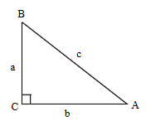

a. Solve each right triangle. Round angle measures to the nearest degree and side lengths to the nearest tenth.

i.

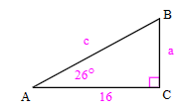

ii.

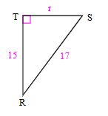

# Objective 2: Use Angles of Elevation and Depression to Solve Problems

An angle formed by a horizontal line and the line of sight to an object that is above the horizontal line is called the **angle of elevation**. The angle formed by a horizontal line and the line of sight to an object that is below the horizontal line is called the **angle of depression**.

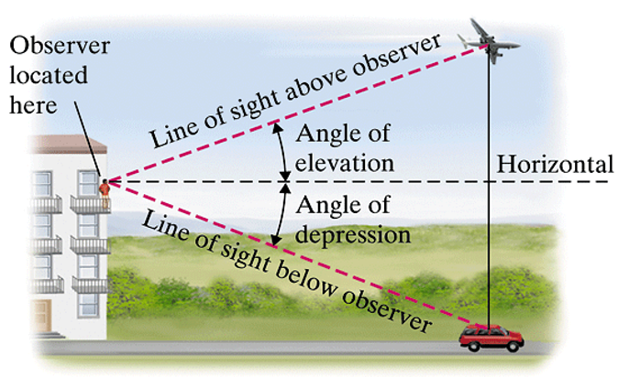

a. A hot air balloon is flying at an altitude of 2276 feet. If the angle of depression from the pilot in the balloon to a house on the ground below is 33°, how far is the house from the pilot to the nearest foot?

b. A tower that is 132 feet tall casts a shadow 173 feet long. Find the angle of elevation of the sun to the nearest degree.

c. Smoke is sighted due north of Lookout Tower 1. From Lookout Tower 2, which is 7.8 miles due west of Tower 1, a ranger reports that the smoke is 46.5° east of due north. How far is the smoke from Tower 1? Find the distance between Lookout Tower 2 and the smoke. Round to the nearest tenth of a mile.

