10.1 Polar Coordinates and Polar Equations

# OBJECTIVE 1: Plotting Points Using Polar Coordinates

Given an ordered pair in the polar coordinate system, the **directed distance** *r* can be positive, negative, or zero.

• If , then *P* lies on the terminal side of angle .

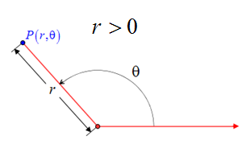

• If , then *P* lies on the ray opposite of the terminal side of angle .

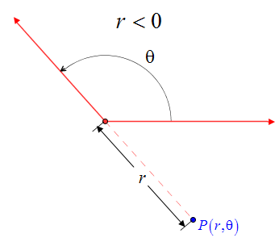

• If , then *P* lies on the pole regardless of the measure of angle .

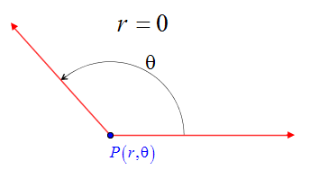

When plotting polar coordinates and sketching polar equations, we will often use a **polar grid**. A polar grid consists of a series of concentric circles of different radii and pre-sketched angles in standard position. Polar grid paper is available for free online if you wish to print and use it.

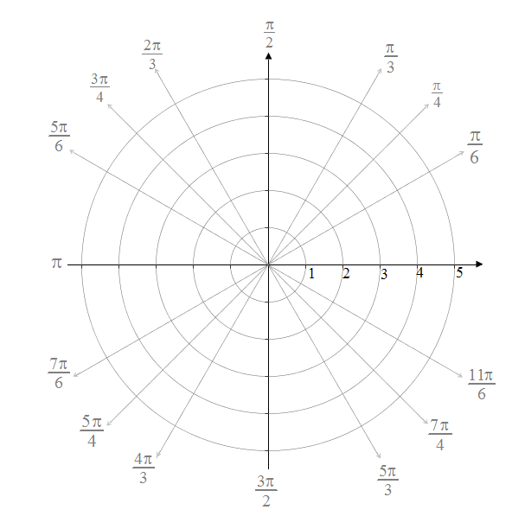

# OBJECTIVE 2: Determining Different Representations of the Point

* Use the same value of *r* but choose an angle coterminal to . The coordinates will be of the form  where *k* is any integer.

A polar grid shows theta measured counterclockwise between the polar axis and the terminal ray extending top right from the pole. The point (r, theta) lies on the terminal ray, on the circumference of the circle with a r unit radius.
 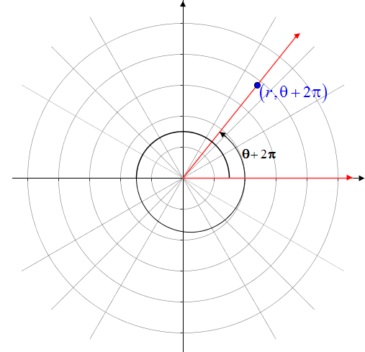

* Use the opposite value of *r* but choose an angle coterminal to the angle located one-half of a rotation from angle . The coordinates will be of the form  where *k* is any integer.

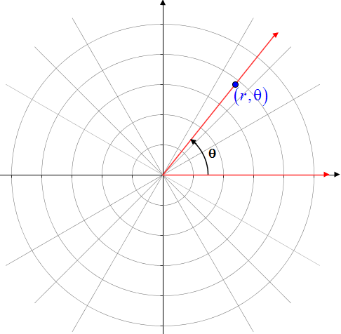 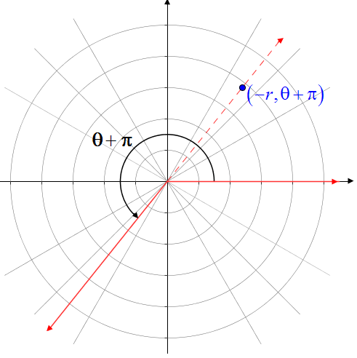

Note: A point located at the pole has coordinates where  is **any** angle.

# OBJECTIVE 3: Converting a Point from Polar Coordinates to Rectangular Coordinates

**Relationships used when Converting a Point from Polar Coordinates to Rectangular Coordinates:**





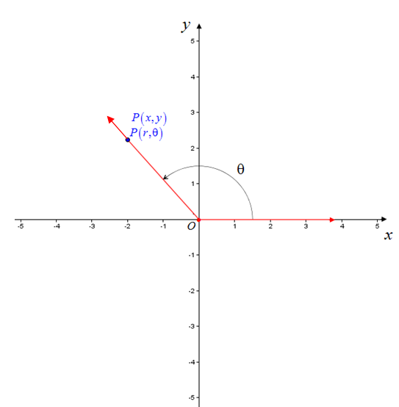

# OBJECTIVE 4: Converting a Point from Rectangular Coordinates to Polar Coordinates

**Converting Rectangular Coordinates to Polar Coordinates for Points Lying Along an Axis**

In each case, assume that .

The point  lies along the positive *x-*axis and has polar coordinates of.

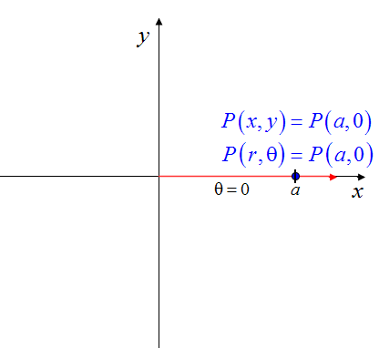

The point lies along the positive *y-*axis and has polar coordinates of .

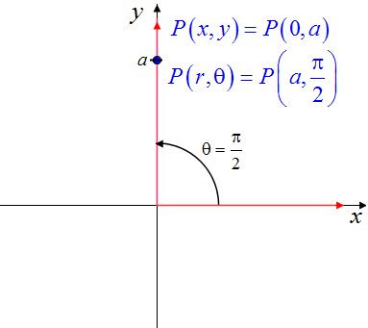

The point lies along the negative *x-*axis and has polar coordinates of.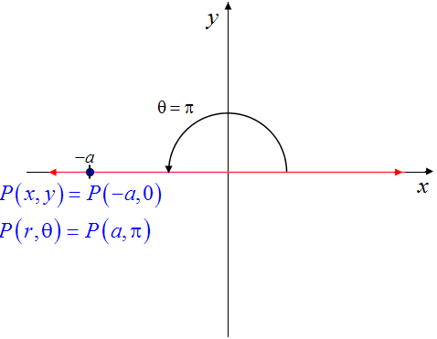

The point lies along the negative *y-*axis and has polar coordinates of .

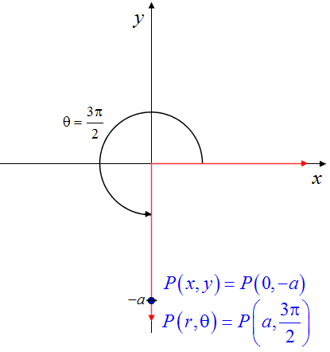

**Converting Rectangular Coordinates to Polar Coordinates for Points Not Lying Along an Axis**

1. Determine the value of *r* using the equation.
2. Plot the point and determine the quadrant in which it lies.
3. Determine the value of the acute reference angle  by solving the equation .
4. Determine the value of  using  and the quadrant in which the point lines. There are four cases:
5. If  lies in Quadrant I, then .
6. If  lies in Quadrant II, then .
7. If  lies in Quadrant III, then .
8. If  lies in Quadrant IV, then .

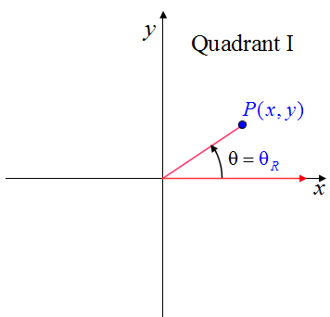 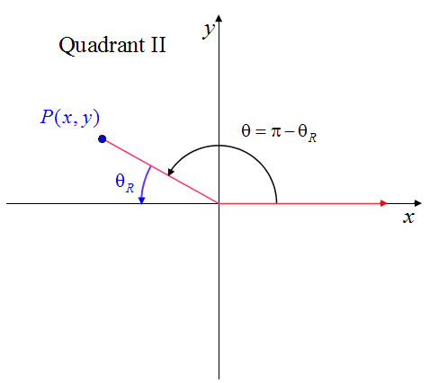

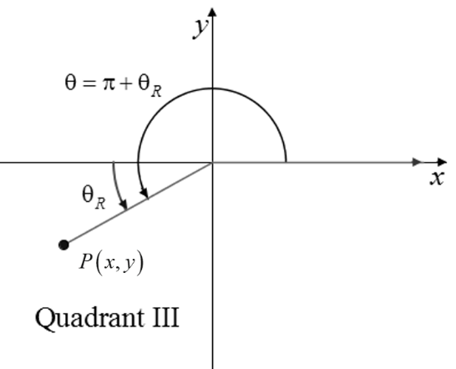 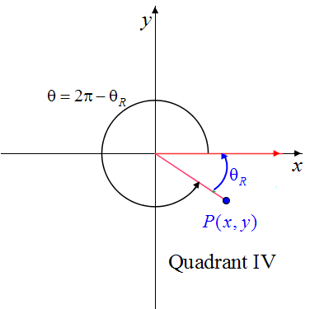

# OBJECTIVE 5: Converting an Equation from Rectangular Form to Polar Form

A **polar equation** is an equation whose variables are *r* and . You will need to use the familiar relationships , , and  to convert equations in *x* and *y* (rectangular form) to polar form.

# OBJECTIVE 6: Converting an Equation from Polar Form to Rectangular Form

   