10.2 Graphing Polar Equations

# OBJECTIVE 1: Sketching Equations of the Form , , , and .

For constants *a, b,* and *c* and angle , these graphs are **lines.**

* The graph of  is a vertical line.
* The graph of  is a horizontal line.
* The graph of  is a line with slope  and *y*-intercept  .
* The graph of  is a line through the pole that makes an angle of  with the polar axis.

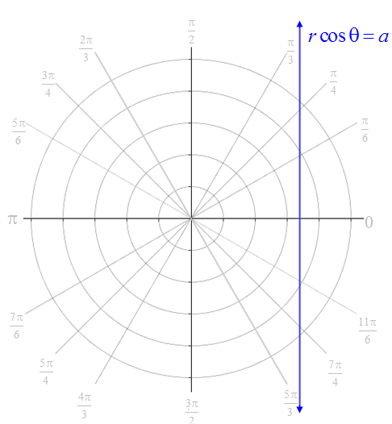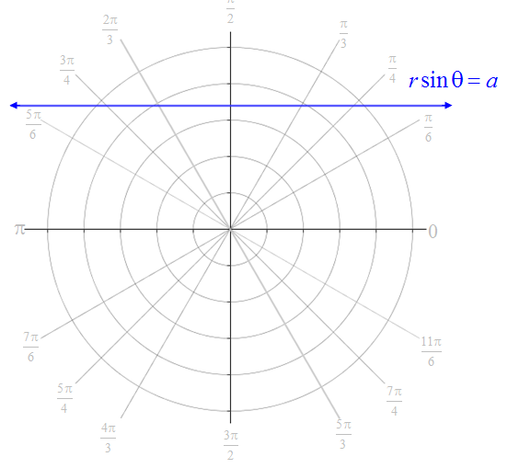

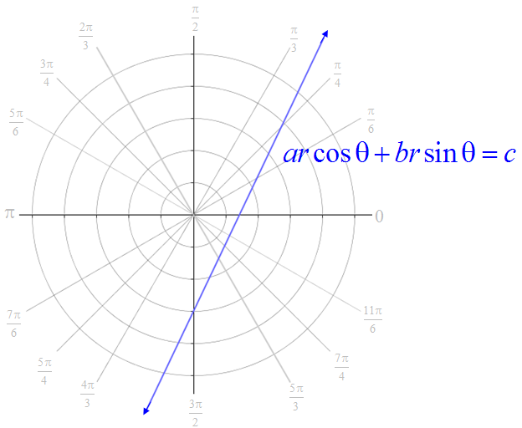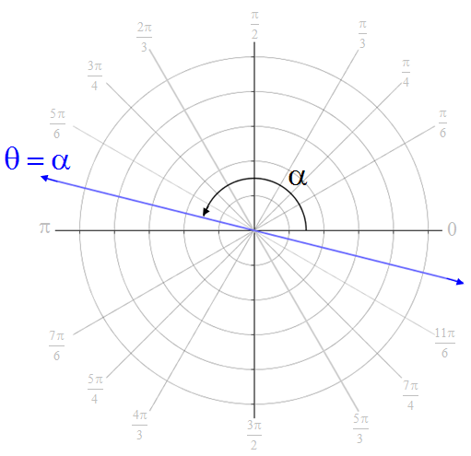

# OBJECTIVE 2: Sketching Equations of the Form , , and

For a constant , these graphs are **circles**.

* The graph of  is a circle centered at the pole with radius of length .
* The graph of  is a circle centered  units from the pole on the line  with a radius of length . If , the center of the circle is to the right of the pole, and if , the center of the circle is to the left of the pole.
* The graph of  is a circle centered  units from the pole on the line  with radius of length . If , the center of the circle is above the pole, and if , the center of the circle is below the pole.

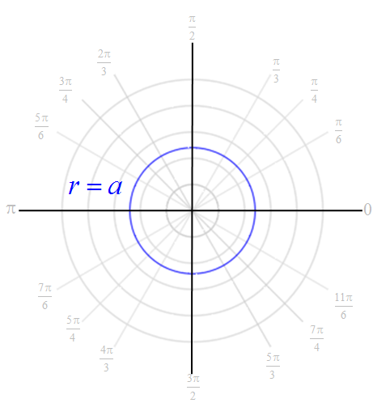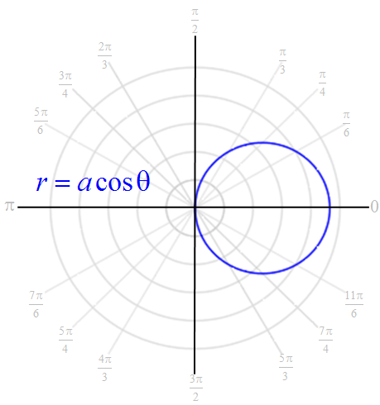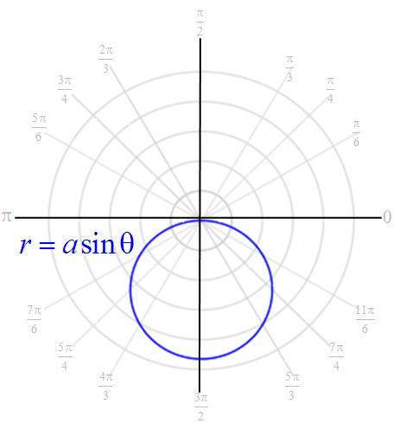

# OBJECTIVE 3: Sketching Equations of the Form and

For constants  and , the shape of the graph of  and  is determined by .

The graph is a **cardioid** if .

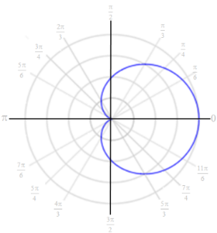 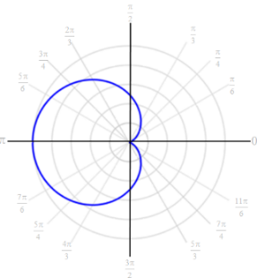 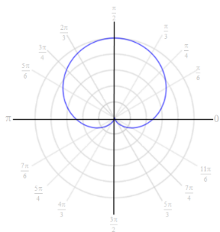 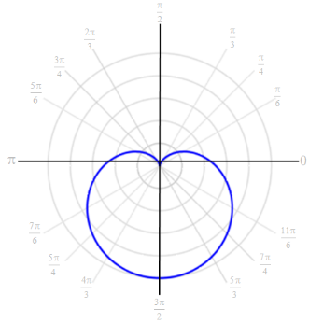

The graph is a **limacon with an inner loop** if .

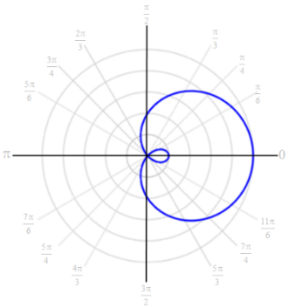 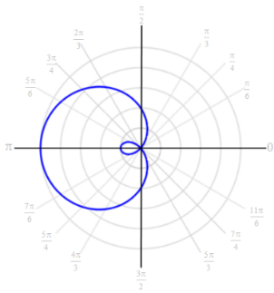 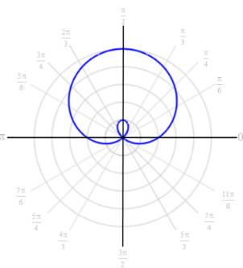 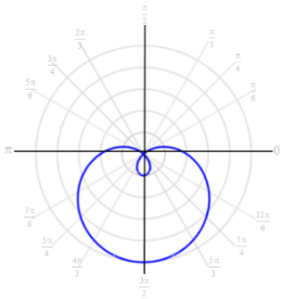

The graph is a **limacon with a dimple** if .

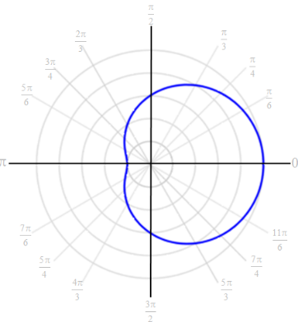 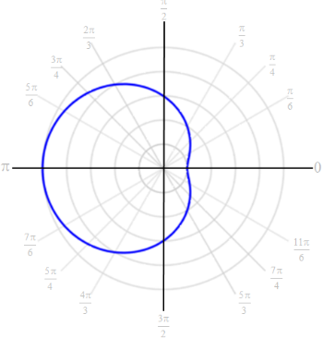 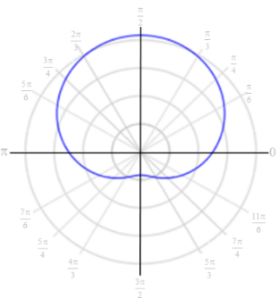 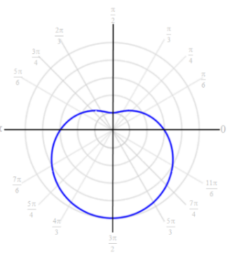

The graph is a **limacon with no inner loop and no dimple** if .

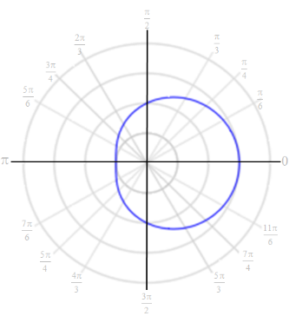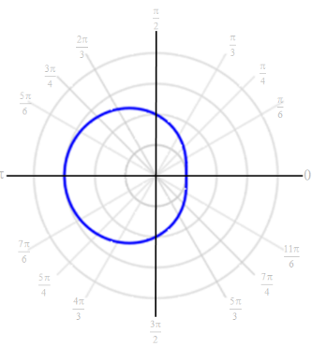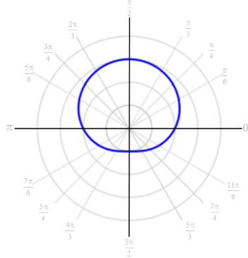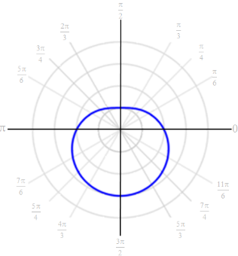

**Steps for Sketching Polar Equations (Limacons) of the Form**  and 

1. Identify the general shape using the ratio .

* If , then the graph is a cardioid.
* If , then the graph is a limacon with an inner loop that intersects the pole.
* If , then the graph is a limacon with a dimple .
* If , then the graph is a limacon with no inner loop and no dimple.

1. Determine the symmetry.

* If the equation is of the form , then the graph must be symmetric about the line .
* If the equation is of the form , then the graph must be symmetric about the polar axis.

1. Plot the points corresponding to the quadrantal angles , , , and .
2. If necessary, plot a few more points until symmetry can be used to complete the graph.

# OBJECTIVE 4: Sketching Equations of the Form and

The graphs of polar equations of the form  and  where  is a constant and  is a positive integer are **roses**.

* The graph of  where *n* is odd is a rose with *n* petals. The endpoint of one petal lies along the vertical line .
* The graph of  where *n* is odd is a rose with *n* petals. The endpoint of one petal lies along the polar axis.
* The graph of  where *n* is even is a rose with 2*n* petals. None of the petals has an endpoint lying on either the polar axis or the line .
* The graph of  where *n* is even is a rose with 2*n* petals. Two of the petals have endpoints lying on the line , and two of the petals have endpoints lying on the polar axis.

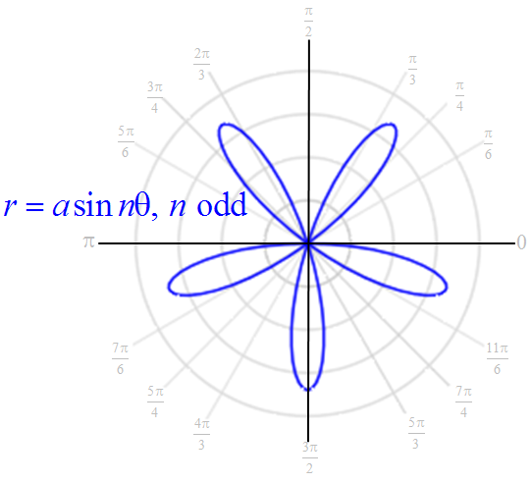 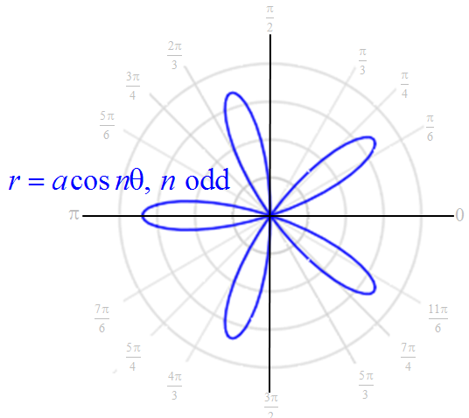

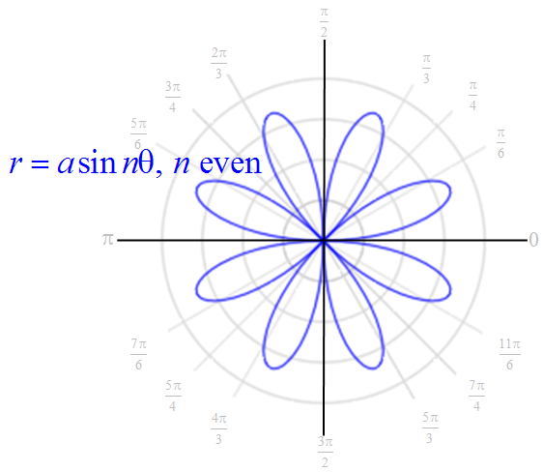 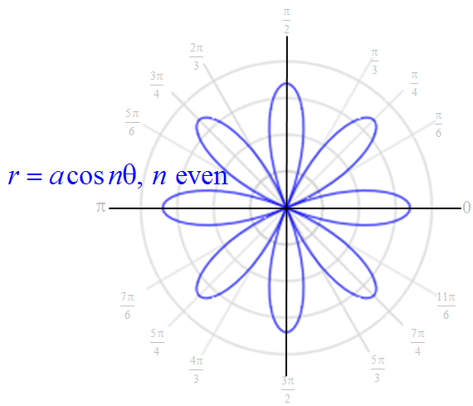

**Steps for Sketching Polar Equations (Roses) of the Form**  **and**  **where  and is a positive integer**.

1. Identify the number of “petals”.

* If *n* is even, then there are 2*n* petals.
* If *n* is odd, then there are *n* petals.

1. Determine the length of each petal.

* The length of each petal is units.

1. Determine all angles where an endpoint of a petal lies.

* If the equation is of the form , then the endpoints occur for angles on the interval * that satisfy the equations  and.
* If the equation is of the form , then the endpoints occur for angles on the interval * that satisfy the equations  and.

*Note that when *n* is odd, it is only necessary to consider angles on the interval . A complete graph is obtained on this interval because the graph will completely traverse itself on the interval .

1. Substitute each angle determined in Step 3 back into the original equation to obtain the appropriate values of *r* for each angle. The ordered pairs obtained represent the endpoints of the rose petals. Plot these points on the graph.
2. Determine angles where the graph passes through the pole. These angles serve as a guide when sketching the width of a petal.

* If the equation is of the form , then the graph passes through the pole when .
* If the equation is of the form , then the graph passes through the pole when .

1. Draw each petal to complete the graph. OBJECTIVE 5: Sketching Equations of the Form  and 

The graphs of polar equations of the form  and  where  is a constant are **lemniscates**.

* The graph of  is a lemniscate symmetric about the pole and the line . The endpoints of the two loops occur when  and . The length of the loops is .
* The graph of  is a lemniscate symmetric about the pole, the horizontal line , and the vertical line . The endpoints of the two loops occur when  and . The length of the loops is .

