10.4 Vectors

# OBJECTIVE 1: Understanding the Geometric Representation of a Vector

A **vector *v* can be represented geometrically** as a directed line segment in a plane having an initial point *P* and a terminal point *Q*. The vector can be denoted as the boldface letter ***v****,* , or **v with an arrow above it**.

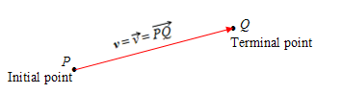

The **magnitude** of a vector ***v*** is the distance between the initial point and the terminal point and is denoted by . If the initial point has coordinates and the terminal point has coordinates , then .

# OBJECTIVE 2: Understanding Operations on Vectors Represented Geometrically

**SCALAR MULTIPLICATION**

A quantity described using only magnitude is called a **scalar quantity**. When working in the context of vectors, real numbers are called **scalars.** Multiplying a vector by a scalar is called **scalar multiplication.**

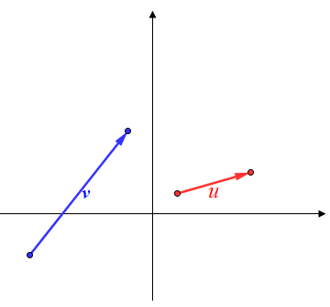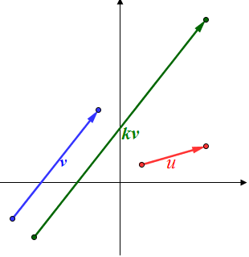 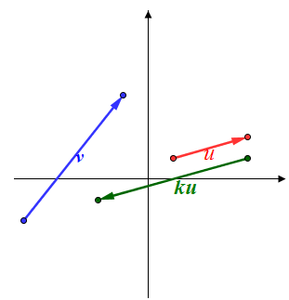

Two vectors ***u*** and ***v*** are **parallel vectors** if there is a nonzero scalar *k* such that .

**VECTOR ADDITION**

The sum of ***u*** and ***v*** is denoted by ***u*** + ***v*** and is called the **resultant vector.** To add the two vectors geometrically, we start by drawing an exact copy of vector ***v*** so that the initial point of ***v*** coincides with the terminal point of vector ***u***. The resultant vector ***u*** + ***v*** is the vector that shares the initial point with ***u*** extending to and sharing the terminal point with ***v***. Vector addition is sometimes referred to as the **triangle law.**

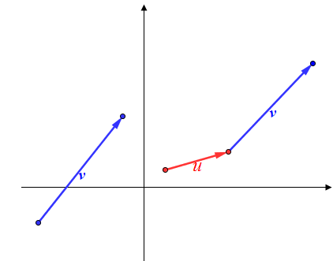 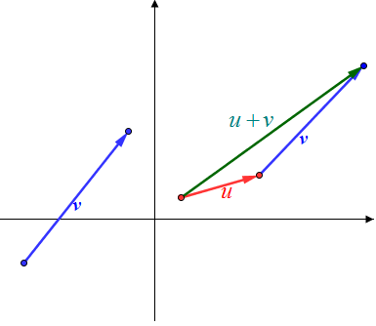

**THE PARALLELOGRAM LAW FOR VECTOR ADDITION**

Another way to illustrate vector addition is to think of the resultant vector ***u*** + ***v*** as the diagonal of a parallelogram. We can complete a parallelogram by drawing copies of vectors ***u*** and ***v*** on opposite sides of each other. We can represent the resultant vector ***u*** + ***v*** as the diagonal of a parallelogram. This is known as the **parallelogram law for vector addition.** The parallelogram law is also a nice illustration to show that **vector addition is commutative**, which means that ***u*** + ***v* = *u*** + ***v****.*

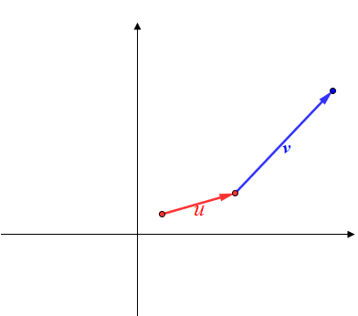 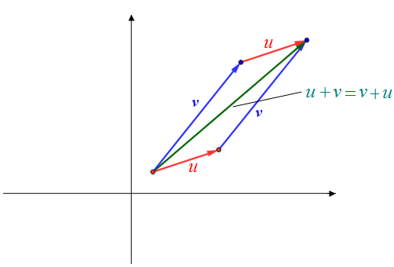

**VECTOR SUBTRACTION**

The difference of two vectors ***u*** - ***v*** is defined as ***u*** - ***v*** = ***u*** +where  is obtained by multiplying ***v*** by the scalar . Therefore, to find the difference of two vectors ***u*** - ***v*,** first draw the vector  in such a way that the initial point of coincides with the terminal point of ***u***. Then use vector addition to add to ***u.***  The resultant vector ***u*** - ***v*** = ***u*** + is the vector that shares the initial point with ***u*** extending to and sharing the terminal point with ***v***.

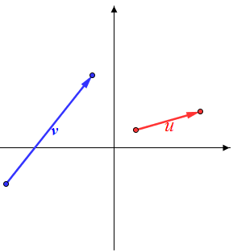 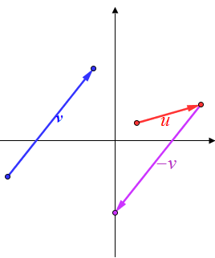 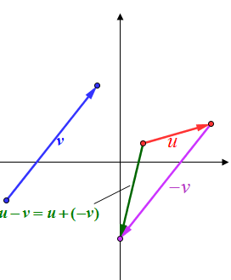

# OBJECTIVE 3: Understanding Vectors in Terms of Components

Two vectors in a plane are **equal vectors** if they have the same magnitude and the same direction.

**Representing a Vector in Terms of Components *a* and *b***

If the initial point of a vector ***v*** is and if the terminal point is , then ***v*** is a **vector represented by components *a* and *b*** where **v**.

 is the horizontal component, and  is the vertical component.

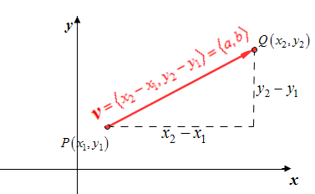

A vector ***v***is in **standard position** if the initial point coincides with the origin. The magnitude is .

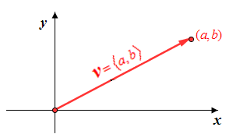

For simplicity, unless otherwise stated, we will consider all vectors discussed in the remainder of this section to be in standard position. This is possible because any vector can be represented in the form ***v*** where the initial point is the origin and the terminal point is .

# OBJECTIVE 4: Understanding Vectors Represented in Terms of i and j

A **unit vector** is a vector that has a magnitude of one unit.

The unit vector whose direction is along the positive *x-*axis is **i**.

The unit vector whose direction is along the positive *y-*axis is **j**.

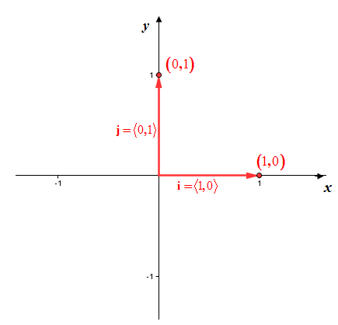

The vector **v** is equivalent to the vector ***v***. Therefore, any vector can be written in terms of unit vectors **i** and **j** which gives us a third way of representing vectors.

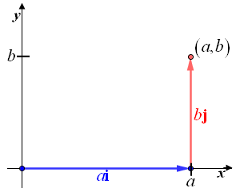 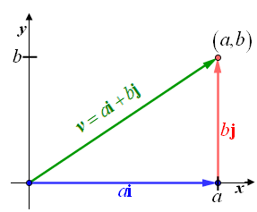

A **Vector Represented in Terms of** i **and j**

Any vector ***v***can be **represented in terms of the unit vectors** **i** and **j** where . The magnitude is .

Note that this representation is ideal for scalar multiplication of vectors and addition and subtraction of vectors.

# OBJECTIVE 5: Finding a Unit Vector

Given a nonzero vector ***v***, the **unit vector *u* in the same direction as *v*** is ***u***.

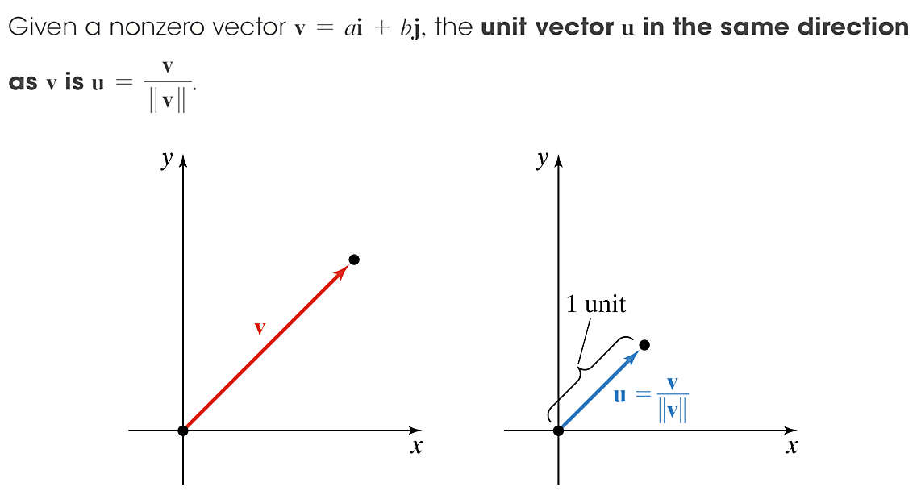

# OBJECTIVE 6: Determining the Direction Angle of a Vector

Given a vector ***v*** in standard position, the **direction angle of *v*** is the positive anglebetween the positive *x-*axis and the vector which satisfies the equation where.

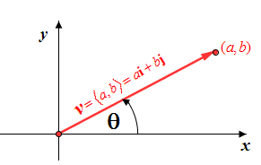

# OBJECTIVE 7: Representing a Vector in Terms of i and j Given its Magnitude and Direction Angle

If is the direction angle measured from the positive *x-*axis to a vector ***v***, then the vector can be expressed as ***v***.

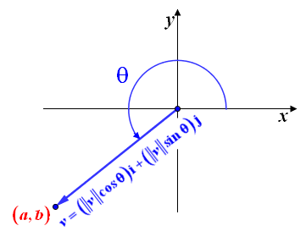

# OBJECTIVE 8: Using Vectors to Solve Applications Involving Velocity

Velocity has both magnitude (speed) and direction. Given the speed and direction of an object in motion, we can use a vector to represent the velocity of the object.