6.1 An Introduction to Angles: Degree and Radian Measure

An **angle** is made up of two rays that share a common endpoint called a **vertex**. An angle is created by rotating one ray away from a fixed ray. The fixed ray is called the **initial side** of the angle and the rotated ray is called the **terminal side** of the angle. A ray rotated in a *counterclockwise* fashion has *positive measure.* A ray rotated in a *clockwise* fashionhas *negative measure*.

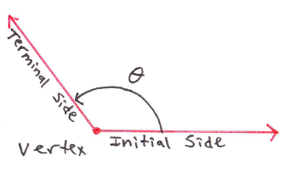 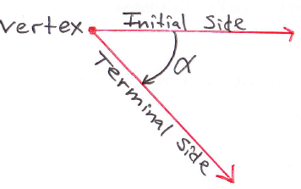

An angle is in **standard position** if the vertex is at the origin and the initial side of the angle is along the positive *x*-axis. The terminal side will always lie in one of four quadrants or on either axis.

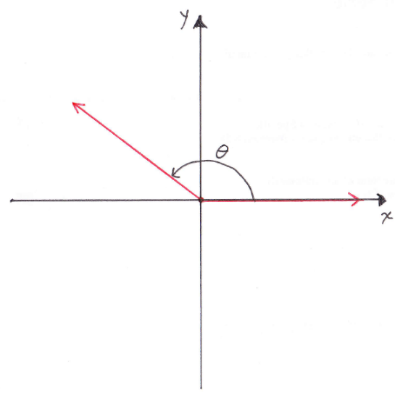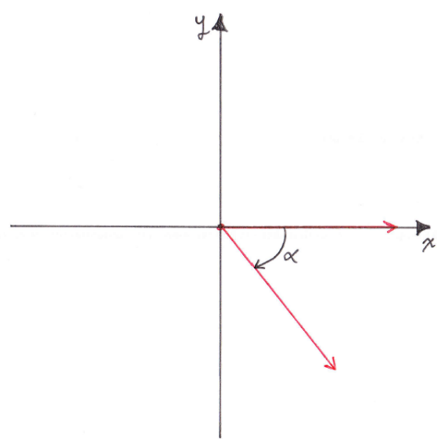

# Objective 1: Understanding Degree Measure.

Some examples are drawn below: An angle of 360° is one complete counterclockwise revolution. An angle of 90° is one-fourth of a counterclockwise revolution. An angle of  is one-eighth of a clockwise revolution.

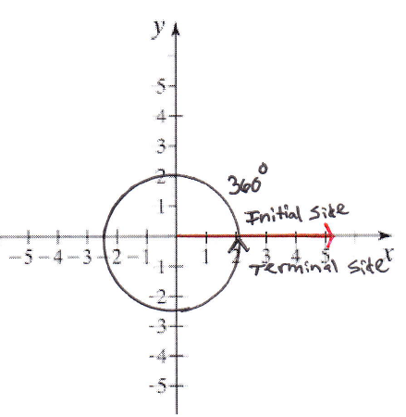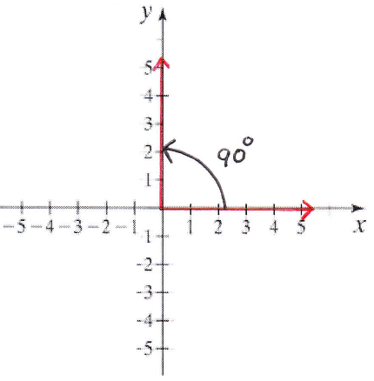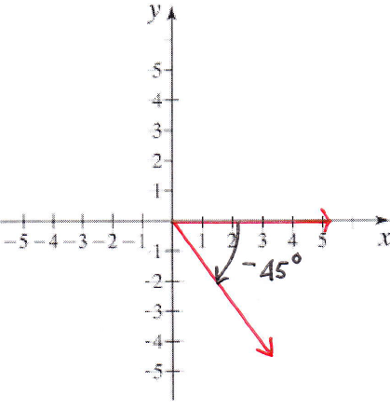

The figure below shows some common positive angles measured in degrees.

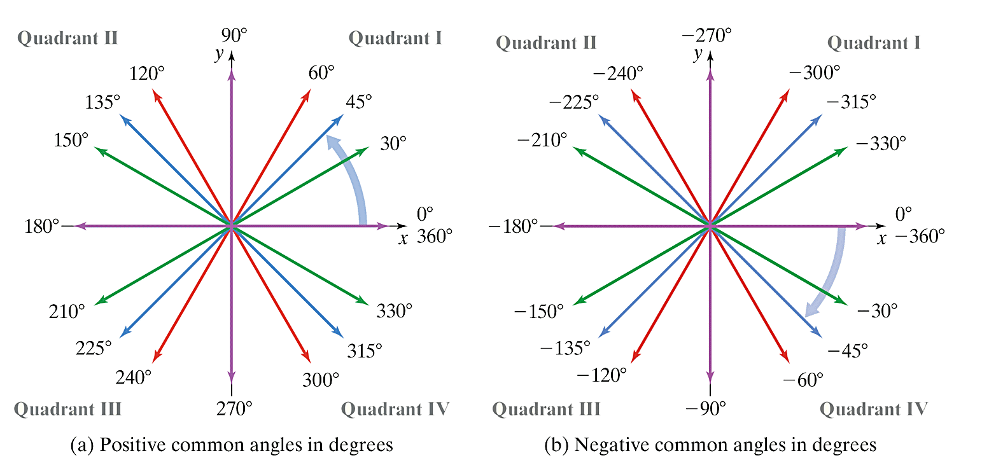

The figure below shows some common negative angles measured in degrees.



# OBJECTIVE 2: Finding Coterminal Angles Using Degree Measure

Angles in standard position having the same terminal side are called **coterminal angles**.

Coterminal angles can be obtained by adding any nonzero integer multiple of 360 degrees to a given angle.

The figures below show the coterminal angles 45°, 405°, and .

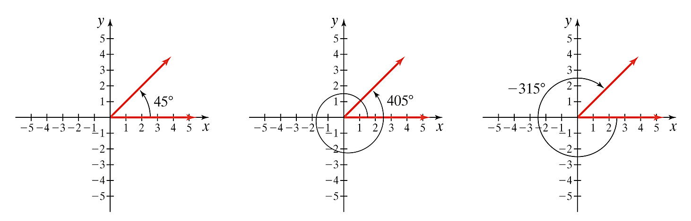

Every angle has a coterminal angle of least non-negative measure. If  is a given angle, then we use the notation  to denote the angle of least non-negative measure coterminal with .

 **Do not write . These angles are coterminal but they are not equal.**

# OBJECTIVE 3: Understanding Radian Measure

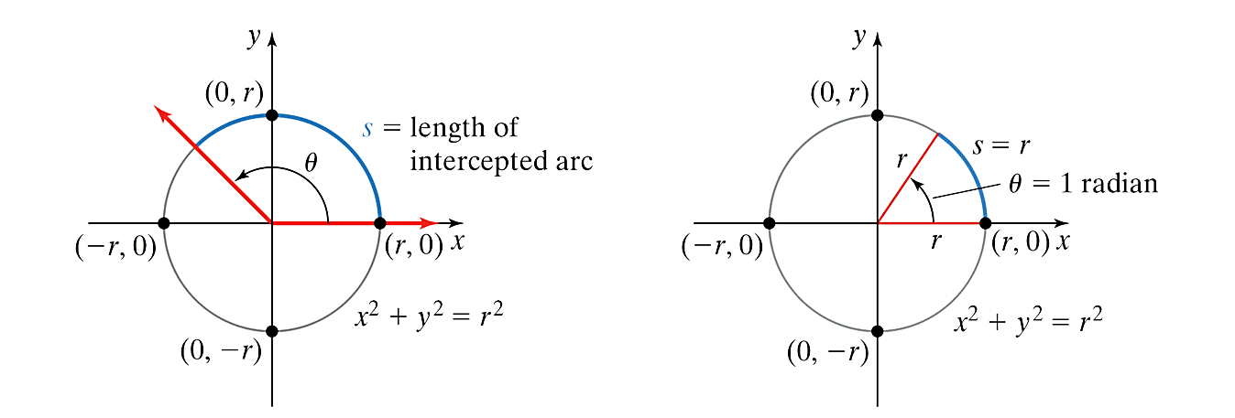 

A **radian** is the measure of a central angle that has an intercepted arcequal in length to the radius of the circle.

**Relationship Between Degrees and Radians:** , so therefore, .

Some examples of angles in radians are drawn below: An angle of radians is one complete counterclockwise revolution. An angle of  radians is one-fourth of a counterclockwise revolution. An angle of  radians is one-eighth of a clockwise revolution. Note that there is no symbol for radians.

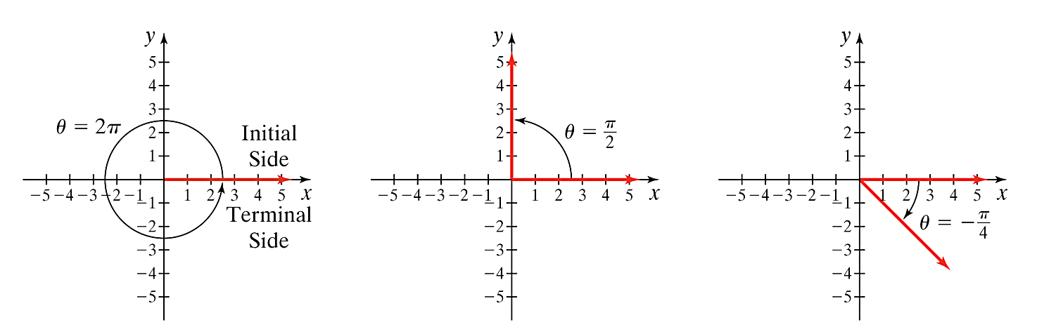

The figure below shows some common positive angles measured in radians.

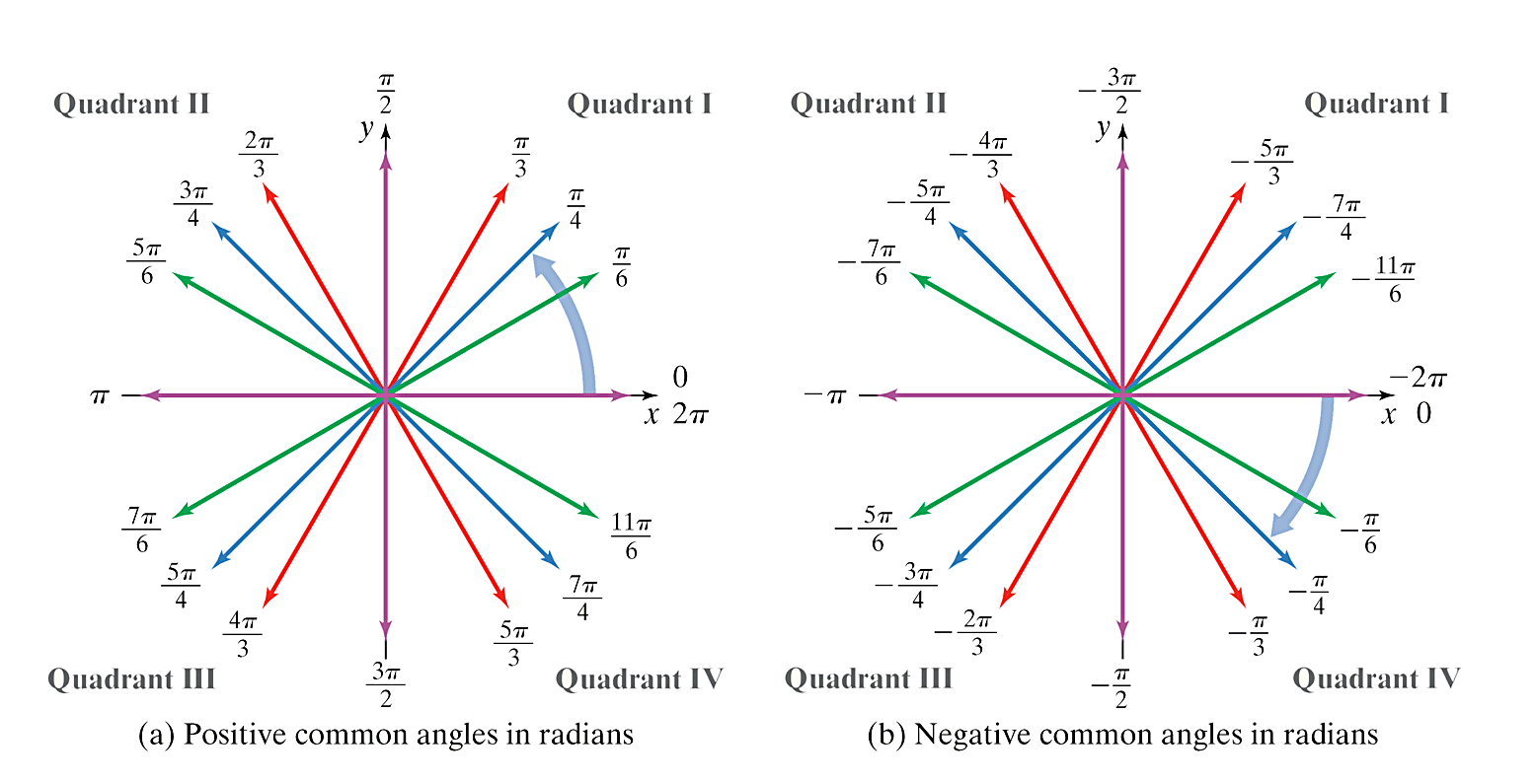

The figure below shows some common negative angles measured in radians.



# OBJECTIVE 4: Converting Between Degree Measure and Radian Measure

To convert degrees to radians, we use the conversion equation .

To convert radians to degrees, we use the conversion equation .

# OBJECTIVE 5: Finding Coterminal Angles Using Radian Measure

Coterminal angles can be obtained by adding any nonzero integer multiple of  to a given angle.

The figures below show the coterminal angles , , , and .

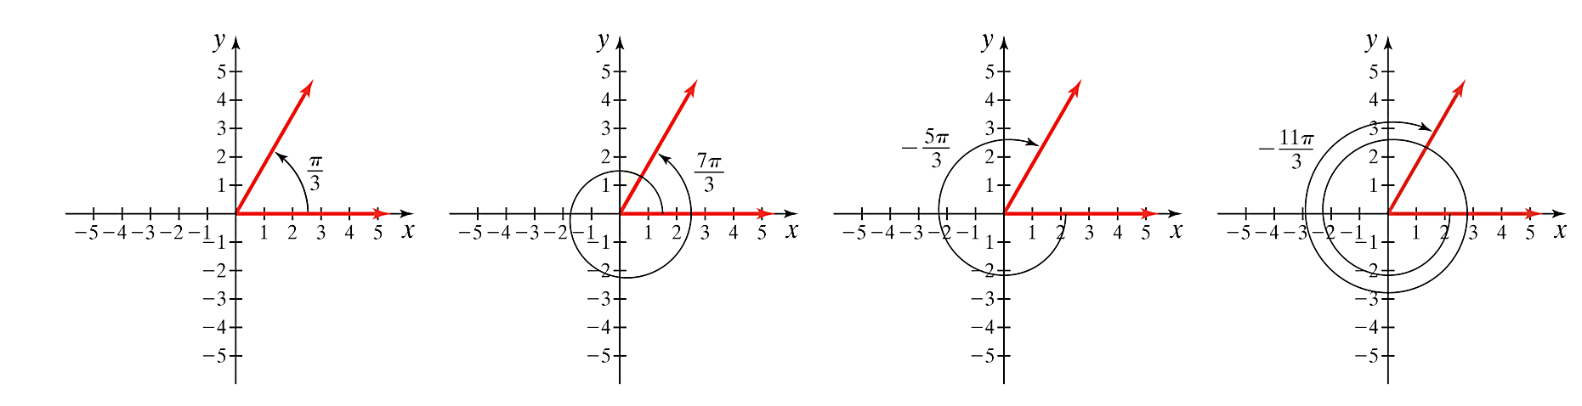   

Every angle has a coterminal angle of least non-negative measure. If  is a given angle, then we use the notation  to denote the angle of least non-negative measure coterminal with .

**Do not write . These angles are coterminal but they are not equal.**