6.3 Triangles

# OBJECTIVE 1: Classifying Triangles

The word “Trigonometry” comes from the Greek words “Trigonon”, meaning triangle, and the word “metron”, meaning measure.

Every triangle has three angles and three sides. The sum of the measures of the three angles is equal to radians or 180°. Two angles of a triangle are **congruent** if the measures of the two angles are the same. Similarly, two sides of a triangle are congruent if the lengths of the two sides are equal.

We can classify triangles based on the measure of their angles or the lengths of their sides. We start by classifying triangles based on their angle measures. A triangle with three acute anglesis called an **acute triangle**. A triangle with one obtuse angle is called an **obtuse triangle**. A triangle with one right angleis called a **right triangle**. The side opposite the right angle of a right triangle is called the **hypotenuse** and the two other sides of a right triangle are called **legs**. The hypotenuse and both legs can be referred to as “sides” but the hypotenuse is never referred to as a “leg.”

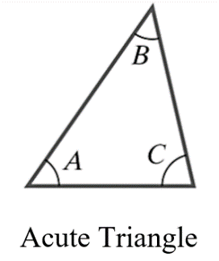 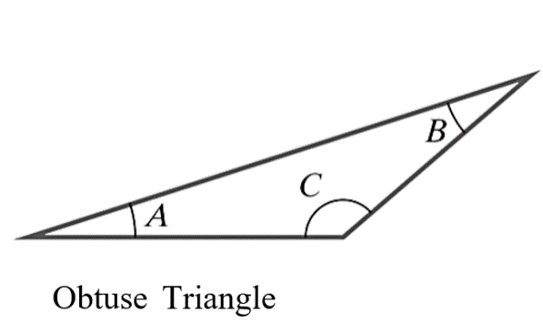 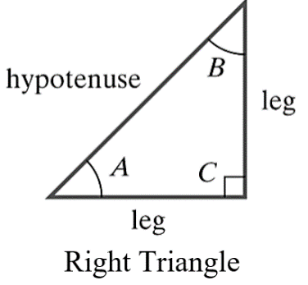

We can also classify triangles based on their side lengths. A triangle with no congruent sides is called a **scalene triangle**. A triangle with at least two congruent sides is called an **isosceles triangle**. The angles opposite the congruent sides of an isosceles triangle are also congruent. A special triangle with three congruent sides is called an **equilateral triangle**. All three angles of an equilateral triangle are congruent with a measure of radians or 60°.

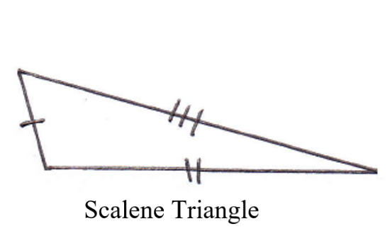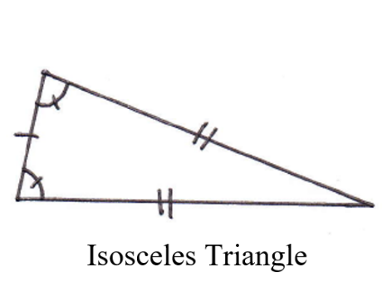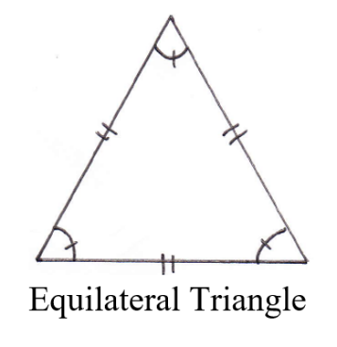

# OBJECTIVE 2: Using the Pythagorean Theorem

The Pythagorean Theorem is one of the most widely recognized theorems in all of mathematics. The Pythagorean Theorem states a unique relationship between the lengths of the legs of a right triangle and the hypotenuse. This relationship does not hold for acute triangles or for obtuse triangles.

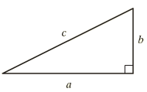

**The Pythagorean Theorem:** Given any right triangle, the sum of the squares of the lengths of the legs is equal to the square of the length of the hypotenuse.

In other words, if *a* and *b* are the lengths of the two legs and if *c* is the length of the hypotenuse, then .

If the lengths of the sides of a right triangle are all integers, then that set of integers is called a Pythagorean triple. In addition to 3-4-5, other examples of Pythagorean triples are 5-12-13 and 8-15-17. Multiples of these numbers are also Pythagorean triples, such as 6-8-10, 9-12-15, 12-16-20, etc. Being familiar with these Pythagorean triples can often save you time and effort in working trigonometric exercises.

# OBJECTIVE 3: Understanding Similar Triangles

Imagine drawing a triangle on a piece of paper and placing the paper in a copy machine. If you increase (or decrease) the size of the image to be copied, the resulting image will be a triangle of exactly the same shape as the original triangle but will be a different size. Triangles that have the same shape but not necessarily the same size are called **similar triangles**. These triangles are similar.

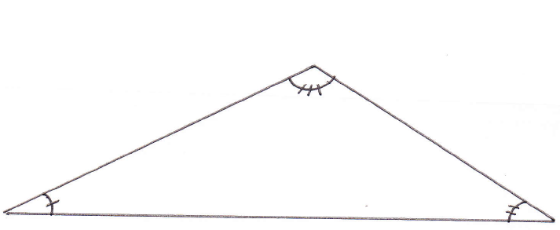 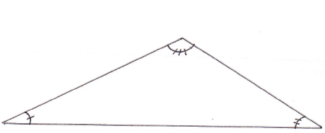

The measures of the corresponding angles of the triangles are equal (as indicated by the small arcs with tick marks) but the lengths of the corresponding sides are obviously different. However, the ratio of the lengths of any two sides of the larger triangle is equal to the ratio of the lengths of the corresponding sides of smaller triangle.

**Properties of Similar Triangles**

The corresponding angles have the same measure.  
The ratio of the lengths of any two sides of one triangle is equal to the ratio of the lengths of the corresponding sides of the other triangle.

For consistency, we will define the **proportionality constant** to always be greater than or equal to 1. Thus, given two similar triangles, the length of a side of the larger triangle is *k* times the length of the corresponding side of the smaller triangle where *k* is the proportionality constant. Also, the length of a side of the smaller triangle is times the length of the corresponding side of the larger triangle.

**Proportionality Constant of Similar Triangles**

If two triangles are similar, there exists a constant *k* called the **proportionality constant** **of similar triangles** equal to the ratio of the lengths of corresponding sides.

Given the similar triangles in the figure below, , where , , and .

A scalene triangle ABC with the length of side CA being b units, BC a units, and AB c units.
A scalene triangle XYZ which is the triangle ABC scaled down proportionately with the length of side ZX being y, side ZY length being x and side XY length being z

# OBJECTIVE 4: Understanding the Special Right Triangles

There are two “special” right triangles whose properties are worth memorizing.

**The   Right Triangle**

Every isosceles right triangle has two acute angles each measuring  radians . Since the triangle is isosceles, the length of the two legs must be congruent. Suppose that the length of a leg is *a* units, then we can use the Pythagorean Theorem to determine that the length of the hypotenuse is  units. The length of the sides of every  right triangle has this relationship. For example, if we let , then the length of the hypotenuse is .

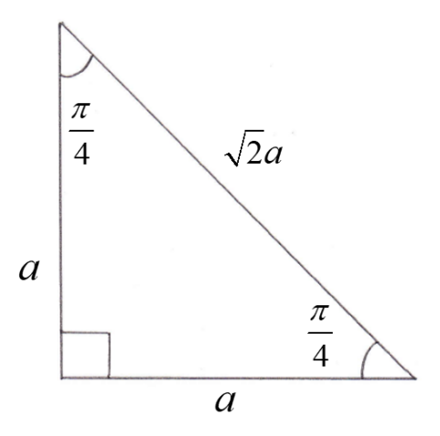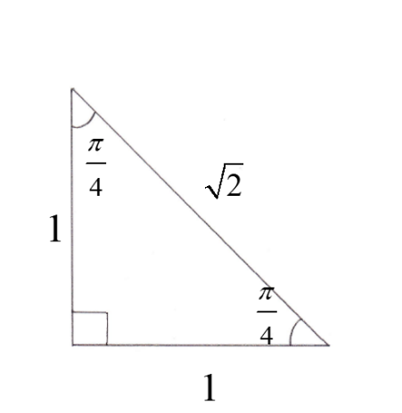

**The   Right Triangle**

The second special right triangle has acute angles of  radians  and  radians . We can construct this triangle by starting with an equilateral triangle whose angles all measure  radians . We can then draw a perpendicular line segment that bisects one of the angles and one of the sides to create two  right triangles.

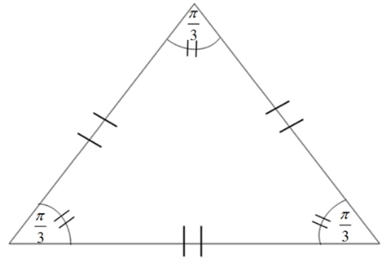 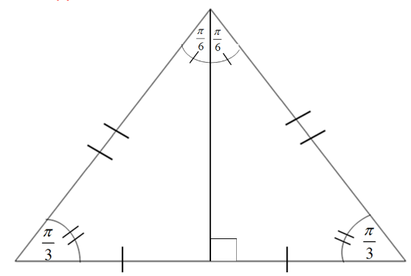

Because we bisected one of the sides of the equilateral triangle to create two triangles, the length of the shortest side of a  triangle must be exactly half of the length of the hypotenuse. (Or, the length of the hypotenuse must be twice as long as the length of the shortest side.) Therefore, if the length of the shorter leg (the leg opposite the  angle) is *a* units, then the length of the hypotenuse is *2a* units. We can use the Pythagorean Theorem to determine that the length of the other leg is units. If we let , then the length of the hypotenuse is 2 and the length of the side opposite the angle of  is .

