6.5 Trigonometric Functions of General Angles

# OBJECTIVE 1: Understanding the Four Families of Special Angles

**The Quadrantal Family of Angles** consists of angles in standard position that are coterminal with .

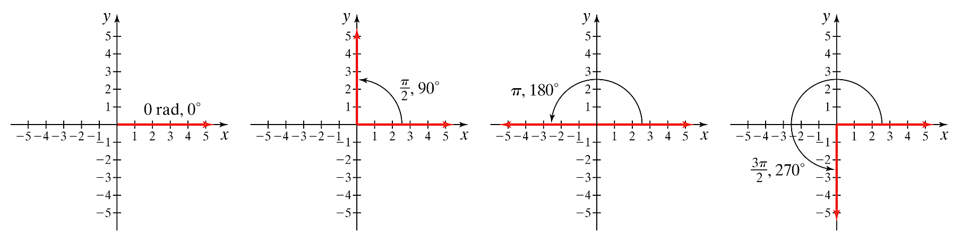

**The Family of Angles** consists of angles in standard position that are coterminal with.

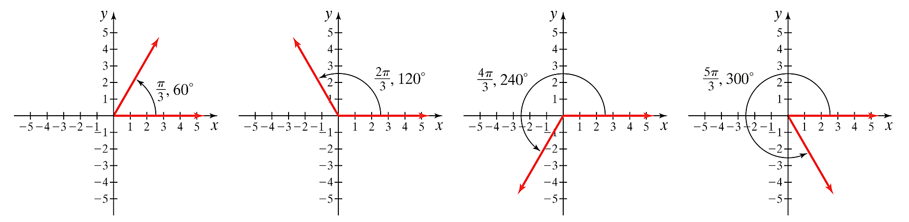

**The** **Family of Angles** consists of angles in standard position that are coterminal with .

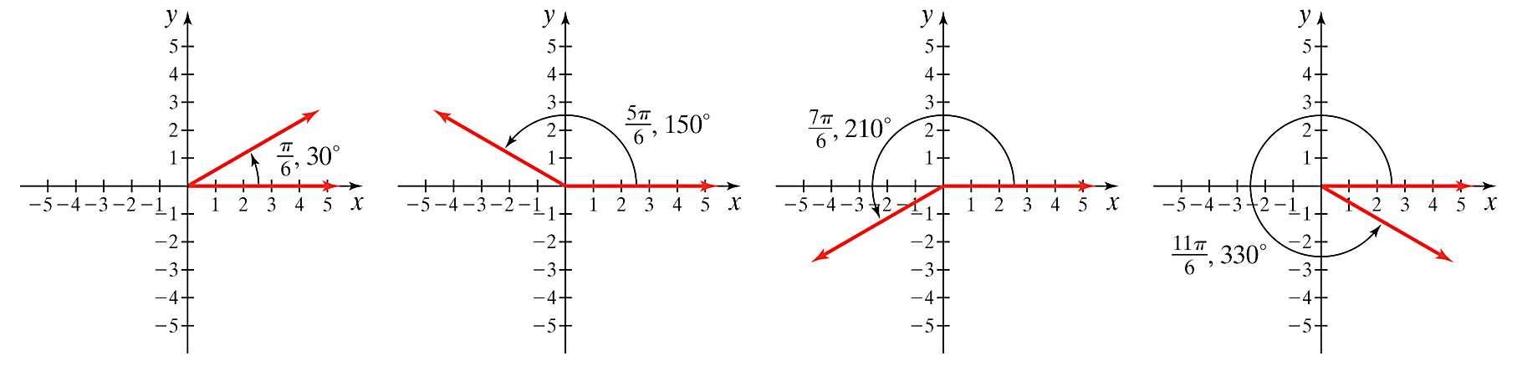

**The Family of Angles** consists of angles in standard position that are coterminal with .

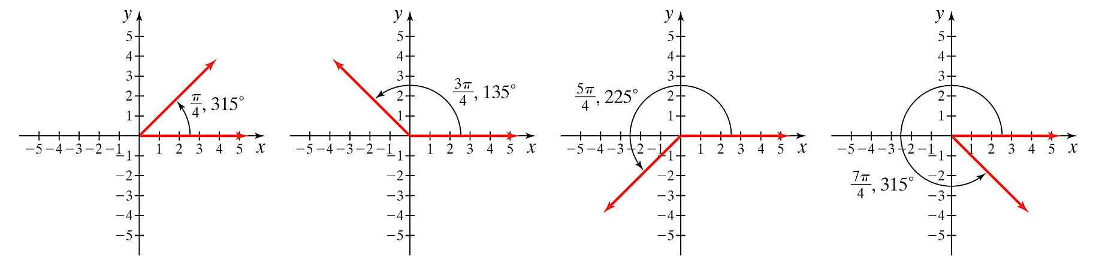

# OBJECTIVE 2: Understanding the Definitions of the Trigonometric Functions of General Angles

In Section 6.4, we defined the six trigonometric functions for acute angles using right triangles. We will now extend these definitions to general angles—angles not restricted in size that can be positive, negative, or zero. To begin, let be a point lying on the terminal side of acute angle  in standard position, and let  represent the distance from the origin to point *P*. By the distance formula, .

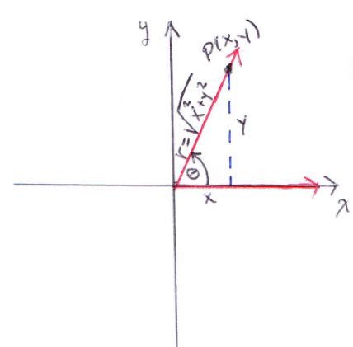

We use the right triangle definitions of the trigonometric functions to write the six trig ratios in terms of x, y, and r:

  

  

**The General Angle Definition of the Trigonometric Functions:** If is a point on the terminal side of *any* angle  in standard position and if  is the distance from the origin to point *P*, then the six trigonometric functions of  are defined as follows:

  

 

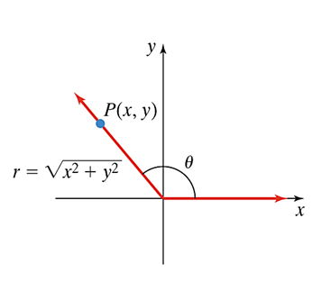

# OBJECTIVE 3: Finding the Values of the Trigonometric Functions of Quadrantal Angles

To determine the values of the trigonometric functions of quadrantal angles, we can use *any* point lying on the terminal side and apply the definitions of the six trigonometric functions. The figures below illustrate an arbitrary point on the terminal side of each of the angles .

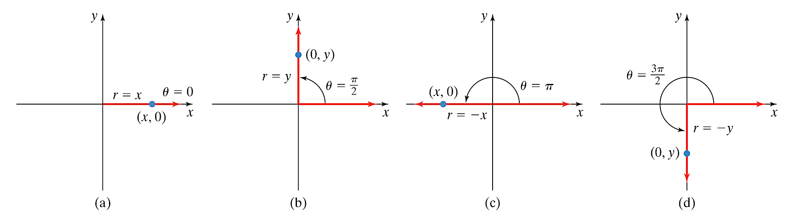   

The table below lists the value of the six trigonometric functions of the angles .

|  |  |  |  |  |  |  |
| --- | --- | --- | --- | --- | --- | --- |
|  | 0 | 1 | 0 | Undefined | 1 | Undefined |
|  | 1 | 0 | Undefined | 1 | Undefined | 0 |
|  | 0 |  | 0 | Undefined |  | Undefined |
|  |  | 0 | Undefined |  | Undefined | 0 |

# OBJECTIVE 4: Understanding the Signs of the Trigonometric Functions

If the terminal side of an angle lies in Quadrant I, then all trigonometric functions are positive.

If the terminal side of an angle lies in Quadrant II, then sine and cosecant are positive.

If the terminal side of an angle lies in Quadrant III, then tangent and cotangent are positive.

If the terminal side of an angle lies in Quadrant IV, then cosine and secant are positive.

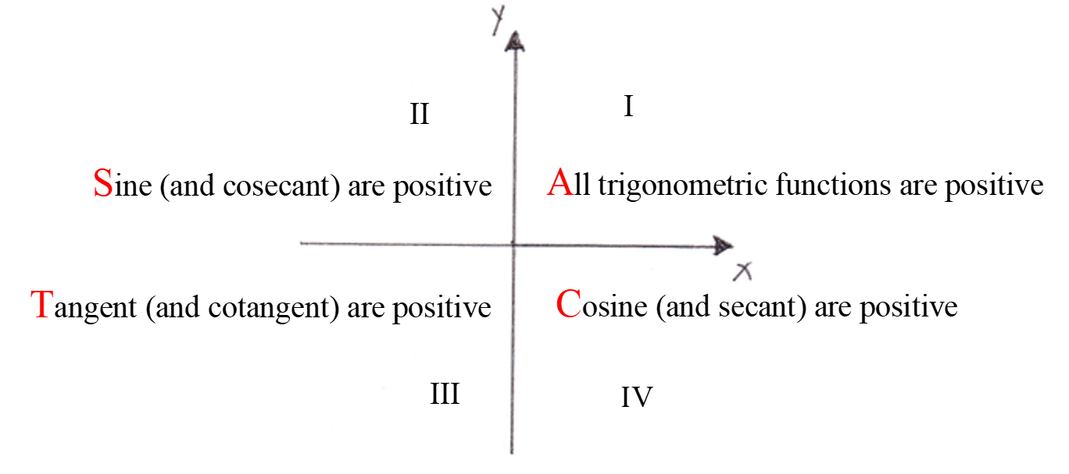

# OBJECTIVE 5: Determining Reference Angles

The **reference angle, **, is the positive acute angle associated with a given angle . Thereference angle is formed by the “nearest” *x-*axis and the terminal side of . Below are angles

sketched in each of the four quadrants along with their corresponding reference angles.

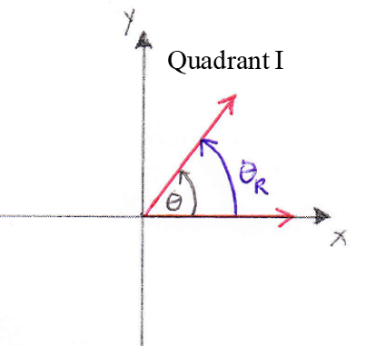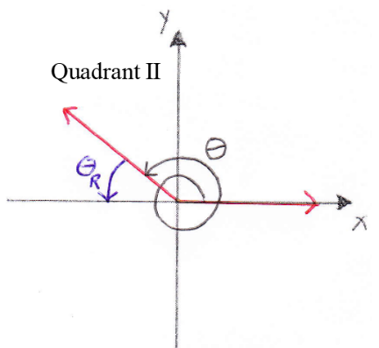

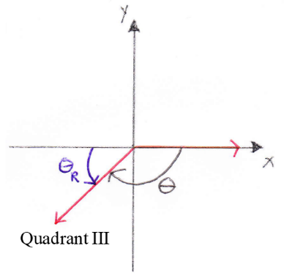 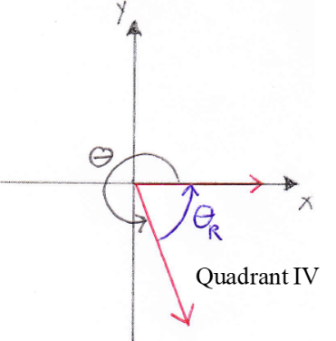

The measure of the reference angle  depends on the quadrant in which the terminal side of  lies. The four cases are described and then illustrated below.

Case 1: If the terminal side of  lies in Quadrant I, then .

Case 2: If the terminal side of  lies in Quadrant II then  (or .)

Case 3: If the terminal side of  lies in Quadrant III then  (or .)

Case 4: If the terminal side of  lies in Quadrant IV then  (or .)

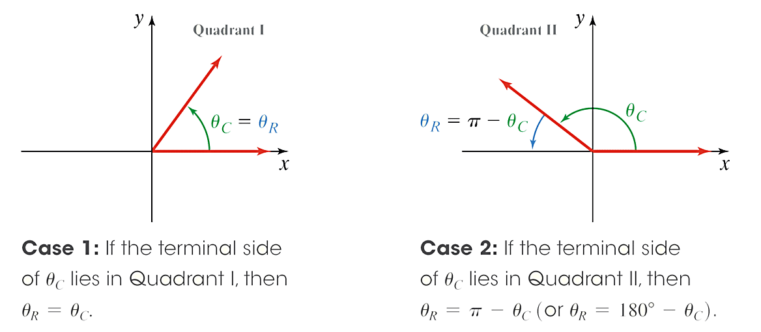

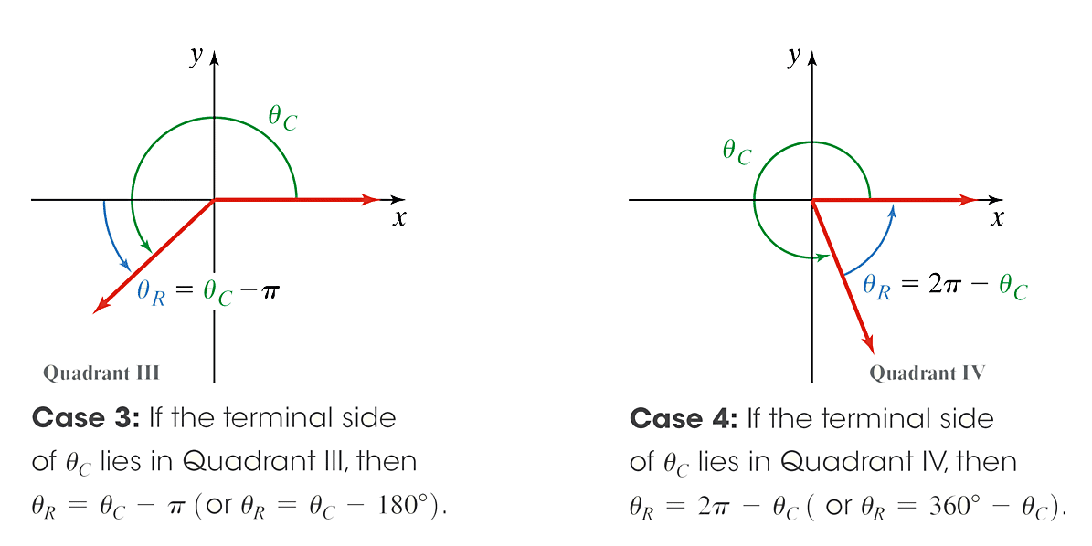

# OBJECTIVE 6: Evaluating Trigonometric Functions of Angles Belonging to the , , or Families

1. Draw the angle and determine the quadrant in which the terminal side of the angle lies.
2. Determine if the sign of the function is positive or negative in that quadrant.
3. Determine if the reference angle,  is ****, , or ****.
4. Use the appropriate special right triangle to determine the value of the trigonometric function.