6.6 The Unit Circle

# OBJECTIVE 1: Understanding the Definition of the Unit Circle

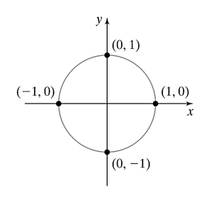

**The Unit Circle:** A circle centered at the origin with a radius of 1 unit is called the **unit circle** whose equation is given by 

# OBJECTIVE 3: Understanding the Unit Circle Definitions of the Trigonometric Functions

So far in this text, we have seen two groups of definitions for the trigonometric functions. In Section 6.4 we saw the Right Triangle Definitions of the Trigonometric functions of acute angles . Then, in Section 6.5 we saw the Definitions of the Trigonometric Functions of General Angles.

We now turn our attention to the third definition of trigonometric functions using the unit circle. Suppose that *t* is the measure (in radians) of a central angle of a unit circle with a corresponding arc length, *s*.

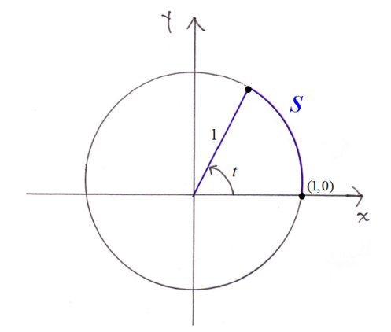

We can use the formula for the arc length of a sector of a circle to find the arc length, *s*, of an arc on a unit circle that corresponds to a central angle of *t* radians.

Write the formula for the arc length of a sector of a circle: 

The radius of the unit circle is 1, and the central angle θ is *t* radians, so substitute: 

Simplify: 

We see that the length of the intercepted arc is. **This means that the arc length of a sector of the *unit circle* is exactly equal to the measure of the central angle!** The arc length and the angle are represented by the same real number *t.*

We can now define the unit circle definitions of the trigonometric functions. To do this, let *t* be any real number and letbe the point on the unit circle that has an arc length of *t* units from the point (1, 0). The measure of the central angle (in radians) is exactly the same as the arc length, *t.* If , then point *P* is obtained by rotating in a *counterclockwise* direction. If , then point *P* is obtained by rotating in a *clockwise* direction.

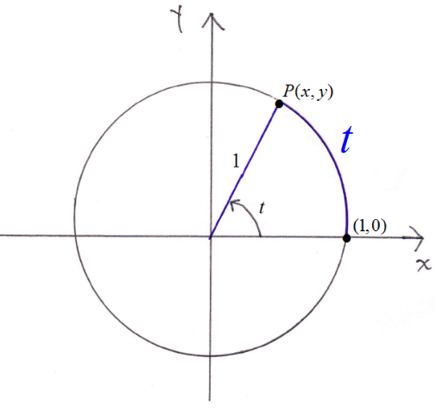 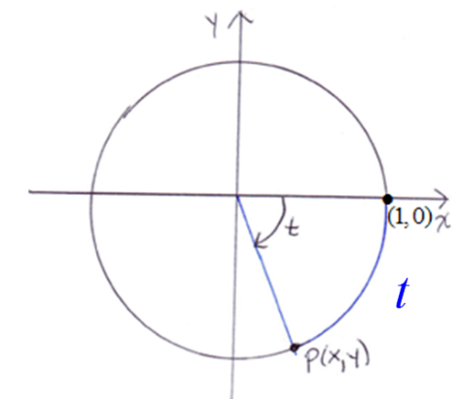

For the real number *t* and the corresponding point lying on the graph of the unit circle, we define the cosine of *t* as the *x*-coordinate of *P* and the sine of *t* as the *y-*coordinate of *P.* Therefore,  and . This choice of *x* for the cosine of *t* and *y* for the sine of *t* is not made arbitrarily. If you remember the Definitions of the Trigonometric Functions of General Angles, the sine of an angle theta was defined as  and the cosine of theta was defined as . Therefore, it seems logical and consistent that we choose to be *y* (which is  when ) and to be *x* (which is  when ).

We now define all six of the trigonometric functions using the unit circle.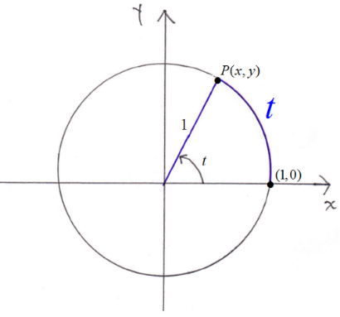

**The Unit Circle Definitions of the Trigonometric Functions:** For any real number *t,* if is a point on the unit circle corresponding to *t*,then

  

  