7.1 The Graphs of Sine and Cosine

# OBJECTIVE 1: Understanding the Graph of the Sine Function and its Properties

In Chapter 6, we sketched an angle  in standard position in the rectangular coordinate system and used the ordered pair  to represent a point P lying on the terminal side of . Now, we will use a rectangular coordinate system for a different purpose. We will plot points and label them , but the *x*-value will represent an angle measured in radians and the *y*-value will represent a trigonometric function of the angle.

Consider the function . When  , , so the ordered pair  represents a point that lies on the graph of .

We obtain the portion of the graph of  shown below by plotting all points of the form  that correspond to angles in the four special families whose terminal side lies in the interval .

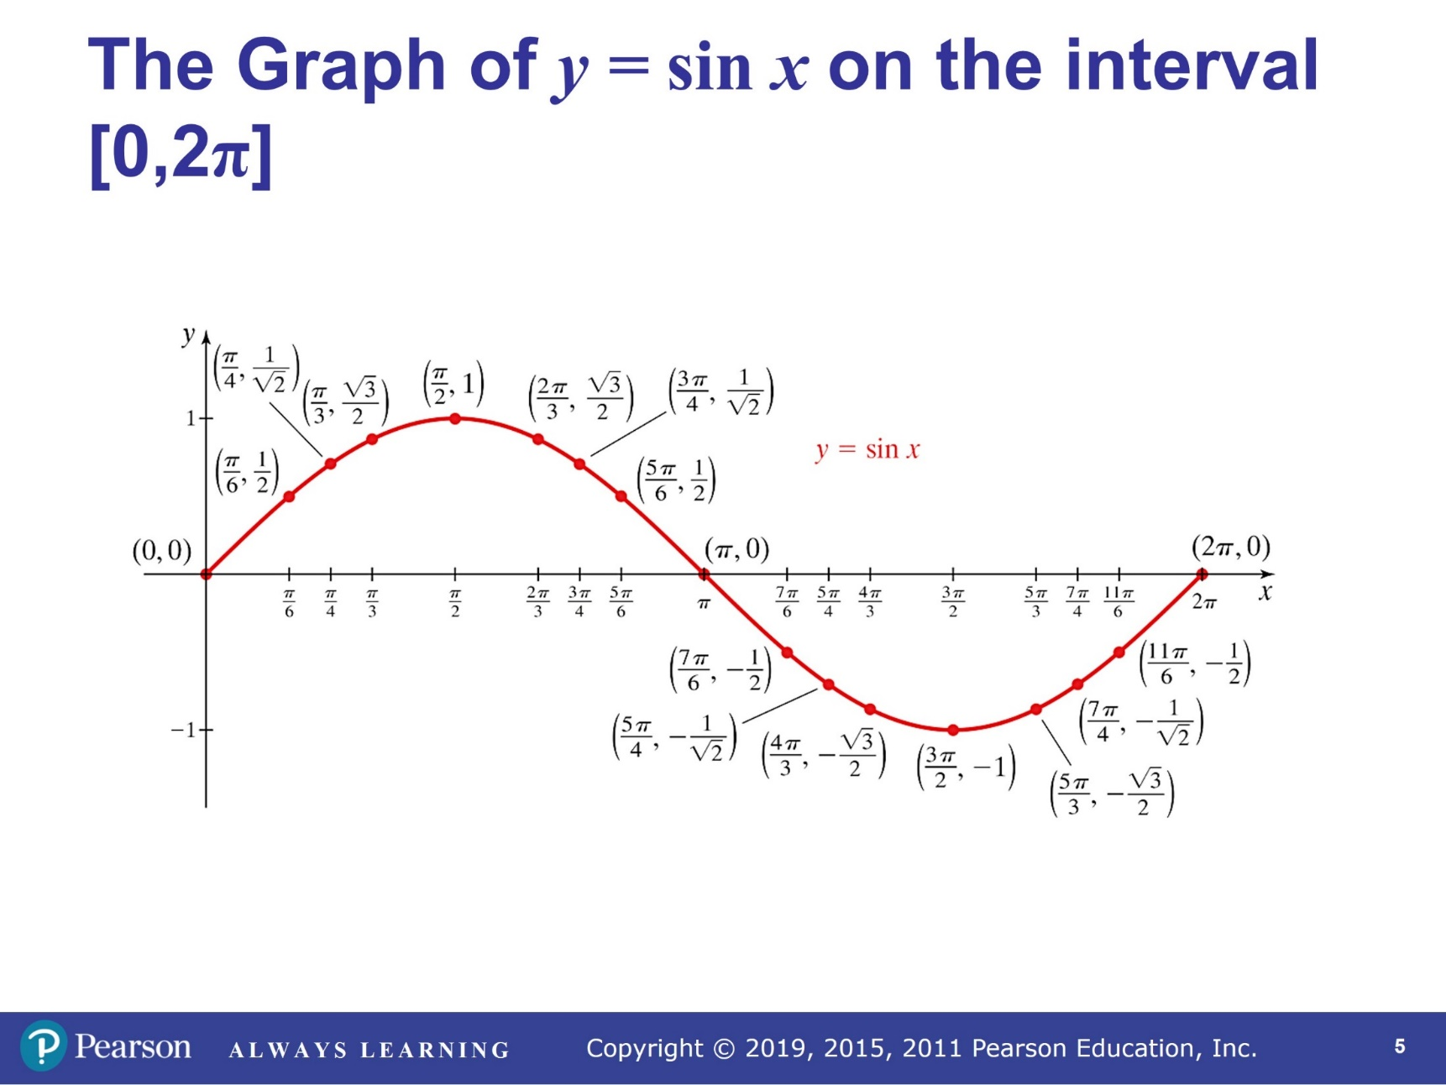

By continuing to plot points of the form  for *x* values greater than  or less than 0, we see that the graph repeats itself in both directions. In fact, on every interval of length , the graph of repeats itself. We say that is a **periodic function** with **period** . This means, for any value of *x*, , where *n* is any integer.

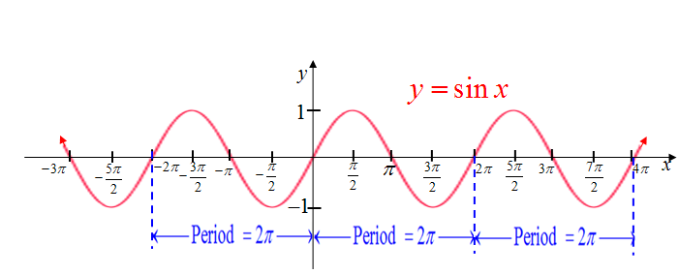

**Characteristics of the Sine Function**

The domain is .

The range is .

The function is periodic with a period of .

The *y-*intercept is 0.

The *x-*intercepts or zeros are of the form where *n* is an integer.

The function is odd which means . The graph is symmetric about the origin.

The function obtains a relative maximum value of 1 at  where *n* is an integer.

The function obtains a relative minimum value of at  where *n* is an integer.

# OBJECTIVE 2: Understanding the Graph of the Cosine Function and its Properties

Consider the function . When  , , so the ordered pair  represents a point that lies on the graph of .

We obtain the portion of the graph of  shown below by plotting all points of the form  that correspond to angles in the four special families whose terminal side lies in the interval .

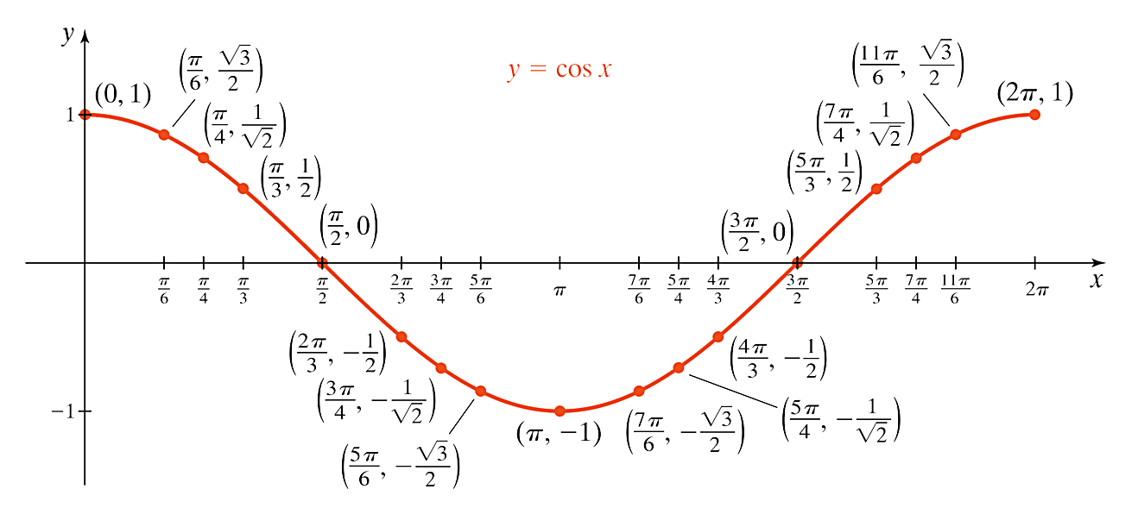

By continuing to plot points of the form  for *x* values greater than  or less than 0, we see that the graph of also repeats itself in both directions on every interval of length . Therefore,  is a **periodic function** with **period** . This means, for any value of *x*, , where n is any integer.

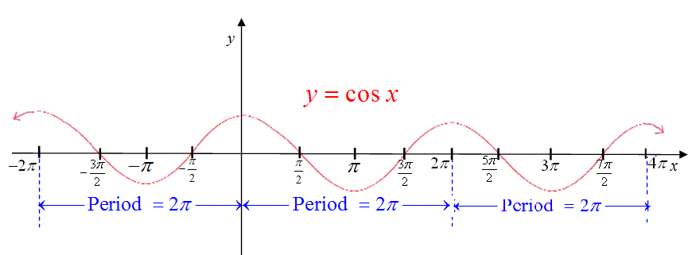

**Characteristics of the Cosine Function**

The domain is .

The range is .

The function is periodic with a period of .

The *y-*intercept is 1.

The *x-*intercepts or zeros are of the form where *n* is an integer.

The function is even which means . The graph is symmetric about the *y-*axis.

The function obtains a relative maximum value of 1 at  where *n* is an integer.

The function obtains a relative minimum value of  at  where *n* is an integer.

When sketching graphs of  and and the upcoming transformations of these graphs, we will focus on sketching five specific points on one complete cycle of the graph with the understanding that this cycle repeats itself indefinitely. These five points evenly divide one cycle of the sine or cosine curve into fourths or quarters. Therefore, we will call these five points the **quarter points**.

**The Five Quarter Points of**  are  ,  , , , and .

One cycle of the graph of  is shown below with these quarter points labeled.

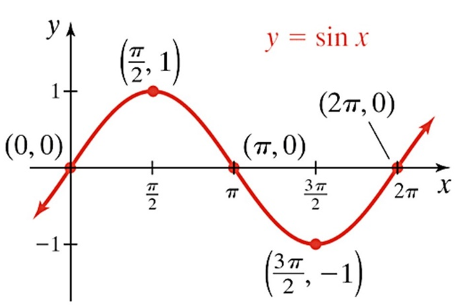

**The Five Quarter Points of**  are  ,  , , , and .

One cycle of the graph of  is shown below with these quarter points labeled.

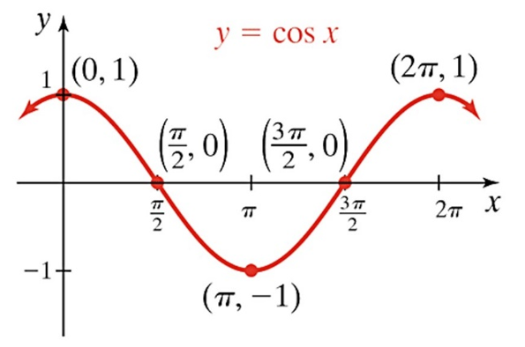

# OBJECTIVE 3: Sketching Graphs of the Form and

The **amplitude** of a sine or cosine curve is the measure of half the distance between the maximum and minimum values.

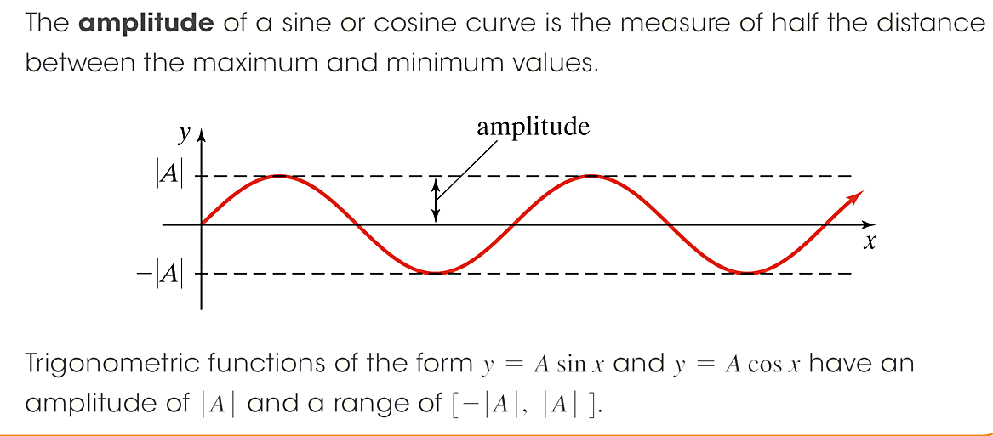

Trigonometric functions of the form and have an amplitude of  and a range of .

# OBJECTIVE 4: Sketching Graphs of the Form and

The **period** of  or  is equal towhere .

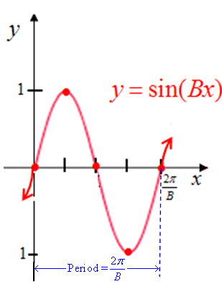 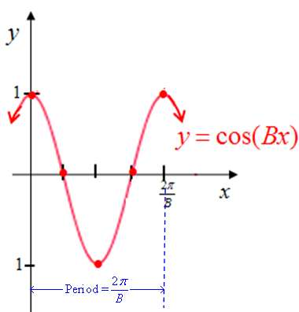

# OBJECTIVE 5: Sketching Graphs of the Form and

**Steps for Sketching Functions of the Form ** **and **

1. If , use the even and odd properties of the sine and cosine function to rewrite the function in an equivalent form such that .

**We now use this new form to determine *A* and *B.***

1. Determine the amplitude and range. The amplitude is . The range is .
2. Determine the period. The period is .
3. An interval for one complete cycle is . Subdivide this interval into 4 equal subintervals of length  by starting with 0 and adding to the *x-*coordinate of each successive quarter point.
4. Multiply the *y-*coordinates of the quarter points of  or by *A* to determine the *y-*coordinates of the corresponding quarter points for the new graph.
5. Connect the quarter points to obtain one complete cycle.

# OBJECTIVE 6 Determine the Equation of a Function of the Form or

# Given Its Graph

We now know how to sketch the graphs of  and. Suppose that we are given a graph whose function is given by  or  for . (We will assume that the value of *B* is positive. Otherwise, there could be more than one correct answer.)

To determine the proper function, we must determine three things:

1. Is the given graph a representation of a function of the form  or ?
2. What is the value of *B*?
3. What is the value of *A*?

Therefore, we can establish the following three steps for determining the proper function.

**Steps for Determining the Equation of a Function of the Form ** **or** **Given the Graph**

1. Determine whether the given graph is a representation of a function of the form or . Choose  if the graph passes through the origin or choose if the graph does not pass through the origin.*
2. Determine the period *P*, and then use the fact that  to find the value of *.*
3. Use the information from Steps 1 and 2 and one of the given points on the graph to solve for *A.*

\**As long as we restrict the choices of the equations to* *and* *where* *, this will be true. Without these restrictions, there would be more than one correct equation represented by the given graph.*