7.2a More on Graphs of Sine and Cosine: Phase Shift

# OBJECTIVE 1: Sketching Graphs of the Form and

The graph of**** is **a horizontal shift** of the graph of , and the graph of  is a horizontal shift of the graph of  .

**If  , the shift is *C* unitsto the right, but if  , the shift is *C* units to the left.**

Consider the function . Since  and ****, the graph is shifted to the right  units. The quarter points for  are obtained by adding to the *x*-coordinate of each quarter point of . The graph of  is shown below on the left, and the graph of  is shown below on the right.

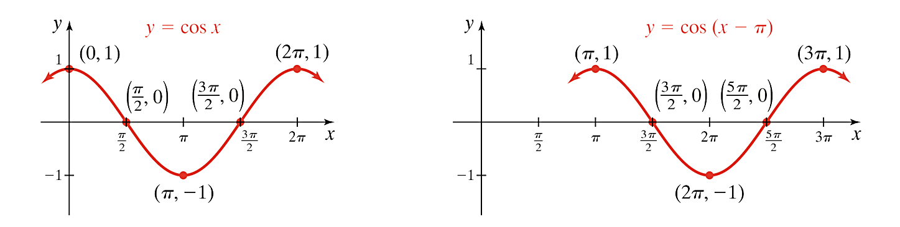 

Now, consider the function . Since  and ****, the graph is shifted to the left  units. The quarter points for  are obtained by subtracting  from the *x*-coordinate of each quarter point of . The graph of  is shown below on the left, and the graph of  is shown below on the right.

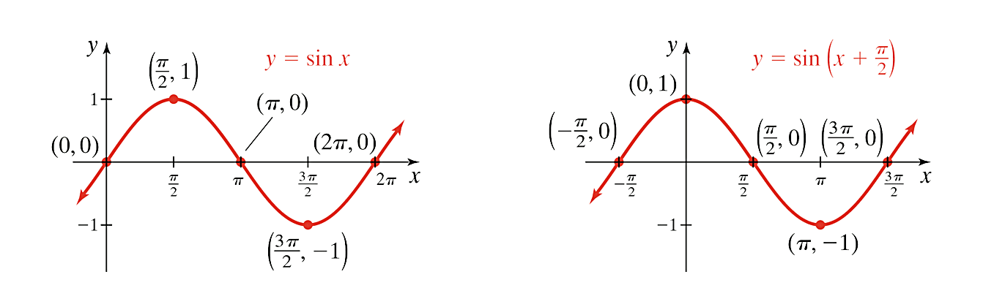 

# OBJECTIVE 2: Sketching Graphs of the Form and

Horizontal stretching and horizontal shifting of sine or cosine functions together determine the **phase shift** of the function. The formula for phase shift is , , and this value will be the *x*-coordinate of the first quarter point of the graph of the function ,  or,.

**Steps for Sketching Functions of the Form ** **and **

1. Rewrite the function as  or . If , then use the even and odd properties of the sine and cosine function to write the function in an equivalent form such that .

**We now use this new form to determine the amplitude, period, and phase shift.**

1. The amplitude is . The range is .
2. The period is .
3. The phase shift is .
4. The *x-*coordinate of the first quarter point is . The *x-*coordinate of the last quarter point is . An interval for one complete cycle is . Subdivide this interval into 4 equal subintervals of length  by starting with and adding to the *x-*coordinate of each successive quarter point.
5. Multiply the *y-*coordinates of the quarter points of or by *A* to determine the *y-*coordinates of the corresponding quarter points for  and **.**
6. Connect the quarter points to obtain one complete cycle.