7.3 The Graphs of the Tangent, Cotangent, Secant, and Cosecant Functions

# OBJECTIVE 1: Understanding the Graph of the Tangent Function and its Properties

The graph of the function  consists of all points of the form . The graph of , , is shown below. By plotting more points, we see that this cycle repeats infinitely in both directions. Therefore,  is a **periodic function** with **period** .

Notice that the shape of the graph of  is very different from the shapes of the graphs of and . Because , the domain of will not be all real numbers. The graph of  will have vertical asymptotes at each *x*-intercept of . Furthermore, the x-intercepts of  will be the same as the x-intercepts of . The graph of is increasing on each cycle.

In addition to the vertical asymptotes,  and , at each end of this cycle of the graph, notice the three important points that are labeled: the center point  and the two halfway points  and .

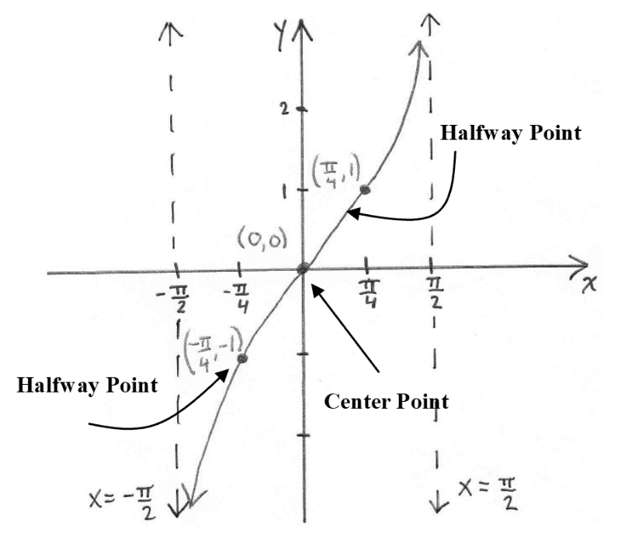

This cycle of the graph of , , is called the **principal cycle**. When sketching graphs of and the upcoming transformations of this graph, we will focus on sketching the asymptotes at the ends of the principal cycle and the center and halfway points of the principal cycle of the graph with the understanding that this cycle repeats itself indefinitely.

Three cycles of the graph of are shown below.

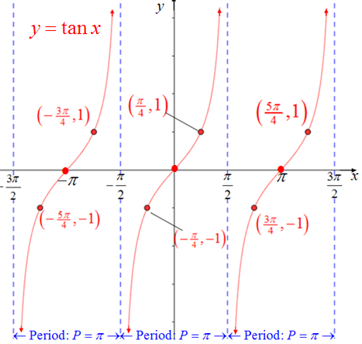

**Characteristics of the Tangent Function**

The domain is .

The range is .

The function is periodic with a period of .

The principal cycle of the graph occurs on the interval .

The function has infinitely many vertical asymptotes with equations  where *n* is an integer.

The *y-*intercept is 0.

For each cycle there is one center point. The *x-*coordinates of the center points are also the *x-*intercepts, or zeros, and are of the form where *n* is an integer.

For each cycle there are two halfway points. The halfway point to the left of an *x-*intercept has a *y-*coordinate of . The halfway point to the right of an *x-*intercept has a *y-*coordinate of 1.

The function is odd which means. The graph is symmetric about the origin.

The graph of each cycle of  is one-to-one.

# OBJECTIVE 2: Sketching Graphs of the form

**Steps for Sketching Functions of the Form** 

1. If, use the odd property of the tangent function to rewrite the function in an equivalent form such that .

**We now use this new form to determine *A, B*, *C,* and *D.***

1. Determine the interval and the equations of the vertical asymptotes of the principal cycle. The interval for the principal cycle can be found by solving the inequality . The vertical asymptotes of the principal cycle occur at the “endpoints” of the interval of the principal cycle.
2. The period is .
3. Determine the center point of the principal cycle of .

The *x-*coordinate of the center point is located midway between the vertical asymptotes of the principal cycle. The *y-*coordinate of the center point is *D*. Note that when , the *x-*coordinate of the center point is the *x-*intercept.

1. Determine the coordinates of the two halfway points of the principal cycle of.

Each *x*-coordinate of a halfway point is located halfway between the *x-*coordinate of the center point and the nearest vertical asymptote. The *y-*coordinates of these points are *A* times the *y-*coordinate of the corresponding halfway point of plus *D.*

1. Sketch the vertical asymptotes, plot the center point, and plot the two halfway points. Connect these points with a smooth curve. Complete the sketch showing appropriate behavior of the graph as it approaches each asymptote.

# OBJECTIVE 3: Understanding the Graph of the Cotangent Function and its Properties

The graph of the function  consists of all points of the form . The graph of , , is shown below. By plotting more points, we see that this cycle repeats infinitely in both directions. Therefore,  is a **periodic function** with **period** .

Notice that the shape of the graph of  is similar to the shape of  with some very distinct differences. Because , the domain of  will not be all real numbers. The graph of  will have vertical asymptotes at each *x*-intercept of . Furthermore, the *x*-intercepts of  will be the same as the *x*-intercepts of . The graph of  is decreasing on each cycle.

In addition to the vertical asymptotes,  and , at each end of this cycle of the graph, notice the three important points that are labeled: the center point  and the two halfway points  and .

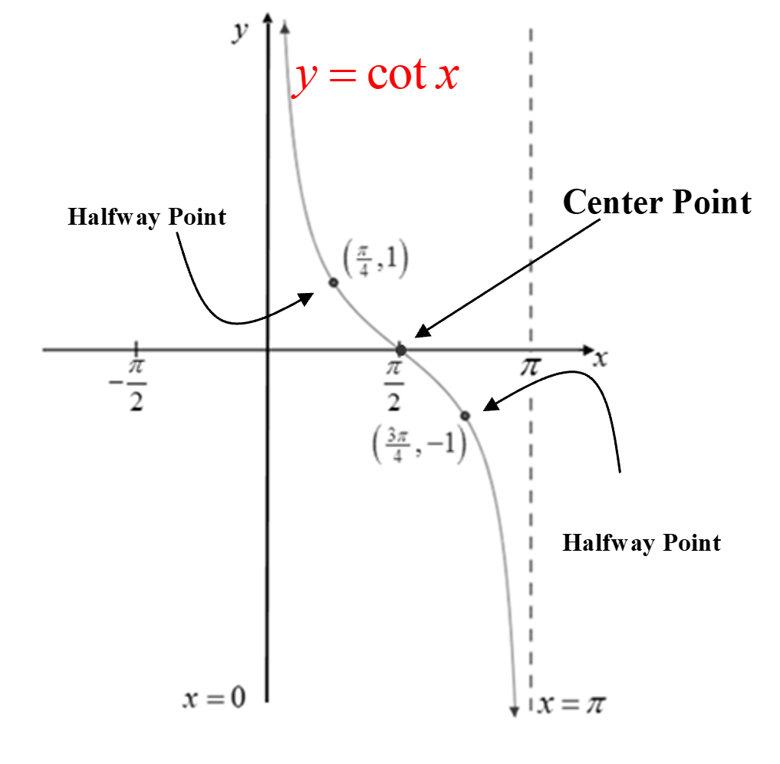

This cycle of the graph of , , is called the **principal cycle**. When sketching graphs of and the upcoming transformations of this graph, we will focus on sketching the asymptotes at the ends of the principal cycle and the center and halfway points of the principal cycle of the graph with the understanding that this cycle repeats itself indefinitely.

Three complete cycles of the graph of  are shown below.

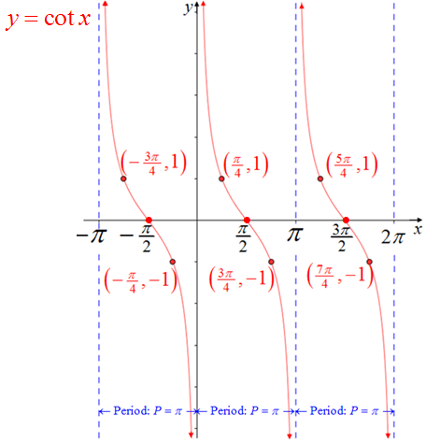

**Characteristics of the Cotangent Function**

The domain is 

The range is .

The function is periodic with a period of 

The principal cycle of the graph occurs on the interval .

The function has infinitely many vertical asymptotes with equations  where *n* is an integer.

There is no *y-*intercept.

For each cycle there is one center point. The *x-*coordinates of the center points are also the *x-*intercepts, or zeros, and are of the formwhere *n* is an integer.

For each cycle there are two halfway points. The halfway point to the left of an *x-*intercept has a *y-*coordinate of 1. The halfway point to the right of an *x-*intercept has a *y-*coordinate of .

The function is odd which means . The graph is symmetric about the origin.

The graph of one cycle is one-to-one.

# OBJECTIVE 4: Sketching Graphs of the form

**Steps for Sketching Functions of the Form **

1. If, use the odd property of the cotangent function to rewrite the function in an equivalent form such that .

**We now use this new form to determine *A, B*, *C,* and *D.***

1. Determine the interval and the equations of the vertical asymptotes of the principal cycle. The interval for the principal cycle can be found by solving the inequality . The vertical asymptotes of the principal cycle occur at the “endpoints” of the interval of the principal cycle.
2. The period is .
3. Determine the center point of the principal cycle of ****.

The *x-*coordinate of the center point is located midway between the vertical asymptotes of the principal cycle. The *y-*coordinate of the center point is *D*. Note that when , the *x-* coordinate of the center point is the *x-*intercept.

1. Determine the coordinates of the two halfway points of the principal cycle of****.

Each *x*-coordinate of a halfway point is located halfway between the *x-*coordinate of the center point and the nearest vertical asymptote. The *y-*coordinates of these points are *A* times the *y-*coordinate of the corresponding halfway point of plus *D.*

1. Sketch the vertical asymptotes, plot the center point, and plot the two halfway points. Connect these points with a smooth curve. Complete the sketch showing appropriate behavior of the graph as it approaches each asymptote.

# OBJECTIVE 6: Understanding the Graphs of the Cosecant and Secant Functions and their Properties

To obtain the graph of , begin by sketching the graph of  . Because  , the graph of will have a vertical asymptote at each x-intercept of . Also because of this reciprocal relationship, each maximum value of 1 for will be a minimum value for , and each minimum value of  for  will be a maximum value for . The “pieces” of the graph of  between the vertical asymptotes are “u-shaped,” opening up if  has a minimum value on that interval and opening down if  has a maximum value on that interval.

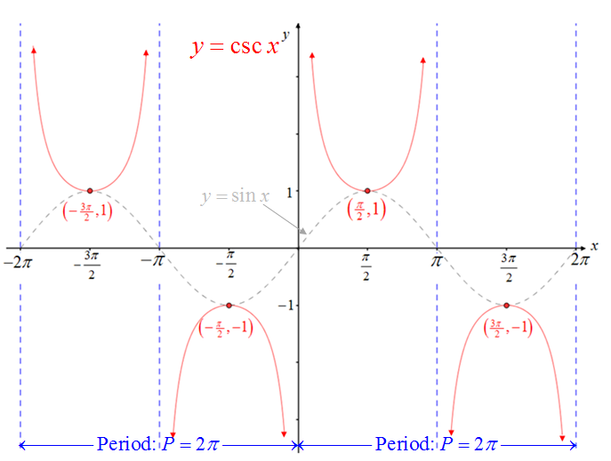

**Characteristics of the Cosecant Function**

The domain is 

The range is .

The function is periodic with a period of 

The function has infinitely many vertical asymptotes with equations  where *n* is an integer.

The function obtains a relative maximum value of  at  where *n* is an integer.

The function obtains a relative minimum value of 1 at  where *n* is an integer.

The function is odd which means . The graph is symmetric about the origin.

To obtain the graph of  , begin by sketching the graph of  . Because , the graph of will have a vertical asymptote at each x-intercept of . Also because of this reciprocal relationship, each maximum value of 1 for  will be a minimum value for , and each minimum value of  for  will be a maximum value for . The “pieces” of the graph of between the vertical asymptotes are “u-shaped,” opening up if  has a minimum value on that interval and opening down if  has a maximum value on that interval.

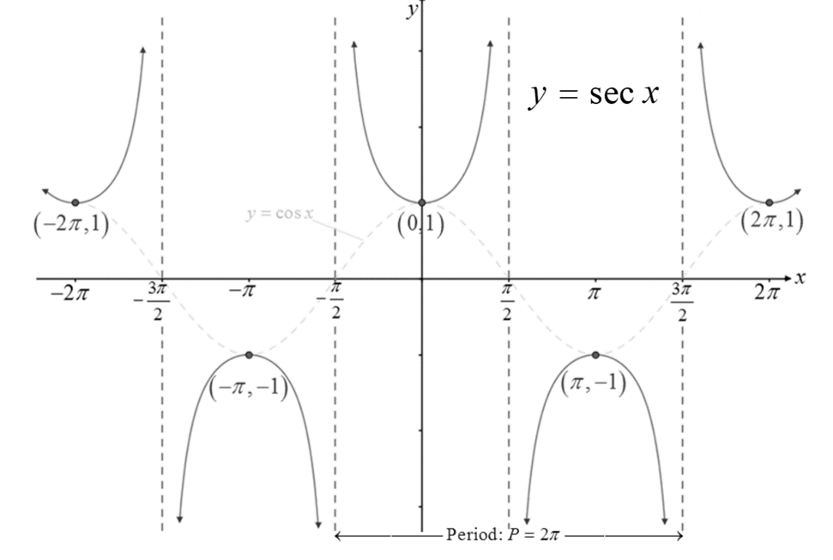

**Characteristics of the Secant Function**

The domain is .

The range is .

The function is periodic with a period of 

The function has infinitely many vertical asymptotes with equations  where *n* is an integer.

The function obtains a relative maximum value of  at  where *n* is an integer.

The function obtains a relative minimum value of 1 at  where *n* is an integer.

The function is even which means . The graph is symmetric about the *y-*axis.

# OBJECTIVE 7: Sketching Graphs of the form and

**Steps for Sketching Functions of the Form and **

1. Lightly sketch at least two cycles of the corresponding reciprocal function or . If , lightly sketch two reciprocal functions, one with and one with .
2. Sketch the vertical asymptotes. The vertical asymptotes will correspond to the *x-*intercepts of the reciprocal function  or .
3. Plot all maximum and minimum points on the graph of  or .
4. Draw smooth curves through each point from Step 3 making sure to show the appropriate behavior of the graph near each asymptote.