9.4 Area of Triangles

# OBJECTIVE 1: Determining the Area of Oblique Triangles

**Area of a Triangle**: In any triangle, the area is given by where *b* is the length of the base of the triangle, and *h*, is the length of the altitude drawn to that base (or drawn to an extension of that base.)

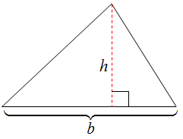 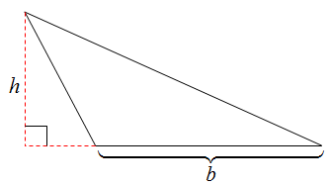

**Area of a Triangle:** If *A*, *B*, and *C* are the measures of the angles of any triangle and if *a*, *b*, and *c* are the lengths of the sides opposite the corresponding angles, then the area of triangle *ABC* is given by  or  or .

# OBJECTIVE 2: Using Heron's Formula to Determine the Area of a SSS Triangle

**Heron’s Formula:** Suppose that a triangle has side lengths of *a*, *b*, and *c*. The semiperimeteris, and the area of the triangle is.

# OBJECTIVE 3: Solving Applied Problems Involving the Area of Triangles