Section 10.3 Exponential Functions

# Objective 1: Graphing Exponential Functions

Functions of the form $f\left(x\right)=b^{x}$ where $b$ is a real number such that $b>0$ and $b≠1$ are called **exponential functions**.

Graph the exponential function by making a table of values.

|  |  |
| --- | --- |
| a.  Blank coordinate plane that spans from negative ten to positive ten on each axis with a scale of one unit. | b.  Blank coordinate plane that spans from negative ten to positive ten on each axis with a scale of one unit. |

**Characteristics of Exponential Functions of the Form $f\left(x\right)=b^{x}$ where $b>0$ and $b≠1$:**

The function $f$:

* is a one to one function.
* has a domain of all real numbers.
* has a range of $y>0$.
* has a horizontal asymptote of $y=0$.
* is increasing on its entire domain for $b>1$.
* is decreasing on its entire domain for $0<b<1$.

The graph of $f$:

* has a $y$-intercept of $1$.
* has no $x$-intercepts.

|  |  |
| --- | --- |
| the graph of an exponential function with base b greater than 1 starts near the x-axis in quadrant II pointing left and rises more and more quickly to the right passing through the point (0,1) into quadrant 1 pointing up | the graph of an exponential function with base b between 0 and 1 starts in quadrant II pointing up and falls more and more quickly to the right passing through the point (0,1) into quadrant I approaching the x-axis and pointing right |

The family of exponential functions are functions that have graphs that are transformations of the graph of $f\left(x\right)=b^{x}$.

Graph $g$ by using transformations of the graph of an exponential function $f\left(x\right)=b^{x}$. For function $g$, state the domain, the range, the $y$-intercept of its graph, an equation of the horizontal asymptote, and if the function is increasing or decreasing on its domain.

|  |  |
| --- | --- |
| c.  Blank coordinate plane that spans from negative ten to positive ten on each axis with a scale of one unit. | d. g  Blank coordinate plane that spans from negative ten to positive ten on each axis with a scale of one unit. |
|  |  |
| e.  Blank coordinate plane that spans from negative ten to positive ten on each axis with a scale of one unit. | f.  Blank coordinate plane that spans from negative ten to positive ten on each axis with a scale of one unit. |

# Objective 2: Solving Equations of the Form $b^{x}=b^{y}$

Because the exponential function $f\left(x\right)=b^{x}$ is a one-to-one function, we know there is only one value of $x$ for any $y$-value in the range of $f$. We can use this characteristic as a way to solve exponential equations.

**Uniqueness of $b^{x}$**

Let $b>0$ and $b≠1$. If $b^{x}=b^{y}$, then $x=y$.

Solve for $x$.

|  |  |
| --- | --- |
| a. $3^{x}=81$ | b. ${81}^{x}=243$ |
|  |  |
| c. $32={\left(\frac{1}{2}\right)}^{x-1}$ | d. ${16}^{x+2}=8^{3x}$ |

# Objective 3: Solving Problems Modeled by Exponential Functions

There are many real world situations that can be modeled with exponential functions. For example, populations over a certain time interval can sometimes be modeled with an exponential function.

The function $p\left(t\right)=75{\left(1.095\right)}^{t}$ models the projected population of a city, in thousands, $t$ years since 2020.

a. What was the population of the city in the year 2020?

b. At what rate is the population of the city projected to increase? Give your answer as a percent per year.

c. What is the projected population of the city in the year 2030?

Another application of exponential functions has to do with interest rates on loans. The **compound interest formula $A=P{\left(1+\frac{r}{n}\right)}^{nt}$** calculates the dollars $A$ accrued (or owed) after $P$ dollars are invested (or loaned) at an annual rate of interest $r$ compounded $n$ times each year for $t$ years.

Suppose $\$1000$ is invested at an annual interest rate of $3.75\%$. How much will the investment be worth in $20$ years if the interest is compounded:

|  |  |  |
| --- | --- | --- |
| d. annually | e. quarterly | f. monthly |
|  |  |  |

# Objective 4: The Natural Exponential Function

a. Complete the table. Round to five decimal places when needed.

|  |  |
| --- | --- |
| $$n$$ | $${\left(1+\frac{1}{n}\right)}^{n}$$ |
| $$1$$ |  |
| $$10$$ |  |
| $$100$$ |  |
| $$1,000$$ |  |
| $$10,000$$ |  |
| $$100,000$$ |  |
| $$1,000,000$$ |  |

The number *e* is an irrational number that is defined as the value of the expression as *n* approaches infinity. The table above shows the values of the expression  for increasingly large values of *n.* The value of *e* is approximately 2.71828. The function  is called the **natural exponential function.** The graph below shows that the graph of  lies between the graphs of $y=2^{x}$ and $y=3^{x}$ when graphed on the same coordinate system.

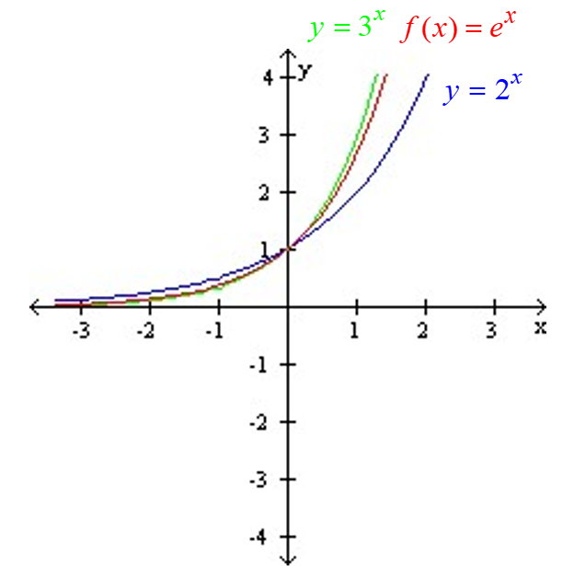

**Characteristics of the Natural Exponential Function**

The natural exponential function is defined as $f\left(x\right)=e^{x}$. The domain of $f$ is the set of all real numbers, and the range is $y>0$.

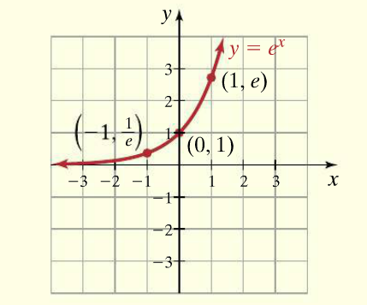

Graph $g$ by using transformations of the graph of the natural exponential function $f\left(x\right)=e^{x}$. For function $g$, state the domain, the range, the $y$-intercept of its graph, an equation of the horizontal asymptote, and if the function is increasing or decreasing on its domain.

|  |  |
| --- | --- |
| b.  Blank coordinate plane that spans from negative ten to positive ten on each axis with a scale of one unit. | c. g  Blank coordinate plane that spans from negative ten to positive ten on each axis with a scale of one unit. |

When interest is being compounded continuously, the compound interest formula becomes $A=Pe^{rt}$. This formula calculates the dollars $A$ accrued (or owed) after $P$ dollars are invested (or loaned) at an annual rate of interest $r$ compounded continuously for $t$ years.

d. Suppose $\$1000$ is invested at an annual interest rate of $3.75\%$. How much will the investment be worth in $20$ years if the interest is compounded continuously?