Section 10.4 Logarithmic Functions

# Objective 1: Using Logarithmic Notation

Every exponential function of the form $f\left(x\right)=b^{x}$ where $b>0$ and $b≠1$ is a one-to-one function and thus has an inverse function. The graph of $f\left(x\right)=b^{x}$ for $b>1$ and its inverse, $f^{-1},$ are shown below.

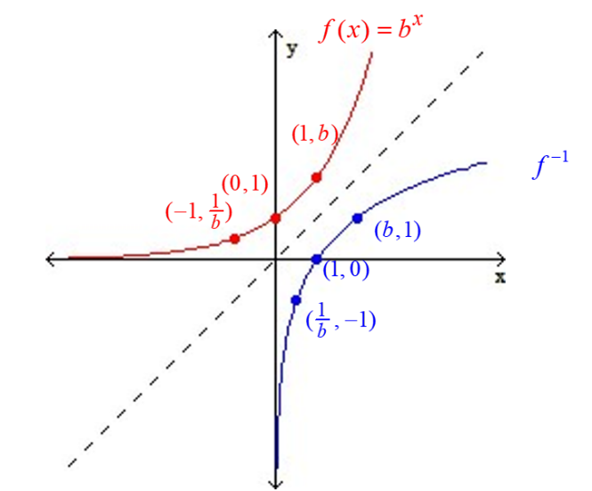

To find the equation of , recall from section 10.2 that we interchange the $x$ and $y$ in the equation of $f$ and then solve for $y$. So the equation of the inverse function is

$x=b^{y}$.

At this point, we are stuck. To solve this equation for $y$, a new notation, the **logarithmic function**, is needed. The expression $\log_{b}{x}$ means “the power to which $b$ is raised in order to produce a result of $x$. The expression $\log_{b}{x}$ is read “log base $b$ of $x$.”

**Logarithmic Definition:**

If $b>0$ and $b≠1$, then

$y=\log_{b}{x}$ means ${x=b}^{y}$

for every $x>0$ and every real number $y$.

a. Complete the table by writing the corresponding equation in each row**.**

|  |  |
| --- | --- |
| **Exponential Equation** | **Logarithmic Equation** |
|  | $$\log_{5}{25=2}$$ |
| $$6^{-2}=\frac{1}{36}$$ |  |
| $${10}^{3}=1000$$ |  |
|  | $$\log_{8}{1=0}$$ |
|  | $$\log_{9}{3=\frac{1}{2}}$$ |
| $$7^{1}=7$$ |  |

# Evaluate each logarithm.

|  |  |
| --- | --- |
| b. $\log_{4}{64}$ | c. $\log_{4}\left(\frac{1}{64}\right)$ |
| d. $\log_{64}{4}$ | e. $\log_{4}{4^{12}}$ |
| f. $\log_{9}{1}$ | g. $\log_{9}{9}$ |
| h. $\log_{9}\left(\frac{1}{9}\right)$ | i. $\log_{9}{27}$ |

# Objective 2: Solving Logarithmic Equations

The ability to interchange the logarithmic and exponential forms of a statement is often the key to solving logarithmic equations.

Solve for x.

|  |  |
| --- | --- |
| a. $\log_{x}{243=5}$ | b. $\log_{8}{x=\frac{2}{3}}$ |
| c. $\log_{2}\left(3x-1\right)=-1$ | d. $\log_{x}\left(\frac{1}{100}\right)=2$ |

# Objective 3: Graphing Logarithmic Functions

A **logarithmic function** is a function that can be defined by $f\left(x\right)=\log_{b}{x}$ where $b$ is a positive real number and $b≠1$. The domain of $f$ is the set of positive real numbers, and the range of $f$ is the set of real numbers.

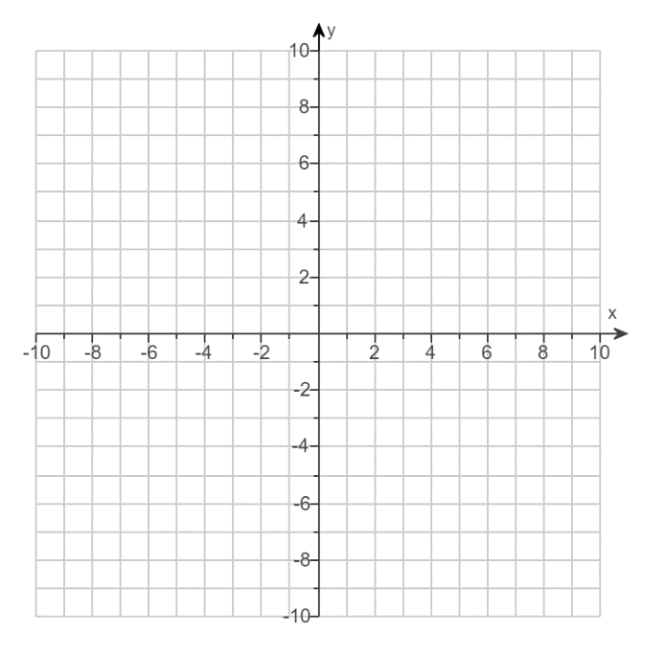a. Consider the function ${f\left(x\right)=log}_{4}{x}.$ Complete the table and graph $f$. Then fill in the missing information about $f$ and its graph.

|  |  |
| --- | --- |
| $$x$$ | $$f(x)$$ |
| $$\frac{1}{4}$$ |  |
| $$1$$ |  |
| $$4$$ |  |

Domain:

Range:

$x$-intercept:

Vertical asymptote:

b. Consider the function ${f\left(x\right)=log}_{\left(1/4\right)}{x}.$ Complete the table and graph $f$. Then fill in the missing information about $f$ and its graph.

|  |  |
| --- | --- |
| $$x$$ | $$f(x)$$ |
| $$\frac{1}{4}$$ |  |
| $$1$$ |  |
| $$4$$ |  |

Domain:

Range:

-intercept:

Vertical asymptote: