Section 11.7 Solving Nonlinear Systems of Equations

Objective 1: Solving a System of One Linear and One Quadratic Equation by Graphing

We now apply the same methods we used to solve systems of two linear equations to solving systems that have one linear equation and one quadratic equation.

One method we use to solve a system of two equations is graphing. Since the solutions to the system correspond to the intersection points of the graph, we are only interested in real number solutions. If the two graphs do not intersect, then we say the system has no solution.

Solve the system by graphing.
a.$\left\{\begin{aligned}y=x^{2}-1 \\ y=-x+1 \end{aligned}\right.$  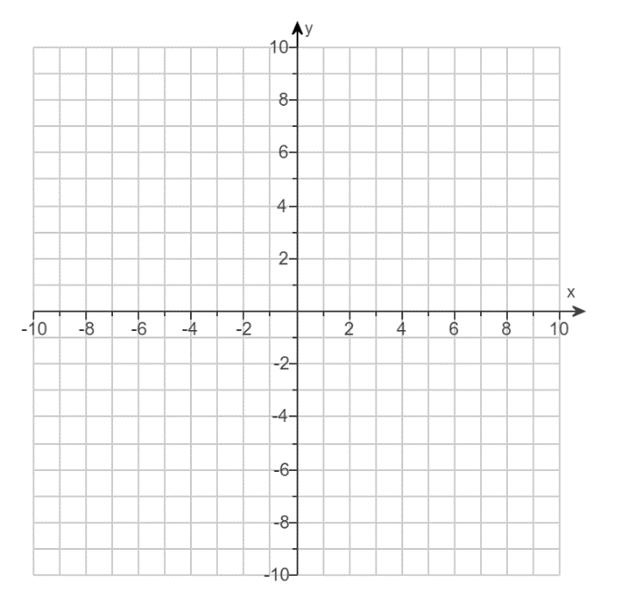 | b. $\left\{\begin{aligned}y=x^{2}-1 \\ y=x-5\end{aligned}\right.$
Recall that equations of the form ${\left(x-h\right)}^{2}+{\left(y-k\right)}^{2}=r^{2}$ graph circles with center $(h,k)$ and radius $r$. These types of equations are also considered quadratic equations.

Solve the system by graphing.

c. $\left\{\begin{aligned}x^{2}+y^{2}=4 \\ y=2\end{aligned}\right.$

Objective 2: Solving a System of One Linear and One Quadratic Equation Algebraically

We solved systems of linear equations algebraically by using the methods of substitution or elimination. These methods can also be used to solve a system of one linear and one quadratic equation.

Solve the system algebraically. Give answers in exact form using simplified radicals when needed.
a.$\left\{\begin{aligned}x^{2}+y^{2}=3 \\ y=-3x \end{aligned}\right.$ | b. $\left\{\begin{aligned}y={3x}^{2}+2x-1 \\ 3x+ y=1\end{aligned}\right.$

