Section 14.1 Angles and Radian Measure

# Objective 1: The Vocabulary of Angles

An **angle** is made up of two rays that share a common endpoint called a **vertex**. An angle is created by rotating one ray away from a fixed ray. The fixed ray is called the **initial side** of the angle and the rotated ray is called the **terminal side** of the angle. A ray rotated in a counterclockwise fashion has positive measure. A ray rotated in a clockwise fashion has negative measure.

An angle is in **standard position** if the vertex is at the origin and the initial side of the angle is along the positive *x*-axis. Angles $α$ and $θ$, drawn below, are both in standard position. The value of $α$ is positive, and the terminal side of $α$ lies in quadrant 2. The value of $θ$ is negative, and the terminal side of $θ$ lies in quadrant 3.

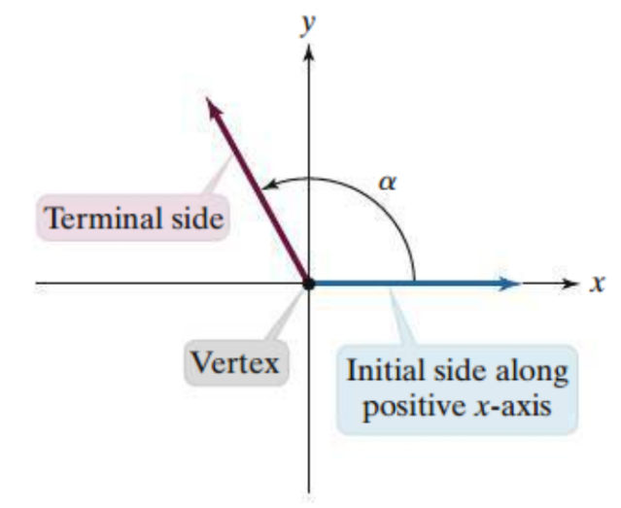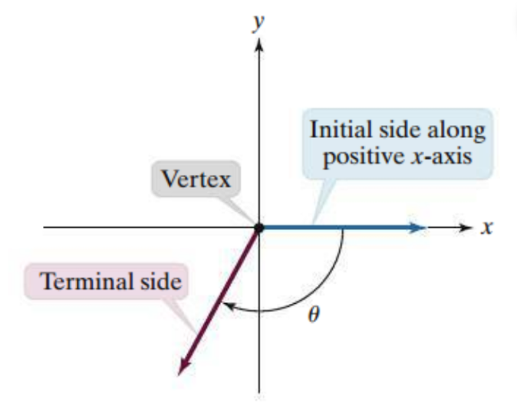

When the terminal side of an angle lies on the $x$- or $y$-axis, the angle is called a **quadrantal angle**. Angle $β$ is a quadrantal angle because its terminal side lies on the negative $y$-axis.

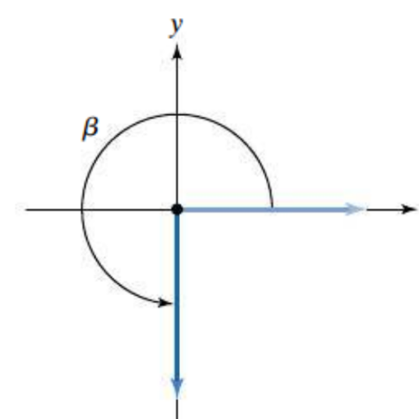

# Objective 2: Measuring Angles Using Degrees

Angles are measured by determining the amount of rotation from the initial side to the terminal side. One way to measure angles is in degrees.

Draw each angle in standard position and state the quadrant in which the terminal side lies or state if the angle lies on the positive or negative $x$- or $y$-axis.

|  |  |
| --- | --- |
| a. $245°$ | b. $-350°$ |
| c. $450°$ | d. $-450°$ |

# Objective 3: Measuring Angles Using Radians

Another way to measure angles is in **radians**. Consider a circle of radius $r$ as shown below. The angle is called a **central angle** because its vertex is located at the center of the circle. This central angle intercepts an arc along the circle measuring $r$ units, the same measure as the radius. The measure of such an angle is defined as $1$ radian.

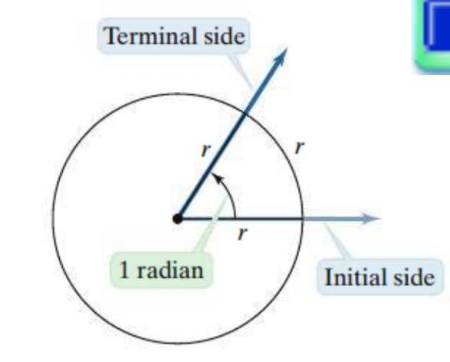

**Definition of a Radian:**

One radian is the measure of the central angle of a circle that intercepts an arc equal to the length of the radius of the circle.

The radian measure of any central angle is the length of the intercepted arc divided by the circle’s radius. For example, the length of the arc intercepted by angle $β$ is $2r$, so angle $β$ has a measure of $2$ radians. Angle $γ$ has a measure of $3$ radians because it intercepts an arc of length $3r$.

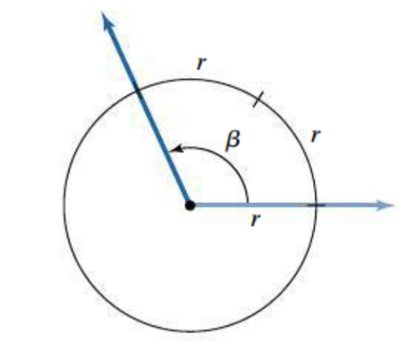 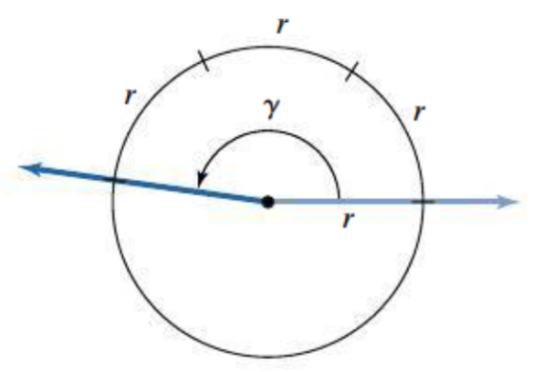

**Radian Measure:**

Consider an arc of length $s$ on a circle of radius $r$. The measure of the central angle, $θ$, that intercepts the arc is $θ=\frac{s}{r}$ radians.

a. Find the radian measure of the central angle of a circle of radius $3$ cm that intercepts an arc of length $11$ cm.

We know that $360°$ is the amount of a rotation of a ray back onto itself. The length of the intercepted arc in this case is equal to the circumference of the circle. Thus, the radian measure of the intercepted arc can be calculated as follows:

$$θ=\frac{s}{r}=\frac{2πr}{r}=2π$$

So one full rotation measures $2π$ radians. Note that there is no symbol or abbreviation to represent the units of radians. When an angle is measured in radians, the units are often not noted.

b. Complete the table and label the graph below the table with the degree and radian measures.

|  |  |  |
| --- | --- | --- |
| Amount of rotation | Degree measure | Radian measure |
| $$0$$ | $$0$$ | $$0$$ |
| $$\frac{1}{4}$$ |  |  |
| $$\frac{1}{2}$$ |  |  |
| $$\frac{3}{4}$$ |  |  |
| $$1$$ | $$360°$$ | $$2π$$ |

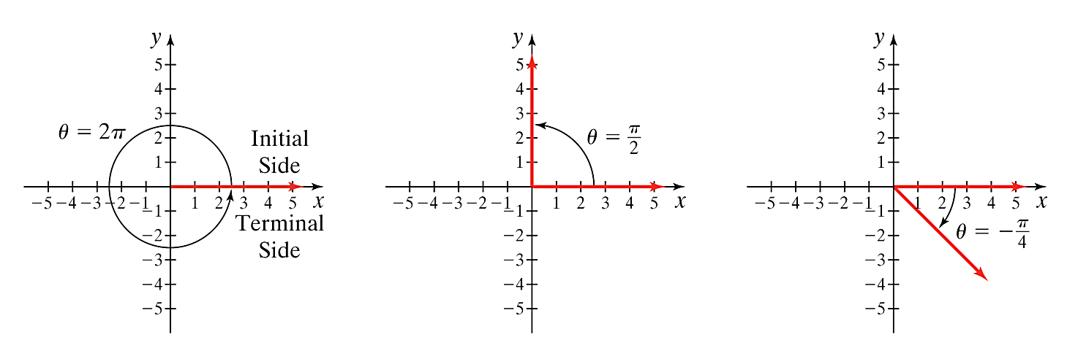

Draw each angle in standard position and state the quadrant in which the terminal side lies or state if the angle lies on the positive or negative $x$- or $y$-axis.

|  |  |
| --- | --- |
| c. $\frac{3π}{4}$ | d. $-π$ |
| e. $\frac{4π}{3}$ | f. $4π$ |
| g. $\frac{11π}{6}$ | h. $-\frac{11π}{6}$ |

# Objective 4: Converting Between Degrees and Radians

We can use one of our known relationships between degrees and radians to convert between the two units of measure. The most convenient one to use is the fact that $180°=π$ radians. Dividing this equation by $180°$ or by $π$ radians, we can see that:

$1=\frac{π radians}{180°}$ and $1=\frac{180°}{π radians}$.

**Conversion Between Degrees and Radians:**

To convert from degrees to radians, multiply the degree measure by $\frac{π radians}{180°}$.

To convert from radians to degrees, multiply the radian measure by $\frac{180°}{π radians}$.

Convert from degrees to radians. Give your answer as an integer or simplified fraction of $π$.

|  |  |  |
| --- | --- | --- |
| a. $60°$ | b. $330°$ | c. $-200°$ |

Convert from radians to degrees. Round to the nearest tenth if necessary.

|  |  |  |
| --- | --- | --- |
| d. $\frac{22π}{9}$ radians | e. $-\frac{7π}{4}$ radians | f. $1$ radian |
| g. $3π$ radians | h. $3$ radians |  |

# Objective 5: Finding Coterminal Angles

There are infinitely many angles of different measures that share the same initial and terminal sides due to different rotations. Angles drawn in standard position that share the same terminal side are called **coterminal angles**.

Consider the angles $30°$ and $-330°$.

a. Draw both angles in standard position.

b. Name two other angles that are coterminal to these angles.

For angles measured in degrees, coterminal angles can be obtained by adding any nonzero integer multiple of $360°$.

c. Name two angles, one negative and one positive, that are coterminal to $-290°$.

For angles measured in radians, coterminal angles can be obtained by adding any nonzero integer multiple of $2π$.

Name two angles, one negative and one positive, that are coterminal to the given angle.

|  |  |
| --- | --- |
| d. $\frac{5π}{4}$ | e. $-\frac{π}{9}$ |
| f. $\frac{10π}{3}$ | g. $-\frac{13π}{2}$ |

# Objective 6: Finding the Length of a Circular Arc

We can use the radian measure formula, $θ=\frac{s}{r}$, to find the length of the arc of a circle by solving the formula for $s$, the arc length.

**The Length of a Circular Arc:**

Let $r$ be the radius of a circle and $θ$ the nonnegative radian measure of a central angle of the circle. The length of the arc intercepted by the central angle is

$s=rθ$.

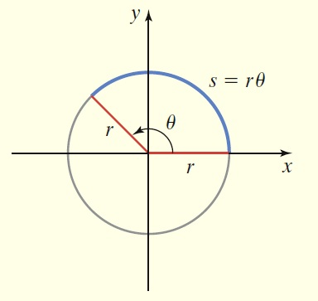

A circle has a radius of $6$ cm. Find the length of the arc intercepted by a central angle of $120°$.