Section 14.2 Right Triangle Trigonometry

# Objective 1: The Six Trigonometric Functions

There are six trigonometric functions that form the foundation of the study of trigonometry. When the input is the measure of an acute angle, the output is the ratio of two sides of a right triangle. The two legs of the right triangle are described by their position relative to the acute angle. For example, in the triangle below, the horizontal leg is the side that is adjacent to angle $θ$, and the vertical leg is the side that is opposite of $θ$.

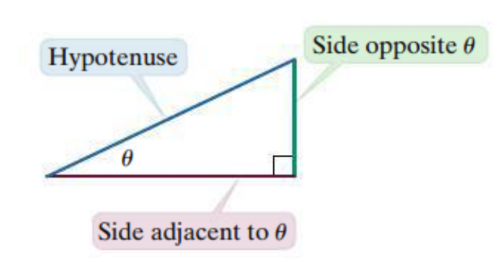

The trigonometric functions have names that are words rather than single letters, like $f$, $g$, or $h$. For example, the **sine of $θ$** is the length of the side opposite of $θ$ divided by the length of the hypotenuse. Or written as an equation,

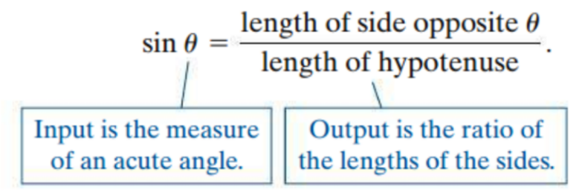

The expression $sinθ$ is read as “sine of theta.” Sine is the name of the function, and $θ$ is the input.

**Right Triangle Definitions of the Trigonometric Functions**

The six trigonometric functions of the acute angle $θ$ are defined as follows.

|  |  |  |
| --- | --- | --- |
| **Name** | **Abbreviation** | **Definition** |
| sine | sin | $$sin θ=\frac{length of side opposite θ}{length of hypotenuse}$$ |
| cosine | cos | $$cos θ=\frac{length of side adjacent to θ}{length of hypotenuse}$$ |
| tangent | tan | $$tan θ=\frac{length of side opposite θ}{length of side adjacent to θ}$$ |
| cosecant | csc | $$csc θ=\frac{length of hypotenuse}{length of side opposite θ}$$ |
| secant | sec | $$sec θ=\frac{length of hypotenuse}{length of side adjacent to θ}$$ |
| cotangent | cot | $$cot θ=\frac{length of side adjacent to θ}{length of side opposite θ}$$ |

Find the value of each of the six trigonometric functions of $θ$.

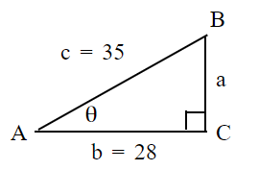

# Objective 2: Function Values for Some Special Angles

When working with the six trigonometric functions, we will often use input values of $30°$ (or $\frac{π}{6}$ radians), $45°$ (or $\frac{π}{4}$ radians), and $60°$ (or $\frac{π}{3}$ radians). Thus, you need to be familiar with two special right triangles.

A right triangle with both acute angles pi over 4, both legs of length 1, and a hypotenuse of length square root of 2.
 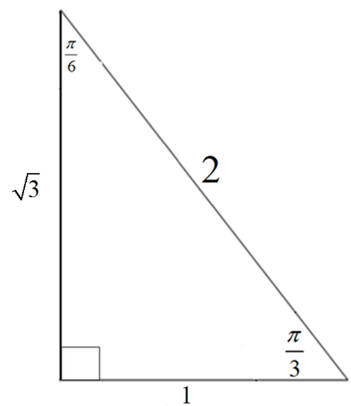

a. Use the two triangles to complete the table.

|  |  |  |  |
| --- | --- | --- | --- |
|  | $$θ=\frac{π}{6}$$ | $$θ=\frac{π}{4}$$ | $$θ=\frac{π}{3}$$ |
| $$sin θ$$ |  |  |  |
| $$cos θ$$ |  |  |  |
| $$tan θ$$ |  |  |  |

State the exact value. If necessary, rationalize the denominator.

|  |  |  |
| --- | --- | --- |
| b. $csc 60°$ | c. $cot 60°$ | d. $sec 60°$ |
| e. $csc \frac{π}{4}$ | f. $cot \frac{π}{4}$ | g. $sec \frac{π}{4}$ |

# Objective 3: Fundamental Identities

Many relationships exist among the six trigonometric functions. These relationships are described using **trigonometric identities**.

The first set of identities comes from the fact that each trigonometric function has another trigonometric function that is its reciprocal.

**The Reciprocal Identities:**  



 

The second set of identities comes from the fact that the tangent and cotangent functions can be written as quotients in terms of sine and cosine.

**The Quotient Identities:**  

To verify the identity consider the triangle shown below.

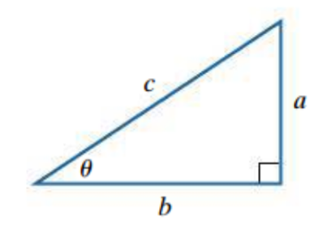

$\frac{sinθ}{cosθ}=\frac{\frac{a}{c}}{\frac{b}{c}}=\frac{a}{c}⋅\frac{c}{b}=\frac{a}{b}=tanθ$

Consider an acute angle $θ$ such that $csc θ=\frac{17}{8}$ and $sec θ=\frac{17}{15}$.

a. Find $sin θ$ and $cos θ$.

b. Find $tan θ$ and $cot θ$.

Find the approximate value using a calculator. Round to four decimal places.

|  |  |
| --- | --- |
| c*. $cos 57°$* | d. $sec 57°$ |
| e. tan $\frac{π}{9}$ | f. cot $\frac{π}{9}$ |

The next set of identities are derived from the Pythagorean Theorem. Consider the same right triangle given previously.

$$a^{2}+b^{2}=c^{2}$$

Dividing both sides by $c^{2}$:

$$\frac{a^{2}}{c^{2}}+\frac{b^{2}}{c^{2}}=1 \\ {\left(\frac{a}{c}\right)}^{2}+{\left(\frac{b}{c}\right)}^{2}=1$$

Substituting in trigonometric functions:

$${\left(sin θ\right)}^{2}+{\left(cos θ\right)}^{2}=1$$

When a trigonometric function is raised to a power, it is standard to write the exponent between the function name and the angle measurement. So the first Pythagorean identity is:

$\sin^{2}{θ}+\cos^{2}{θ}=1$.

The other two Pythagorean Identities can be derived by starting from the Pythagorean Theorem and dividing both sides by $b^{2}$ and then by $a^{2}$ respectively.

**The Pythagorean Identities:**   

g. Consider an acute angle $θ$ such that $sin θ=\frac{\sqrt{7}}{7}$. Use a Pythagorean identity to find $cos θ$.

h. State the exact value of $\tan^{2}\left(\frac{3π}{11}\right)-\sec^{2}\left(\frac{3π}{11}\right).$