Section 14.4

Trigonometric Functions of Real Numbers; Periodic Functions

# Objective 1: Trigonometric Functions of Real Numbers

In previous sections, we considered trigonometric functions of angles measured in degrees or radians. To define trigonometric functions of real numbers, rather than angles, we will use a **unit circle** which is a circle of radius $1$ unit. For a unit circle with its centers at the origin of a rectangular coordinate plane, the equation is $x^{2}+y^{2}=1$.

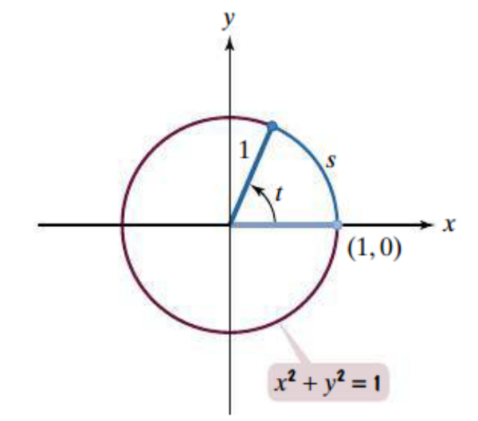

The central angle is $t$ radians. Using the formula for the length of a circular arc, we see that the length of the intercepted arc is $t$ units.

$$s=rθ=1⋅t=t$$

Thus, in a unit circle, the radian measure of the central angle is equal to the length of the intercepted arc. Both are given by the same real number $t$.

In the figures below, the radian measure of the angle and the length of the intercepted arc are both $t$. Let $P (x,y)$ denote the point on the unit circle that has arc length $t$ from $(1,0)$. If $t$ is positive, point $P$ is reached by moving counterclockwise along the unit circle from $\left(1,0\right).$ If $t$ is negative, point $P$ is reached by moving clockwise along the unit circle from $\left(1,0\right).$ For each real number $t$, there corresponds a point $P (x,y)$ on the unit circle.

A graph of a unit circle with the angle t measured counterclockwise from the initial side along the positive x-axis ending at (1, 0) to the terminal side of length 1 pointing up in quadrant 1 and ending at a point P(x,y) on the unit circle.  An arc t is traced between the two points.

And a second graph of a unit circle with the angle t measured clockwise from the initial side along the positive x-axis ending at (1, 0) to the terminal side of length 1 pointing up in quadrant 4 and ending at a point P(x,y) on the unit circle.  An arc t is traced between the two points.

The sine function of $t$ is defined as the $y$-coordinate of point $P$, so $sin t=y$. Remember that $t$ is a central angle of a unit circle, so $r=1$. Thus, this definition is consistent with our definition of the sine function from section 14.3 where we defined the sine of an angle $θ$ as $sin θ=\frac{y}{r}$.

The cosine function of $t$ is defined as the $x$-coordinate of point $P$, so $cos t=x$. Again, because $r=1$, this definition is consistent with our definition of the cosine function from section 14.3 where we defined the cosine of an angle $θ$ as $cos θ=\frac{x}{r}$.

**Definitions of the Trigonometric Functions in Terms of a Unit Circle**

Let $t$ be a real number and $P(x,y)$ be a point on the unit circle that corresponds to $t$.

$\sin{t}=y$ $\cos{t}=x$ $\tan{t}=\frac{y}{x}$, $x≠0$

$\csc{t}=\frac{1}{y}$, $y≠0$ $\sec{t}=\frac{1}{x}$, $x≠0$ $\cot{t}=\frac{x}{y}$, $y≠0$

The point $P\left(\frac{21}{29},-\frac{20}{29}\right)$ is shown on the unit circle corresponding to a real number $t$. Find the values of the trigonometric functions at $t$.

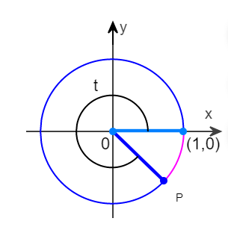

# Objective 2: Even and Odd Trigonometric Functions

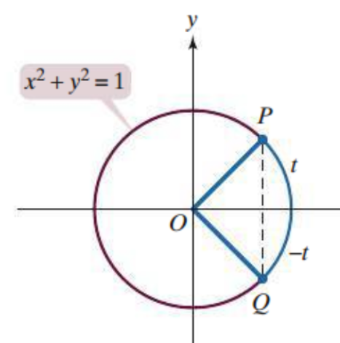Consider the unit circle below with point $P$ which has coordinates $(cos t$, $sin t)$ and point $Q$ which has coordinates $(cos (-t)$, $sin (-t))$. Notice that the $x$-coordinates of points $P$ and $Q$ are the same but that the $y$-coordinates are negatives of each other. Using the definitions of the trigonometric functions we can establish the following relationships.

$$cos \left(-t\right)=cos t \\ sin \left(-t\right)=-sin t \\ tan \left(-t\right)=-tan t$$

These relationships hold true for any real number $t$ for which the trigonometric functions are defined. Thus, the cosine function is an even function, and the sine and tangent functions are odd functions.

Let $sin t=m$ and $cos t=n$. Write each expression in terms of $m$ and $n$.

|  |  |
| --- | --- |
| a. $5sin \left(-t\right)+2sin t$ | b. $5cos \left(-t\right)+2cos t$ |
| c. $5sin \left(-t\right)+2cos (-t)$ |  |

# Objective 3: Periodic Functions

If we begin at any point $P$ on the unit circle and travel a distance of $2π$ units along the perimeter, we will return to the same point $P$. Because sine and cosine are defined in terms of the coordinates of that point $P$, we obtain the following results:

$$\sin\left(t+2π\right)=sin t$$

$$\cos\left(t+2π\right)=cos t$$

The sine and cosine functions are **periodic functions** and have a period of $2π$.

The tangent function is also a periodic function. If we begin at any point $P(x,y)$ on the unit circle and travel a distance of $π$ units along the perimeter, we will arrive at a point $(-x,-y$) as shown below. The tangent function at these two points is the same. Thus,

$\tan\left(t+π\right)=tan t$.

The tangent function has a period of $π$.

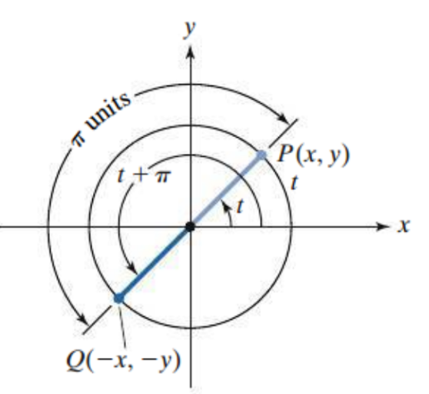

Find the exact value of the trigonometric function.

|  |  |
| --- | --- |
| a. $sin \frac{2π}{3}$ | b. $sin \frac{8π}{3}$ |
| c. cos $\frac{π}{6}$ | d. $cos \frac{25π}{6}$ |
| e. tan $\frac{7π}{4}$ | f. tan $\frac{11π}{4}$ |

Let $sin t=m$, $cos t=n$, and $tan t=p$. Write each expression in terms of $m$, $n$, and $p$.

g. $5sin \left(t+2π\right)+2cos \left(t+10π\right)-tan (t+3π)$

h. $5sin \left(-t-2π\right)+2cos \left(-t-10π\right)-tan (-t-3π)$