Section 14.5 Graphs of Sine and Cosine Functions

# Objective 1: The Graph of $y=sin x$

We can graph $y=sin x$ by finding and plotting select points , where the *x*-value represents an angle measured in radians and the *y*-value represents the sine of the angle.

The table shows some select values that we can use to graph the function. Because the period of the sine function is $2π$, we will graph the function on the interval $0≤x≤2π$. The rest of the graph is made up of repetitions of this portion.

A table two rows. Row 1 is x 0, pi/6, pi/3, pi/2, 2pi/3, 5pi/6, pi, 7pi/6, 4pi/3, 3pi/2, 5pi/3, 11pi/6, 2pi. Row 2 is y = sinx and the value of sine for each x-value.

Below the table is a description of the value of sine on the intervals 0 to pi/2, pi/2 to pi, pi to 3pi/2, and 3pi/2 to 2pi.

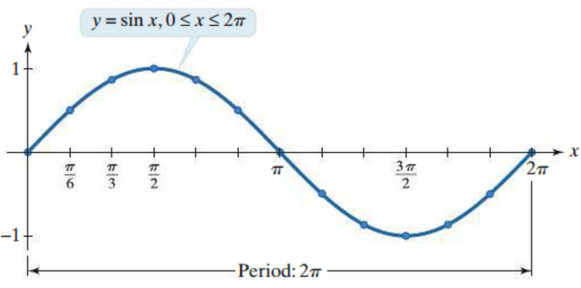

We can obtain a more complete graph of the sine function by graphing more cycles. Any part of the graph that corresponds to one period ($2π$) is one cycle of the graph of $y=sin x$.

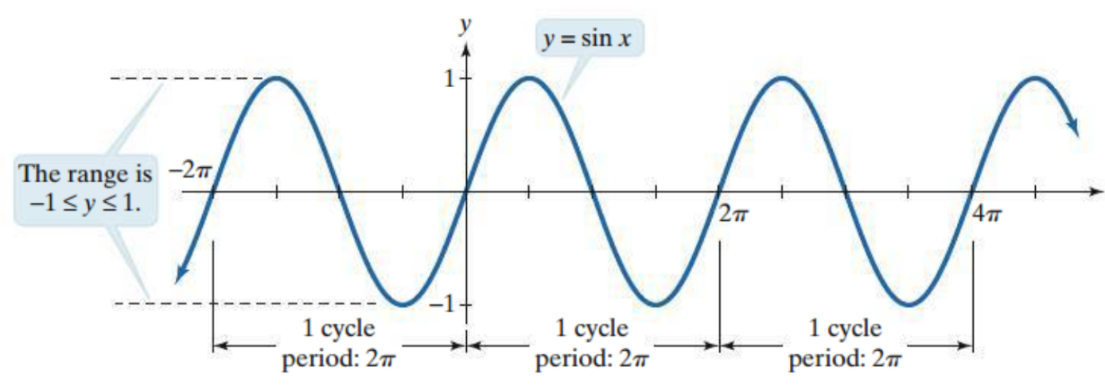

**Characteristics of the Sine Function and Its Graph:**

* The domain is all real numbers.
* The range is $-1≤y≤1$.
* The period is $2π$.
* The function is odd. The graph is symmetric about the origin.
* The $x$-intercepts of the graph are of the form $x=nπ$ where $n$ is an integer.

# Objective 2: Graphing Variations of $y=sin x$

To graph one complete cycle of any transformation of the sine function, it is necessary to find a minimum of five points: three $x$-intercept points, one maximum point, and one minimum point. Notice that on the graph of $y=sin x$, these five points evenly divide one cycle into fourths or quarters. The $x$-coordinates of the five key points can be defined as follows.

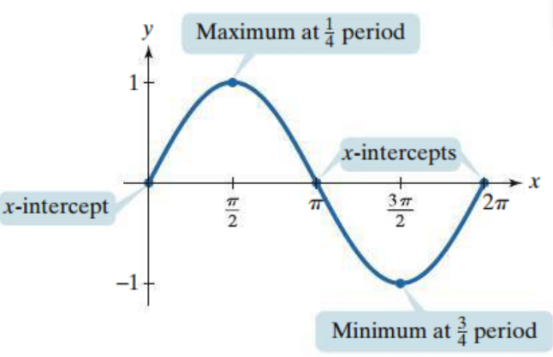

$x_{1}=$ value of $x$ where the cycle begins

$x_{2}=x_{1}+\frac{period}{4}$

$x_{3}=x_{2}+\frac{period}{4}$

$x_{4}=x_{3}+\frac{period}{4}$

$x_{5}=x_{4}+\frac{period}{4}$

The $y$-coordinates of the five key points are obtained by evaluating the given function at each of these $x$-values.

The **amplitude** of a sine curve is the measure of half the distance between the maximum and minimum values.

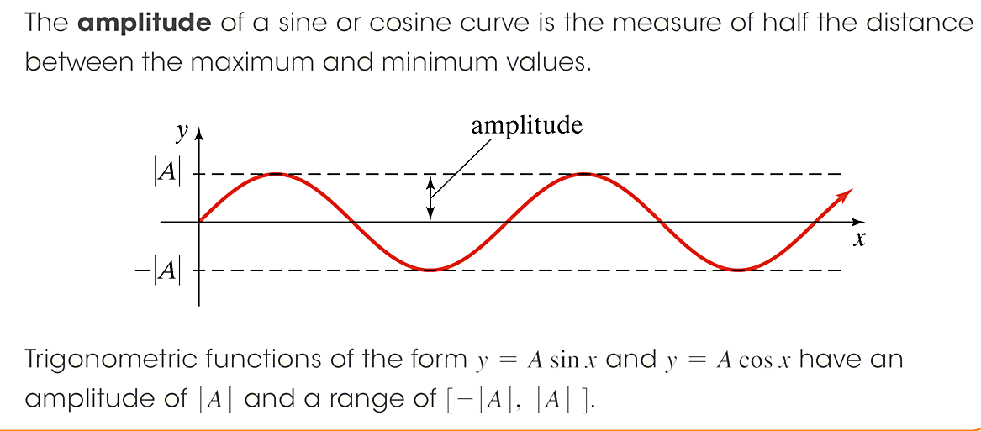

Trigonometric functions of the form $y=Asin x$ have an amplitude of $|A|$ and a range of $-|A|≤y≤|A|$.

Determine the amplitude of the function. Then graph the function and $y=sin x$ on the interval $0≤x≤2π$ on the same coordinate plane.

|  |  |
| --- | --- |
| a. $f\left(x\right)=5sin x$ | b. $f\left(x\right)=-5sin x$ |
| c. $f\left(x\right)=\frac{1}{2}sin x$ |  |

We will now look at functions of the form $y=Asin(Bx)$ where $B>0$. Because the graph of $y=sin x$ completes one cycle from $x=0$ to $x=2π$, we know that the graph of $y=Asin(Bx)$ completes one cycle as $Bx$ increases from $0$ to $2π$.

$$0≤Bx≤2π$$

$$0≤x≤\frac{2π}{B}$$

So the graph of $y=Asin(Bx)$ completes one full cycle from $0$ to $\frac{2π}{B}$. The period is $\frac{2π}{B}$.

**Amplitude and Period:**

The graph of $y=Asin(Bx)$ has amplitude = $|A|$ and period = $\frac{2π}{B}$.

Determine the amplitude and period of the function. Then graph one period of the function.

|  |  |
| --- | --- |
| d. $f\left(x\right)=sin (2x)$ | e. $f\left(x\right)=sin \left(\frac{1}{2}x\right)$ |
| f. $f\left(x\right)=3sin (πx)$ | g. $f\left(x\right)=-\frac{5}{2}\sin\left(\frac{2x}{3}\right)$ |

We will now consider functions of the form $y=Asin(Bx-C)$ where $B>0$. The graph still has amplitude = $|A|$ and period = $\frac{2π}{B}$. The graph completes one cycle as $Bx-C$ increases from $0$ to $2π$.

$$0≤Bx-C≤2π$$

$$C≤Bx≤2π+C$$

$$\frac{C}{B}≤x≤\frac{2π}{B}+\frac{C}{B}$$

$\frac{C}{B}$ is the value of the $x$-coordinate on the left where the cycle begins, and $\frac{2π}{B}+\frac{C}{B}$ is the value of the $x$-coordinate on the right where the cycle ends. The graph of $y=Asin(Bx-C)$ is the graph of $y=Asin(Bx)$ shifted horizontally $\frac{C}{B}$ units. This horizontal shift of $\frac{C}{B}$ is called the **phase shift** of the graph of the sine function.

Determine the amplitude, period, and phase shift of the function. Then graph one period of the function.

|  |  |
| --- | --- |
| h. $f\left(x\right)=2sin \left(x-\frac{π}{4}\right)$ | i. $f\left(x\right)=3sin \left(2x+π\right)$ |
| j. $f\left(x\right)=-\frac{1}{2}sin \left(6x-\frac{π}{2}\right)$ | k. $f\left(x\right)=10\sin\left(\frac{x}{3}+\frac{π}{3}\right)$ |

# Objective 3: The Graph of $y=cos x$

As we did to first graph the sine function, we can graph $y=cos x$ by finding and plotting select points , where the *x*-value represents an angle measured in radians and the *y*-value represents the cosine of the angle.

The table shows some select values that we can use to graph the cosine function.

A table two rows. Row 1 is x 0, pi/6, pi/3, pi/2, 2pi/3, 5pi/6, pi, 7pi/6, 4pi/3, 3pi/2, 5pi/3, 11pi/6, 2pi. Row 2 is y = cosx and the value of cosine for each x-value.

Below the table is a description of the value of cosine on the intervals 0 to pi/2, pi/2 to pi, pi to 3pi/2, and 3pi/2 to 2pi.

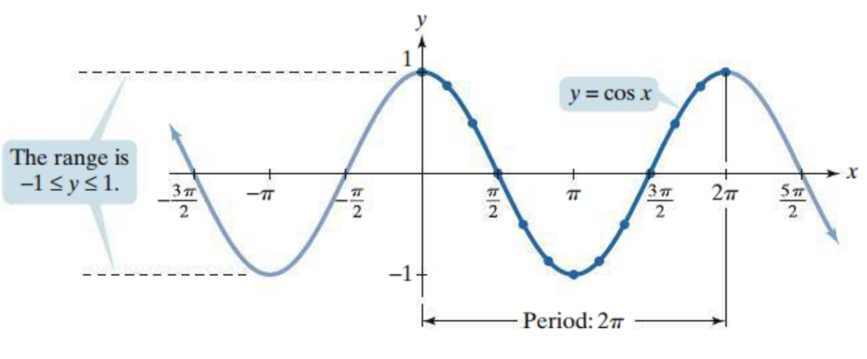

**Characteristics of the Cosine Function and Its Graph:**

* The domain is all real numbers.
* The range is $-1≤y≤1$.
* The period is $2π$.
* The function is even. The graph is symmetric about the $y$-axis.
* The $x$-intercepts of the graph are of the form $x=\frac{nπ}{2}$ where $n$ is an odd integer.

# Objective 4: Graphing Variations of $y=cos x$

We will graph variations of the graph of the cosine function in the same way that we graphed variations of the sine function.

The graph of $y=Acos(Bx)$ has amplitude = $|A|$ and period = $\frac{2π}{B}$. The graph of $y=Acos(Bx-C)$ is the graph of $y=Acos(Bx)$ shifted horizontally $\frac{C}{B}$ units. In other words, the graph of $y=Acos(Bx-C)$ has a phase shift of $\frac{C}{B}$.

Determine the amplitude and period. Then graph one period of the function.

|  |  |
| --- | --- |
| a. $f\left(x\right)=-\frac{1}{4}\cos\left(\frac{x}{3}\right)$ | b. $f\left(x\right)=7cos \left(\frac{2π}{5}x\right)$ |

Determine the amplitude, period, and phase shift of the function. Then graph one period of the function.

|  |  |
| --- | --- |
| c. $f\left(x\right)=cos\left(3x-π\right)$ | d. $f\left(x\right)=9cos \left(x+\frac{3π}{2}\right)$ |
| e. $f\left(x\right)=-\frac{3}{2}cos \left(4x-3π\right)$ | f. $f\left(x\right)=6\cos\left(\frac{πx}{6}+2π\right)$ |

# Objective 5: Vertical shifts of Graphs of Sine and Cosine Functions

We will now look at graphs of $y=Asin\left(Bx-C\right)+D$ and $y=Acos\left(Bx-C\right)+D$. The constant $D$ shifts the graph of $y=Asin(Bx-C)$ and $y=Acos(Bx-C)$ vertically $D$ units.

Graph one period of the function.

|  |  |
| --- | --- |
| a. $f\left(x\right)=3cos x-2$ | b. $f\left(x\right)=-2sin x+4$ |
| c. $f\left(x\right)=cos \left(3x\right)+4$ | d. $f\left(x\right)=4\sin\left(\frac{πx}{4}\right)-1$ |

**Objective 6: Modeling Periodic Behavior**

Many real-world situations are cyclical and can therefore be modeled with a sine or cosine function.

The number of hours of daylight on a given day in a certain city is given by the equation $y=3\sin\left(\frac{2π}{365}\left(x-79\right)\right)+12$ where $x$ represents the number of days after January $1$.

a. How many hours of daylight are there on the longest day of the year?

b. How many hours of daylight are there on the shortest day of the year?