Section 4.1 Solving Systems of Linear Equations in Two Variables

# Objective 1: Determining Whether an Ordered Pair is a Solution

Recall that a solution of an equation in two variables is an ordered pair $(x,y)$ that makes the equation true. A **solution of a system** of two equations in two variables is an ordered pair $(x,y)$ that makes both equations true.

Determine whether the ordered pair $(5,4)$ is a solution of the system $\left\{\begin{aligned}2x-5y=-10 \\ 2x+4y=6\end{aligned}\right.$.

# Objective 2: Solving a System by Graphing

We can estimate the solution(s) of a system of equations by graphing each equation on the same coordinate system and estimating the coordinates of any point of intersection.

a. Solve the system by graphing.

$\left\{\begin{aligned}-2x+y=-5 \\ 2x-4y=8\end{aligned}\right.$

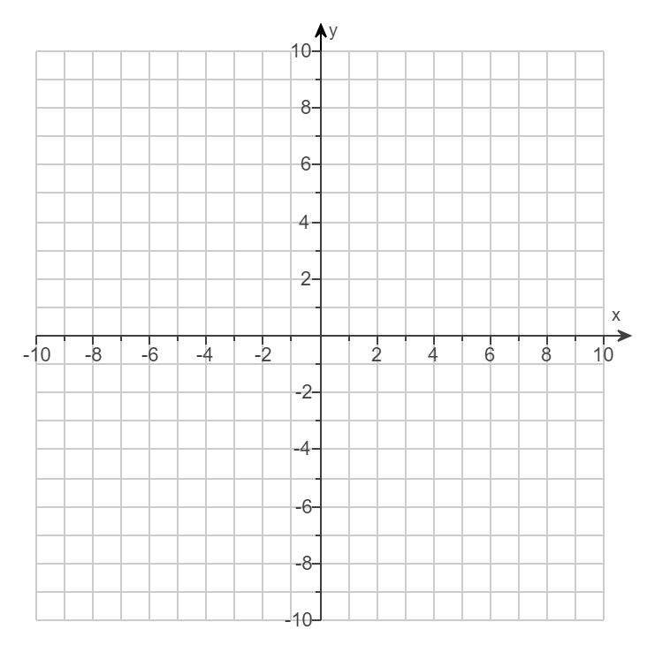

A system of two linear equations can have one solution, no solution, or infinitely many solutions.

Solve each system by graphing.

|  |  |
| --- | --- |
| b. $\left\{\begin{aligned} 2x-y=6 \\ 6x-3y=6\end{aligned}\right.$ | c. $\left\{\begin{aligned} 2x-y=6 \\ 6x-3y=18\end{aligned}\right.$ |



**Objective 3: Solving a System by Substitution**

One algebraic method for solving systems of equations is substitution. It is more reliable than solving by graphing which can sometimes only give approximate solutions.

Solve the system of equations by using the substitution method.

$\left\{\begin{aligned} 9x-2y=-1 \\ 9x+y=0\end{aligned}\right.$

# Objective 4: Solving a System by Elimination

The elimination method, or addition method, is a second algebraic method for solving systems of equations.

For this method, we rely on a version of the addition property of equality which states that “equals added to equals are equal.” Or stated another way, if $A=B$ and $C=D$, then $A+C=B+D.$

Solve each system of equations by using the elimination method.

|  |  |
| --- | --- |
| a. $\left\{\begin{aligned} 9x-2y=-1 \\ 9x+y=0\end{aligned}\right.$ | b. $\left\{\begin{aligned} x-4y=14 \\ 4x-16y=14\end{aligned}\right.$ |

Solve each system of equations using any method.

|  |  |
| --- | --- |
| c. $\left\{\begin{aligned} y=3-7x \\ 3y=9-21x\end{aligned}\right.$ | d. $\left\{\begin{aligned}\frac{2}{3}x+y=3 \\ -\frac{1}{8}x-\frac{3}{4}y=-\frac{27}{8}\end{aligned}\right.$ |

e. $\left\{\begin{aligned}6x-5y=9 \\ -5x+3y=-11\end{aligned}\right.$