Section 8.1 Radicals and Radical Functions

# Objective 1: Finding Square Roots

To find the **square root** of a number $a$, we find a number that was squared to get $a$. For example, since $5^{2}=25$ and ${\left(-5\right)}^{2}=25$, both $5$ and $-5$ are square roots of $25$.

**Principal and Negative Square Roots:**

If $a$ is a nonnegative number, then

* $\sqrt{a}$ is the **principal**, or **nonnegative**, **square root** of $a$.
* $-\sqrt{a}$ is the **negative square root** of $a$.

An expression containing a radical sign is called a **radical expression**. An expression within or “under” a radical sign is called a **radicand**. For example, $\sqrt{a}$ is a radical expression with a radicand of $a$.

Simplify. Assume all variables under radicals represent nonnegative numbers.

|  |  |
| --- | --- |
| a. $\sqrt{x^{10}}$ | b. $\sqrt{64n^{18}}$ |

# Objective 2: Approximating Roots

Square roots of perfect square radicands simplify to rational numbers. When the radicand of a square root is not a perfect square or the quotient of two perfect squares, then it is an **irrational number**.

For example, $\sqrt{13}$ is an irrational number. Without a calculator, we can tell that its value is somewhere between $3$ and $4$ since $\sqrt{9}<\sqrt{13}<\sqrt{16}$. With a calculator, we can find a decimal approximation.

$$\sqrt{13}≈3.606$$

# Objective 3: Finding Cube Roots

Finding roots can be extended to other roots such as cube roots. For example, since $2^{3}=8$, we call $2$ the **cube root** of $8$. Using a radical sign, we write $\sqrt[3]{8}=2$ which is read “the cube root of $8$ is $2$.”

**Cube Root:**

The cube root of a real number $a$ is written as $\sqrt[3]{a}$, and $\sqrt[3]{a}=b$ if and only if $b^{3}=a$.

Evaluate the cube root.

|  |  |
| --- | --- |
| a. $\sqrt[3]{125}$ | b. $\sqrt[3]{-125}$ |

Notice that unlike with square roots, it is possible to have a negative radicand when finding a cube root. This is because the cube of a negative number is a negative number. Therefore, the cube root of a negative number is a negative number.

Simplify.

|  |  |
| --- | --- |
| c. $\sqrt[3]{x^{12}}$ | d. $\sqrt[3]{64n^{18}}$ |

# Objective 4: Finding $nth$ Roots

We can find the $nth$ **root** of a number, where $n$ is any natural number. The $nth$ root of $a$ is written as $\sqrt[n]{a}$, where $n$ is called the **index**. For example, $\sqrt[4]{16}$ has an index of $4$ and is read as “the fourth root of $16."$

$\sqrt[4]{16}=2$ because $2^{4}=16$

For square roots, the index of $2$ is usually omitted.

Simplify. Assume all variables under radicals represent nonnegative numbers.

|  |  |
| --- | --- |
| a. $\sqrt[4]{81}$ | b. |

|  |  |
| --- | --- |
| c. $\sqrt[5]{32k^{15}}$ | d. |

|  |  |
| --- | --- |
| e. $\sqrt{\frac{x^{12}}{100}}$ | f. $\sqrt[4]{625r^{8}s^{12}}$ |

# Objective 5: Graphing Square Root Functions

Consider the square root function $f\left(x\right)=\sqrt{x}$.

a. Graph the function by creating a table of values.

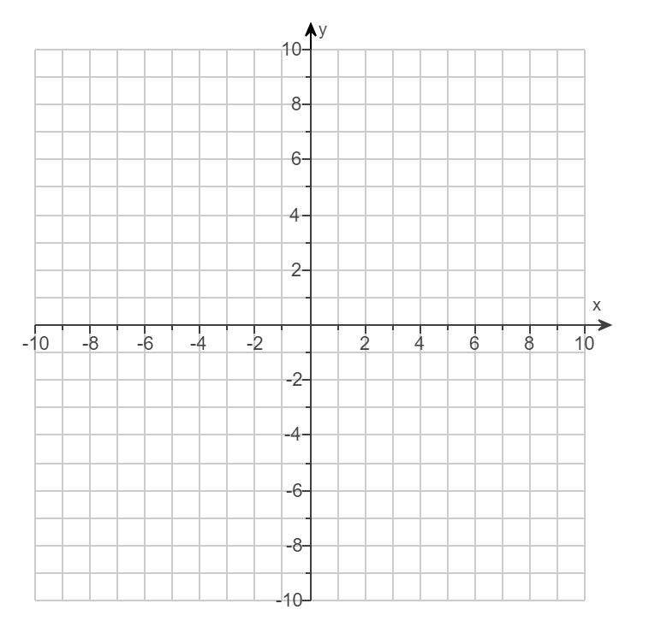

b. State the domain of $f$.

For functions that are transformations of the square root function, the domain includes all real numbers that make the radicand greater than or equal to $0$.

Graph by using transformations of the square root function $f\left(x\right)=\sqrt{x}$. State the domain of $g$.

|  |  |
| --- | --- |
| c. $g\left(x\right)=\sqrt{x}+4$ | d. |



|  |  |
| --- | --- |
| e. $g\left(x\right)=-\sqrt{x-1}$ | f. $g\left(x\right)=\sqrt{x+2}-3$ |



# Objective 6: Graphing Cube Root Functions

Consider the cube root function $f\left(x\right)=\sqrt[3]{x}$.

a. Graph the function by creating a table of values.



b. State the domain of $f$.

For functions that are transformations of the cube root function, the domain is all real numbers.

Graph by using transformations of the cube root function $f\left(x\right)=\sqrt[3]{x}$. State the domain of $g$.

|  |  |
| --- | --- |
| c. $g\left(x\right)=\sqrt[3]{x-5}$ | d. |



|  |  |
| --- | --- |
| e. $g\left(x\right)=-\sqrt[3]{x}+3$ | f. $g\left(x\right)=\sqrt[3]{x+4}+1$ |

