Section 8.7 Complex Numbers

Objective 1: Writing Numbers in the Form $bi$

In this section, we examine a number system that includes roots of negative numbers. We know that $\sqrt{-1}$ is not a real number because there is no real number whose square is $-1$, so $\sqrt{-1}$ is not included in the real number system. The complex number system includes the set of real numbers as a subset and also includes numbers that contain the imaginary unit.

Imaginary Unit:
The imaginary unit, written $i$, is the number whose square is $-1$.
$i^{2}=-1$ and $i=\sqrt{-1}$

To write the square root of a negative number in terms of $i$, we use the property that if $a$ is a positive number, then
$\sqrt{-a}=\sqrt{-1}⋅\sqrt{a}=i\sqrt{a}$.

Numbers that can be written in the form $i\sqrt{a}$ where $a$ is a positive number are called imaginary numbers.

Simplify, using $i$ notation as needed.
a. $\sqrt{-64}$ | b. $\sqrt{-15}$

c. $\sqrt{-28}$ | d. $-\sqrt{-164}$

The product and quotient rules for radicals do not necessarily hold true for expressions containing imaginary numbers. Therefore, to multiply or divide square roots of negative numbers, first write each number in terms of the imaginary unit $i$. For example, to multiply $\sqrt{-2}$ and $\sqrt{-8}$, first write each number in the form $i\sqrt{a}$.
$$\sqrt{-2}⋅\sqrt{-8}=i\sqrt{2}⋅i\sqrt{8}=i^{2}\sqrt{16}=-1⋅4=-4$$

Note that if we had multiplied first, we would have gotten the incorrect result that the expression is equal to $4$.

Multiply or divide. Give answers in simplified form using $i$ notation as needed.
e. $\sqrt{-9}⋅\sqrt{9}$ | f. $\sqrt{-9}⋅\sqrt{-9}$ | g. $\sqrt{-2}⋅\sqrt{-6}$

h. $\frac{\sqrt{-9}}{\sqrt{9}}$ | i. $\frac{\sqrt{-18}}{\sqrt{-9}}$

Objective 2: Graphing Complex Numbers

A complex number is a number that can be written in the form $a+bi$, where $a$ and $b$ are real numbers. For example, $-5+3i$ is a complex number.

The set of real numbers is a subset of the set of complex numbers since a real number can be thought of as a complex number in the form $a+bi$ where $b=0$. For example, the real number $10$ can be thought of as $10+0i$.

The numbers we saw in objective 1 are called pure imaginary numbers. The set of pure imaginary numbers are also a subset of the set of complex numbers because they are numbers in the form $a+bi$ where $a=0$ and $b≠0$. For example, $7i$ is a complex number that is a pure imaginary number and can be written as $0+7i$.

Recall that a real number can be plotted as a point on the real number line. In a similar manner, a complex number can be plotted as a point in the complex plane. In the complex plane, the horizontal axis is called the real axis, and the vertical axis is called the imaginary axis.

Graph the complex number.
a.$-5+3i$  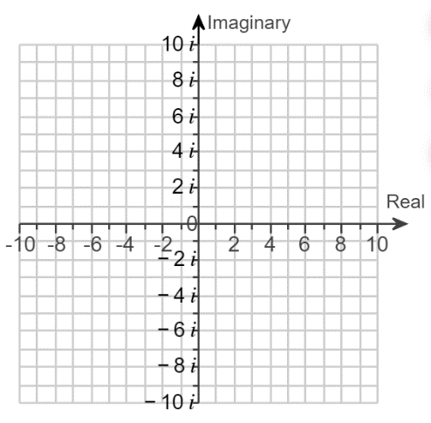 | b. $7i$

Objective 3: Adding or Subtracting Complex Numbers

Complex numbers can be added or subtracted by adding or subtracting their real parts and adding or subtracting their imaginary parts.

Sum or Difference of Complex Numbers:
If $a+bi$ and $c+di$ are complex numbers, then their sum is given by
$\left(a+bi\right)+\left(c+di\right)=\left(a+c\right)+\left(b+d\right)i$.
Their difference is given by
$\left(a+bi\right)-\left(c+di\right)=\left(a-c\right)+\left(b-d\right)i$.

Add or subtract.
a.$\left(6-2i\right)+(-8+10i)$ | b. $\left(6-2i\right)-(-8+10i)$

Objective 4: Multiplying Complex Numbers

In section 8.4, we multiplied radical expressions by using the distributive property. We also use the distributive property to multiply two complex numbers.

Write each expression in the form $a+bi$.
a.$4i(1-i)$ | b. $\left(6-2i\right)(-8+10i)$

c.$(\sqrt{2}-i\sqrt{6})(\sqrt{2}+i\sqrt{6}$) | d. ${\left(3+4i\right)}^{2}$

Objective 5: Dividing Complex Numbers

In section 8.5, we rationalized a numerator or denominator that contained a radical expression that was the sum or difference of two terms by using conjugates. We will use a similar technique to divide by a complex number.

To divide by a complex number, multiply the numerator and denominator by its complex conjugate. The complex numbers $(a+bi)$ and $(a-bi)$ are complex conjugates of each other. The product of complex conjugates is a real number.
$$\left(a+bi\right)\left(a-bi\right)=a^{2}-{\left(bi\right)}^{2}=a^{2}-b^{2}i^{2}=a^{2}-b^{2}\left(-1\right)=a^{2}+b^{2}$$

Divide. Give your answer in the form $a+bi$.
a.$\frac{4i}{1-i}$ | b. $\frac{6-2i}{-8+10i}$

c.$\frac{1-i}{4i}$

Objective 6: Finding Powers of $i$

We know from the definition of the imaginary unit that $i^{2}=-1$. Using this fact and properties of exponents, we can find higher powers of $i$.
$$i^{3}=i⋅i^{2}=i\left(-1\right)=-i \\ i^{4}={\left(i^{2}\right)}^{2} ={\left(-1\right)}^{2}=1$$

a. Complete the table.
$$i^{1}=i$$ | $$i^{5}=$$ | $$i^{9}=$$
$$i^{2}=-1$$ | $$i^{6}=$$ | $$i^{10}=$$
$$i^{3}=-i$$ | $$i^{7}=$$ | $$i^{11}=$$
$$i^{4}=1$$ | $$i^{8}=$$ | $$i^{12}=$$
Notice that the values repeat as we raise $i$ to higher powers. We can use this pattern and properties of exponents to determine the value of $i$ raised to any integer. For example,
$i^{30}=i^{28}⋅i^{2}={\left(i^{4}\right)}^{7}⋅i^{2}={(1)}^{7}⋅-1=-1$.

Note that there are other ways we could rewrite $i^{30}$ and still get the same result. For example,
$i^{30}={\left(i^{2}\right)}^{15}={\left(-1\right)}^{15}=-1$.

Find each power of $i$.
b.$i^{100}$ | c. $i^{103}$ | d. $i^{-9}$

