Section 9.5 Graphs of Polynomial Functions

Objective 1: Graphing Power Functions

In this section, we will look at a special type of polynomial function called a power function.

Power Function:
A power function of degree $n$ is of the form $f\left(x\right)=ax^{n}$ where $a$ is a real number constant, $a≠0$, and $n$ is a positive integer.

The graphs of five power functions of the form $f\left(x\right)=x^{n}$ are shown for $n=1, 2, 3, 4,$and $5$.

$$f\left(x\right)=x$$  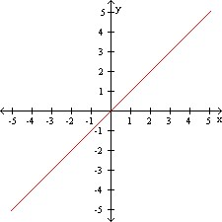 | $$f\left(x\right)=x^{2}$$  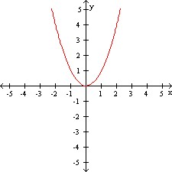 | $$f\left(x\right)=x^{3}$$  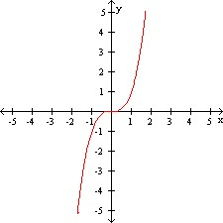 | $$f\left(x\right)=x^{4}$$  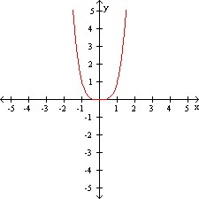 | $$f\left(x\right)=x^{5}$$  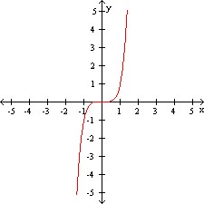

Notice that for odd values of $n$, the graphs are symmetric to the origin. This means that for every point $(x,y)$ on the graph of $f$, there is a symmetric point $(-x,-y)$. This will be true for any power function of the form $f\left(x\right)=ax^{n}$ where $n$ is odd. We say that these functions are odd.

Notice that for even values of $n$, the graphs are symmetric to the $y$-axis. This means that for every point $(x,y)$ on the graph of $f$, there is a symmetric point $(-x,y)$. This will be true for any power function of the form $f\left(x\right)=ax^{n}$ where $n$ is even. We say that these functions are even.

Use transformations to graph each power function. State whether the function is odd or even.
a. $f\left(x\right)=\frac{1}{2}x^{4}$  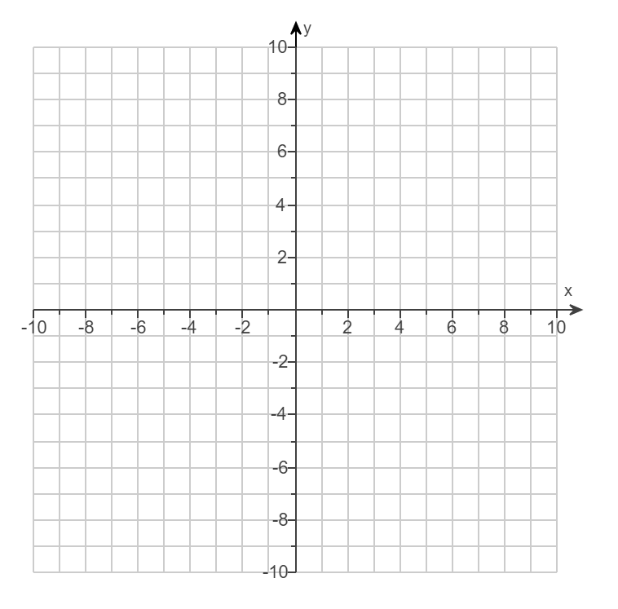 | b. $f\left(x\right)=-4x^{3}$

Objective 2: Describing End Behavior

The end behavior of a function is the behavior of the function as $x$ approaches positive infinity or negative infinity. We will use an arrow to mean “approaches.” For example, $x→∞$ is read “$x$ approaches infinity.”

The end behavior of a power function $f\left(x\right)=ax^{n}$ is determined by both the power, $n$, and the constant, $a$.

Describe the end behavior of the function by using its graph.
a.$f\left(x\right)=\frac{1}{2}x^{4}$  As $x→∞$, $f(x)→$_______.  As $x→-∞$, $f(x)→$_______. | b. $f\left(x\right)=-4x^{3}$  As $x→∞$, $f(x)→$_______.  As $x→-∞$, $f(x)→$_______.

More generally, the end behavior of any polynomial function $f\left(x\right)=a_{n}x^{n}+a_{n-1}x^{n-1}+a_{n-2}x^{n-2}…+a_{1}x+a_{0}$ is determined by its degree, $n$, and the sign of the leading coefficient, $a_{n}$.

If the degree n is odd, the graph has opposite left-hand and right-hand end behavior, that is, the graph “starts” and “finishes” in opposite directions.
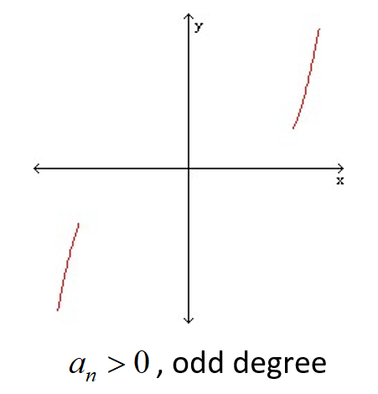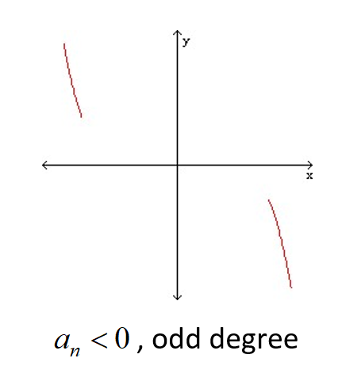

If the degree n is even, the graph has the same left-hand and right-hand end behavior, that is, the graph “starts” and “finishes” in the same direction.
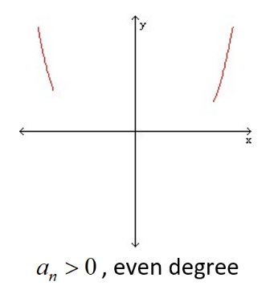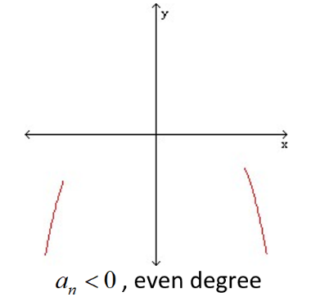

c. Describe the end behavior of the function.
$f\left(x\right)=-7x^{6}-5x^{5}+x^{4}+6x^{3}-10x^{2}-18$

As $x→∞$, $f(x)→$_______.
As $x→-∞$, $f(x)→$_______.

Objective 3: Real Zeros of Polynomial Functions and Their Multiplicities

As stated in the previous section, real zeros correspond to $x$-intercepts. A polynomial function of degree $n$ can be written as the product of $n$ linear factors. Therefore, a polynomial function can have at most $n$ real zeros, and its graph can have at most $n$ $x$-intercepts.

When a polynomial function is written in factored form, the number of times a factor associated with a zero appears is called the multiplicity of the zero. For example $f\left(x\right)=\left(x-2\right){\left(x+3\right)}^{2}{\left(x+5\right)}^{3}$ has three zeros, $2$, $-3$, and $-5$. The multiplicity of each zero is $1$, $2$, and $3$ respectively. The multiplicity affects the behavior of the graph close to that zero.

The Shape of the Graph of a Polynomial Function Near a Zero of Multiplicity $k$:
Suppose c is a real zero of a polynomial function f of multiplicity k, that is,
is a factor of f. Then the shape of the graph of f near c is as follows:

If and k is even, then the graph touches the x-axis at c.
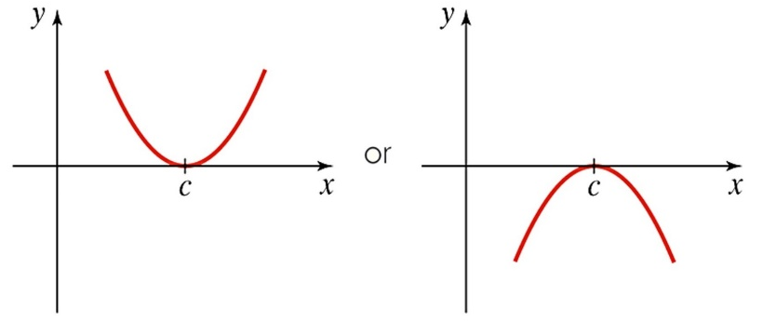
If and k is odd, then the graph crosses the x-axis at c.
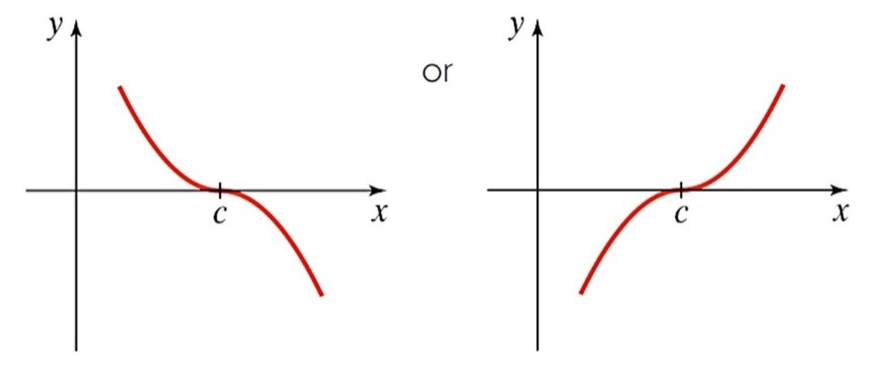

Objective 4: Sketching the Graph of a Polynomial Function

Four-Step Process for Sketching the Graph of a Polynomial Function

1. Determine the end behavior.
2. Find the y-intercept by evaluating $f(0)$.
3. Completely factor f to find all real zeros and their multiplicities.
4. Use the information from steps 1 – 3 to sketch the graph.

Note that without calculus, there is no way to precisely determine the exact coordinates of the turning points. However, the degree of the polynomial function does tell you the maximum number of turning points the graph can have. The graph of a polynomial function of degree $n$ has at most $(n-1)$ turning points.

Sketch the graph of the polynomial function showing correct intercepts, shape, and end behavior.
a.$f\left(x\right)=x^{4}-9x^{2}$ | b. $f\left(x\right)=-4(x+5)(x-3)(x-8)$
c.$f\left(x\right)=-{\left(x+1\right)}^{3}(x-2)$ | d. $f\left(x\right)=x{\left(x+2\right)}^{2}{\left(x-5\right)}^{2}$
e.$f\left(x\right)=x^{3}+4x^{2}-x-4$ | f. $f\left(x\right)=-x^{5}+10x^{4}$

