Section X.2 Standard Deviation

# Objective 1: Deviation from the Mean

We begin this section by examining how to find by how much a data item deviates from the mean. To do this, first compute the mean of the data set, $\overline{x}$. Then subtract the mean from the data item, $x-\overline{x}$.

Enter the deviation from the mean for each data item in the table.

|  |  |  |  |  |
| --- | --- | --- | --- | --- |
| $$2.35$$ | $$2.90$$ | $$2.45$$ | $$2.25$$ | $$3.05$$ |
|  |  |  |  |  |

What is the sum of the deviations from the mean?

The sum of the deviations from the mean for a set of data is always zero.

# Objective 2: Calculating Standard Deviation

The **standard deviation** of a data set is found by determining how much each data item differs from the mean. It is not useful to use an average of the deviations since that average will always be zero. Therefore, we use a kind of average of the deviations from the mean called the **standard deviation** that is found by squaring each deviation.

**Computing the Standard Deviation for a Data Set:**

1. Find the mean of the data set.
2. Find the deviation of each data item from the mean.
3. Square each deviation.
4. Find the sum of the squared deviations.
5. Divide the sum by $n-1$ where $n$ represents the number of items in the data set.
6. Take the square root of the quotient from step 5.

a. Find the standard deviation of the data set.

$$2.35, 2.90, 2.45, 2.25, 3.05$$

Note that this process is for calculating the standard deviation of a sample. When calculating the standard deviation of an entire population, the sum of the square deviations is divided by $n$ rather than $n-1$. Unless otherwise indicated, data sets represent samples, and we divide by $n-1$.

Consider the two samples A and B.

Sample A: $73, 75, 77, 79, 81, 83$

Sample B: $40, 44, 92, 94, 98, 100$

b. Without computing, which data set has the larger standard deviation? Why?

c. Calculate the standard deviation for each data set.

Graphing calculators and online statistics calculators can be used to compute standard deviation. This is particularly useful when working with large data sets.

d. Use technology to find the standard deviation of the data items displayed below.

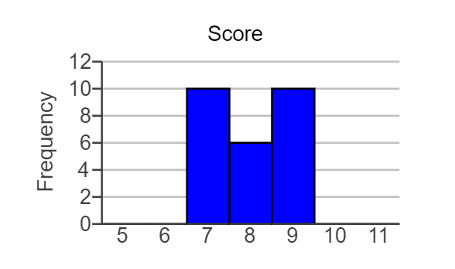

# Objective 3: Interpreting Standard Deviation

Interpreting a data set based just on a measure of center, such as its mean, can be misleading because the mean does not indicate anything about the spread of the data set.

Suppose two fifth-grade classes have nearly identical mean scores on a test, but one class has a standard deviation three times that of the other class. What does that tell you about the test scores in each class?