Section X.3 The Normal Distribution

# Objective 1: The Normal Distribution

Consider the heights of 100 adult men selected at random, shown on histogram (a). The data set is approximately symmetric. If the sample size increases, the data set becomes more symmetric, shown on histograms (b) and (c). If it were possible to measure the heights of the adult men of the entire population, the histogram would approach what is called the **normal distribution** shown in figure (d). This distribution is also sometimes called the **bell curve**.

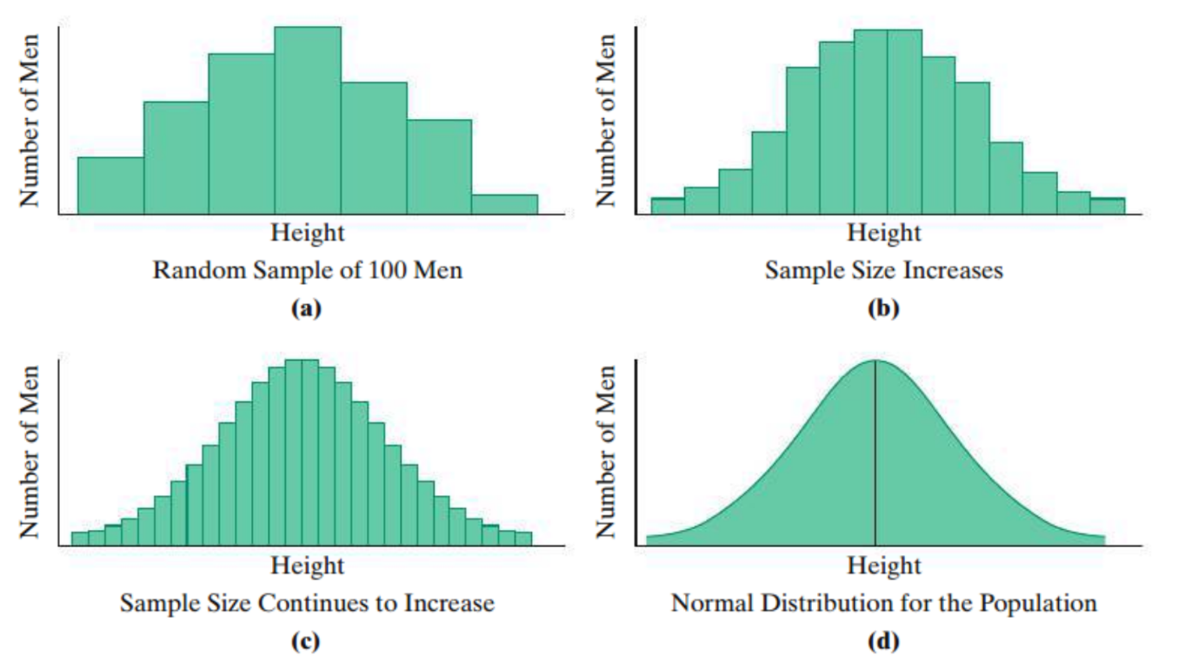

The normal distribution is bell-shaped and symmetric about a vertical line through its center. The mean, median, and mode of a normal distribution are all equal and located at the center of the distribution.

The shape of the normal distribution depends on the mean and the standard deviation. The figure below shows three normal distributions with the same mean but different standard deviations.

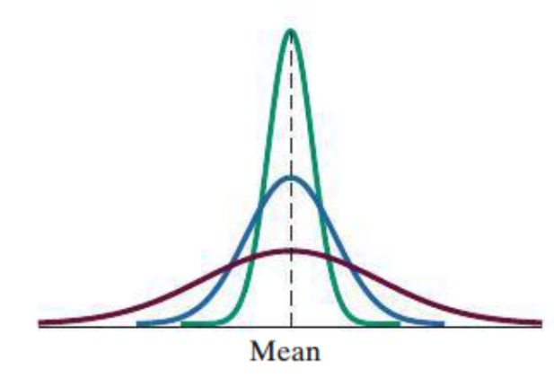

Data sets of samples that are symmetric or approximately symmetric can be modeled using the normal distribution. The normal distribution can then be used to make predictions about an entire population.

# Objective 2: The Standard Deviation in Normal Distribution

The standard deviation plays a crucial role in the normal distribution, summarized by the $68$**- $95$- $99.7$ Rule**.

**The $68$- $95$- $99.7$ Rule for the Normal Distribution**

* Approximately $68\%$ of the data items fall with $1$ standard deviation of the mean (in both directions).
* Approximately $95\%$ of the data items fall with $2$ standard deviations of the mean.
* Approximately $99.7\%$ of the data items fall with $3$ standard deviations of the mean.

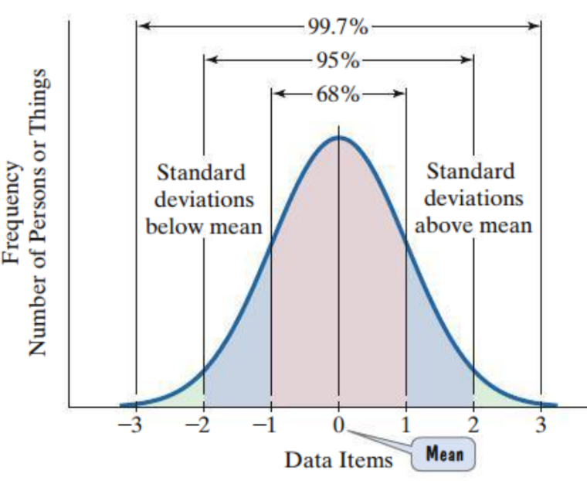

A very small percentage of the data in a normal distribution lies more than $3$ standard deviations above or below the mean. The tails of the curve approach, but never touch, the horizontal axis. Thus, no matter how far out from the mean we move, there is always a very small probability of a data item occurring farther out.

The scores on a test are normally distributed with a mean of $60$ and a standard deviation of $12$.

a. What is the score that is one standard deviation above the mean?

b. Approximately what percentage of test scores lie between $36$ and $84$? Explain.

# Objective 3: Computing $z$-Scores

In a normal distribution, a $z$-score describes how many standard deviations a particular data item ­­­­lies above or below the mean. Data items above the mean have positive $z$-scores. Data items below the mean have negative $z$-scores. The $z$-score for the mean is $0$. The $z$-score can be obtained by using the following formula.

$z$- $score =\frac{data item-mean }{standard deviation}$

The mean weight of newborn infants is $7$ pounds. The standard deviation is $0.8$ pounds. The weights of newborn infants are normally distributed.

a. Draw the normal distribution curve and label three standard deviations above and below the mean.

b. Find the $z$-score for each weight and explain what it means in this context.

|  |  |
| --- | --- |
| $9$ pounds | $7$ pounds |

c. What weight corresponds to a $z$-score of $-3$?

# Objective 4: Margins of Error

You have likely seen surveys and opinion polls report a **margin of error**. Statisticians use properties of the normal distribution to estimate the probability that a result obtained from a single sample, such as a poll or survey, reflects what is true of the larger population.

**Margin of Error in a Survey:**

If a statistic is obtained from a random sample of size $n$ with a normal distribution, there is a $95\%$ probability that it lies within $\frac{1}{\sqrt{n}}⋅100\%$ of the true population percent, where $±\frac{1}{\sqrt{n}}⋅100\%$ is called the margin of error.

A random sample of $1000$ U.S. adults were surveyed. Of those questioned, $46\%$ said that they dread public speaking.

a. Find the margin of error for this survey.

b. Fill in the blanks of the statements.

We can be $_______\%$ confident that between _______% and _______% of all U.S. adults dread public speaking.