MATH 3355-1: Probability Thursday August 27, 12:10 - 1:30PM, Lockett 276

This reviews material from last time and provides motivation for the new material we’ll see today. You can talk to your classmates while working on this, till I arrive around 12:30. This work resembles tests that you will be getting, so it’s worth your attention for this reason, too.

A. Review. A probabilistic experiment consists of rolling two dice (one red, one green), each marked with the numbers from 1 to 6 and then observing the numbers come up on each.

- Describe the sample space. How many outcomes does it contain?
- Describe the following events. How many outcomes in each?
- the sum of numbers that come up is 3;
- the sum of numbers that come up is 7;
- the sum of numbers that come up is strictly greater than 7;
- the sum of the numbers that come up on the two dice is even;
- the number that comes up on one of the dice is even (i.e., on the red, on the green OR on both);
- the intersection of a) and e);
- the intersection of d) and e);
- the complement of e)
- the sum of numbers that come up on the two dice is 1;
- the complement of i).

B. New stuff. Experience shows that if either of the dice is rolled over and over again, each of the numbers tends to appear with equal frequency. (In this case, we say “the dice are fair.”)

- Suppose the green die is rolled 1,000,000 times. About how many times would you expect to see the outcome “5”?
- Suppose the pair is rolled 1,000,000 times. About how many times would you expect to see the outcome “green=5 & red = 2”?
- Suppose the pair is rolled 1,000,000 times. About how many times would you expect to see each of the outcomes in A.2.?

A different pair of dice (one orange and one blue) has been tested and found to be unfair. Their behavior is given by the following table.

Table 1. The proportion of times each number tends to appear on each die
 | 1 | 2 | 3 | 4 | 5 | 6
Orange die | 50% | 10% | 10% | 10% | 10% | 10%
Blue die | 50% | 25% | 25% | never | never | never

- Suppose the orange-blue pair is rolled 1,000,000 times. Assuming the dice do not influence one another, about how many times would you expect to see:
- the outcome “orange=2 & blue = 1”?
- the outcome “orange=1 & blue = 2”?
- the event A.2.a)?
- the event A.2.b)?

C. Fun stuff
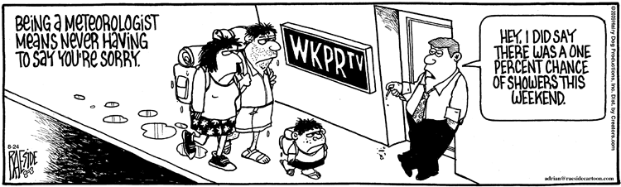
What is the probability that it rained?

